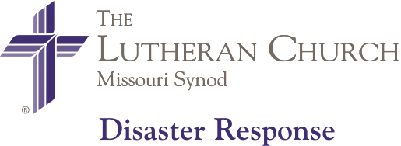
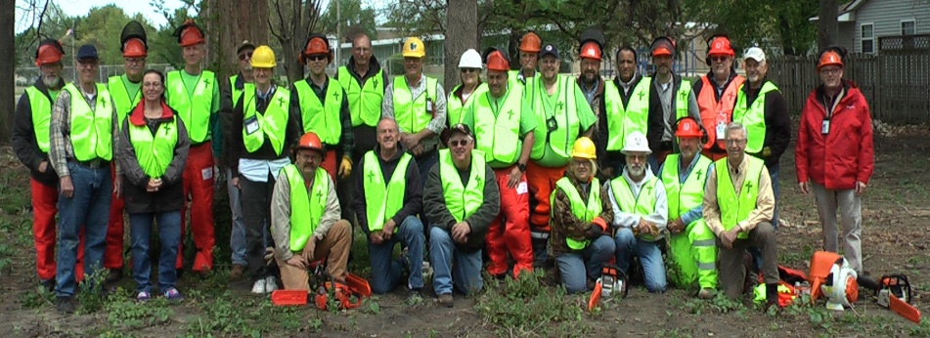

LERT Chainsaw Training Event

To be held at: Immanuel Lutheran Church
902 Cleveland Avenue
Charleston, Illinois 61920

Saturday, August 7, 2021 9 am to 5:00 pm

The registration fee ($35.00) will include breakfast and lunch.
You must be a certified LERT member to attend this class.

If you are already LERT chainsaw certified, the event is considered continuing education (no charge).

Chainsaw Training Registration Online Link:

Please click on link below or copy and paste and complete the entire registration form.

https://www.lcms-lert.org/need/detail/?need_id=590681

