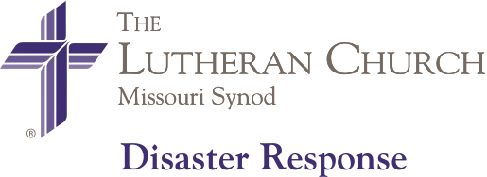
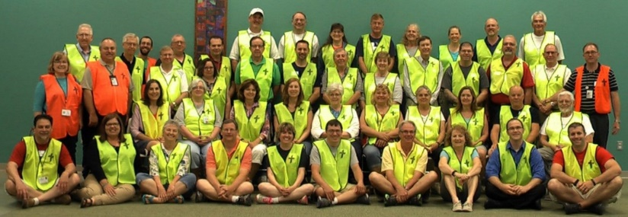

LERT Volunteer Basic Training Event

To be held at: Trinity Lutheran Church
1201 West Jackson Street
Auburn, IL 62615

Saturday, May 21, 2022
9 a.m. to 3:00 p.m.
(Sign-in begins 8:30 a.m. and sessions begin 9 a.m.)

The registration fee ($35.00) will include light breakfast, lunch, manual, credential card, and
t-shirt. Walk-ins are welcome.

If you are already LERT certified, the event is considered continuing education (no charge for re-training, but $15 if you want a manual and/or t-shirt). A $5 to $8 offering is welcome to help pay for food.

To register, follow the registration link below. You will need to register for access to the LCMS LERT website first and then you can view training events and deployments.

Basic Disaster Preparedness Training Registration

To Register: copy/paste the Online Link:
https://www.lcms-lert.org/need/detail/?need_id=668961

For further information, please contact Stephen Born at 217.220.0162 or email at bornstephen@yahoo.com or Cindy Steinwedel at cmsteinwedel@gmail.com

