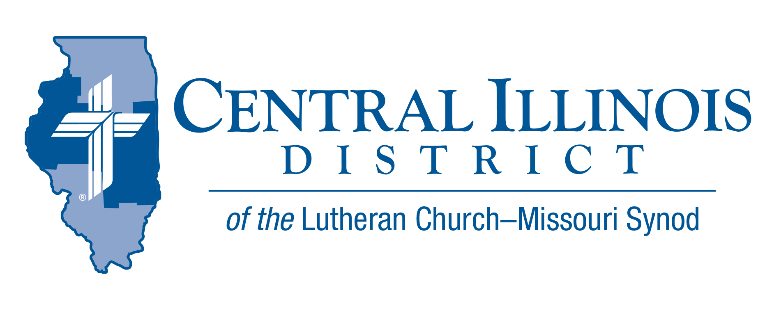
January 2021 Mid Month
News You Can Use

Many people have no clear sense of purpose. Maybe this is because contemplating our purpose in life may leave us feeling like we have failed. The “should have’s” and “what if’s” can discourage us and keep us stuck without a sense of purpose, and feeling unfulfilled, discontent, and unworthy of God’s blessings. So, how do we identify our purpose, embrace it, and successfully live it in meaningful and significant ways?
The first thing is to realize that God has already given us a purpose. Rick Warren wrote in The Purpose Driven Life, our purpose is to “give God glory and share His story.” How we specifically live out God’s purpose is determined by the context of our life and by the gifts, talents, and strength he gives us. As life changes, how we live out our purpose will change. An 88 year-old may live out his purpose differently than a 48 year old or an 18 year old. But each one’s life is made meaningful by their sense of purpose.
Secondly, put away regrets. We should do three things with past mistakes: learn from them, let go of them, and live what we have learned. Regret is different from guilt. Regret is buried within us and remains there, weighing us down and holding us back. We can bring our guilt to God where it is taken away by Christ’s forgiveness. He frees us to move forward from our mistakes and failures.
Thirdly, accept that we are never complete. We continually learn and grow, often from our mistakes. Making mistakes is part of growing. The person who never makes mistakes accomplishes nothing and never learns anything. Martin Luther wrote: “A Christian is never in a state of completion but always in a process of becoming.”
Finally, trust that God works in us, through us, and even in spite of us. A friend of mine likes to say: I take comfort in knowing that I have insufficient strength to ruin God’s plans. God graciously allows us to carry out his purpose with his strength and by His blessing. Colossians 1:29 says To this end I labor, struggling with all his energy, which so powerfully works in me.
God cannot fail. He can turn our failures and mistakes into something good in order to fulfill his purpose in us. We can joyfully live out our purpose. And God will one day graciously say to us: “Well done, good and faithful servant!”

Rev. Jeff Harter

ITEMS OF INTEREST TO SHARE
CTSFW – Continuing Education Class
Trinity Lutheran Church- 1960 E. Johns Ave Decatur, IL
June 21-23 2021
“The Book of Jeremiah: Overcoming Life’s Sorrows “
Instructor- Dr. R. Reed Lessing – Professor of Theology and Ministry and the Director of the Center of Biblical Studies at Concordia -St. Paul.

Based upon Dr. Lessing’s forthcoming book on Jeremiah (Concordia Publishing House, September 2021), this course will be a combination of in-depth study and practical application—all based upon one of the prophet’s major themes: surviving life’s sorrows. Jeremiah offers a hope and future in Christ to all who have experienced a major disaster in life.

For cost and additional information contact email Rev. Matthew Versemann at pastorversemann@msn.com or by phone 217-420-0586

LCMS- Virtual Life Conference
March 19-20, 2021
Cost: For $20, you get access to the event live. For $40, you get that, plus ongoing access to the recordings for another 90 days.
Each participant must register individually. See the following link for additional information and to register. https://www.lcms-life.org/?r_done=1.

Camp CILCA “Life Changing, Life Long, Life Eternal” Campaign Update
In 2018 Camp CILCA launched the Life Changing, Life Long, Life Eternal capital campaign with the goal of raising $1,000,000 to expand the Dining Hall, add a full-time program director, eliminate debt, and add a significant amount of money to CILCA's endowment fund. The generosity of God's people abounded and two of these goals were met in full. The $60,000 mortgage was paid in full and the endowment fund is up to $100,000. The funds from this endowment go toward providing "camperships" for children who might not otherwise be able to afford a full week at camp.

While 2020 was a tumultuous year, CILCA was able to break ground on the Dining Hall expansion in September. As of January 11, the exterior frame is nearly completed, and interior work continues. With the Lord's blessings the work will be completed by Spring. Once the Dining Hall is completed the program director position will become the next priority.

Our Lord has been truly generous, and His grace has made this all possible, working through His people. "Thank you" to all who have prayed, donated, and volunteered. You are a gift from the Lord.

