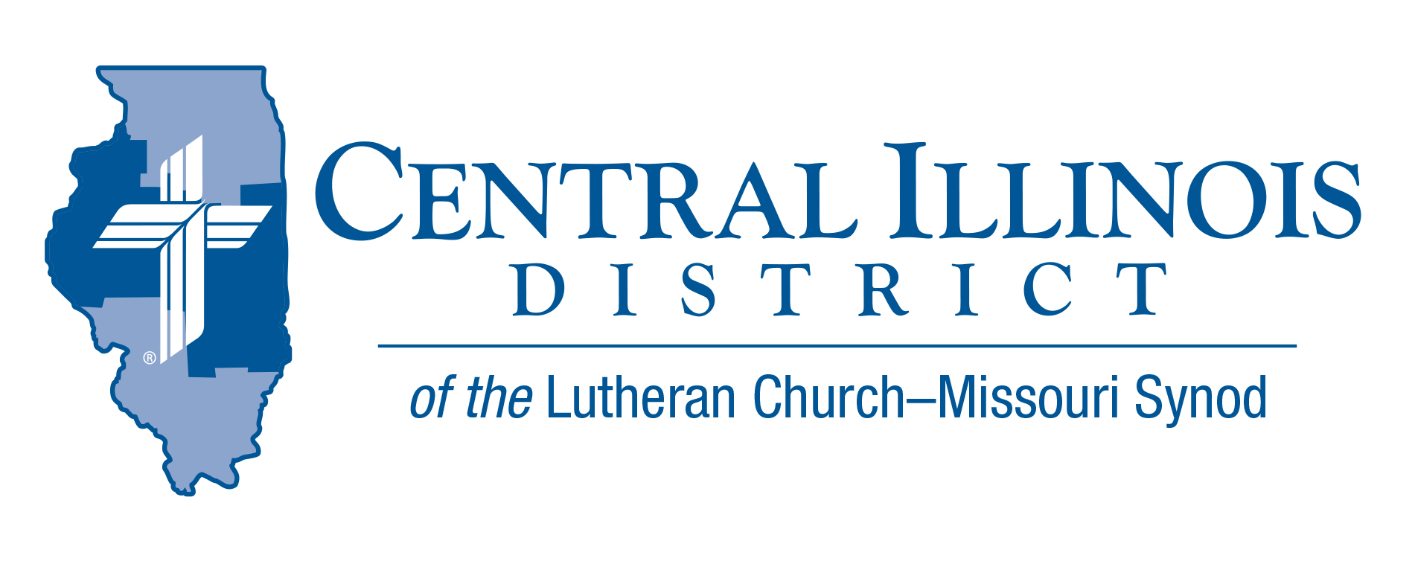
March 2021 midmonth
News You Can Use
Why Not Me?

“Here I am dying of cancer while wicked people are living healthy and happy lives!” Joan exclaimed in frustration. Many godly people who suffer pain, loss, or misfortune ask, “Why doesn’t God help me the same way as he helps others?”
Job struggled with this question. Elijah prayed in exasperation, “I have been very jealous for the Lord , the God of hosts…and I, even I only, am left, and they seek my life, to take it away.” 2 Kings 19:10. There are no easy answers to the question.
Luther gives us good advice: “If you cannot understand how…then grant the Holy Spirit the honor of being more learned than you are.” (What Luther Says Vol.1 p.93)
How terrible it would be if God knew only what we know! His promises would be contingent on an unknown future. He could not have devised and implemented the wondrous plan of salvation accomplished through a virgin birth and Christ’s resurrection.
God has not promised that we will live 100 years, or have great wealth and possessions. He has promised us greater things than these: to be with us always; to guide and comfort us; to provide for our needs; to forgive us; to give us eternal life. Of these promises we can be certain. St. Paul says in 2 Cor.1:20: For no matter how many promises God has made, they are “Yes” in Christ. And so, through him the “Amen” is spoken by us to the glory of God.
Life can be painful and unfair, and the wicked prosper. But God brings justice into an unjust world. We have the joy and hope that Isaiah proclaimed to a lost and hurting people: “Be strong, do not fear; your God will come, he will come with vengeance; with divine retribution he will come to save you.” Is.35:4

Rev. Jeff Harter
ITEMS OF INTEREST TO SHARE

Central Illinois District Youth Bible Bowl (April 18th @ 2:00pm)
CID’s Youth Bible Bowl: The Exodus. Exodus (chapters 1-20, 24, 32-34, & 40). This year we are having an “online” Bible Bowl. No team is too small to participate in the Online Bible Bowl. Contact Pastor Mark Eddy at zionlcms@juno.com if your congregation’s youth might participate in this year’s Bible Bowl.

Higher Things “Forgiven” 2021 Conferences

- North Dakota State University Fargo, ND June 29-July 2, 2021
- Colorado State University Fort Collins, CO July 6-9, 2021
- Concordia University Texas Austin, TX July 27-30, 2021
- Calvin University Grand Rapids, MI July 20-23,
Higher Things® offers an incredible, multi-day experience to registrants who attend one of the many events each summer. These conferences are held on college or university campuses around the country, giving registrants a taste and feel for what going off to school will be like. We’ve been at it since 2000. Higher Things has hosted between one and five Lutheran youth conferences each summer! Conferences in any given summer are planned around the same basic structure, but each has its own distinctive “personality” and dynamics, making each a singular, unique experience. For more information visit: (www.higherthings.org)

Here I Stand Sunday April 18th
More information will be released from the Synodical Office in the future. As a reminder in its 2019 convention, the Synod adopted the following resolution:

4-09, To Declare April 18, 2021, as “Here I Stand” Sunday and to Encourage Multi-Congregation Celebrations
- “Resolved, That April 18, 2021 be declared “Here I Stand” Sunday throughout The Lutheran Church—Missouri Synod, its districts, circuits, and congregations; and be it further
- “Resolved, That these entities be encouraged to gather for worship celebrations to commemorate this event; and be it further
- “Resolved, That a synod wide thank offering be coordinated and collected for this day, to be used toward the continued proclamation of the Gospel throughout the world . . .

BASIC LERT (Lutheran Emergency Reponses Training) TRAINING will be conducted at St. John, 1450 30th Ave., East Moline, on Saturday, April 24, 9:00 a.m. to 3:00 p.m. Check-in will be at 8:30 a.m. Participants are asked to register online in advance and also pay a $35 training fee which includes the cost of lunch. For registration, visit Https://form.jotform.com/81215292634959 use the training code:0082.

Recruiting Pastors and Other Church Workers
A convocation on church worker recruitment, particularly that of pastors, will be sponsored by the Shelbyville, Effingham, and Altamont Circuits at St. John Lutheran Church, Effingham on Pentecost, May 23, 3 to 6 p.m.
Dr. Dale Meyer, President Emeritus of Concordia Seminary, St. Louis, will be the featured guest speaker. Representatives of the seminaries, Concordia-Chicago, and Concordia-Wisconsin will be there, also folks from LCMS Ministry to the Armed Forces and Camp CILCA.
You can register for this Circuit Convocation, starting April 1. Please register by May 7 at www.stjohnsLCMS.net

