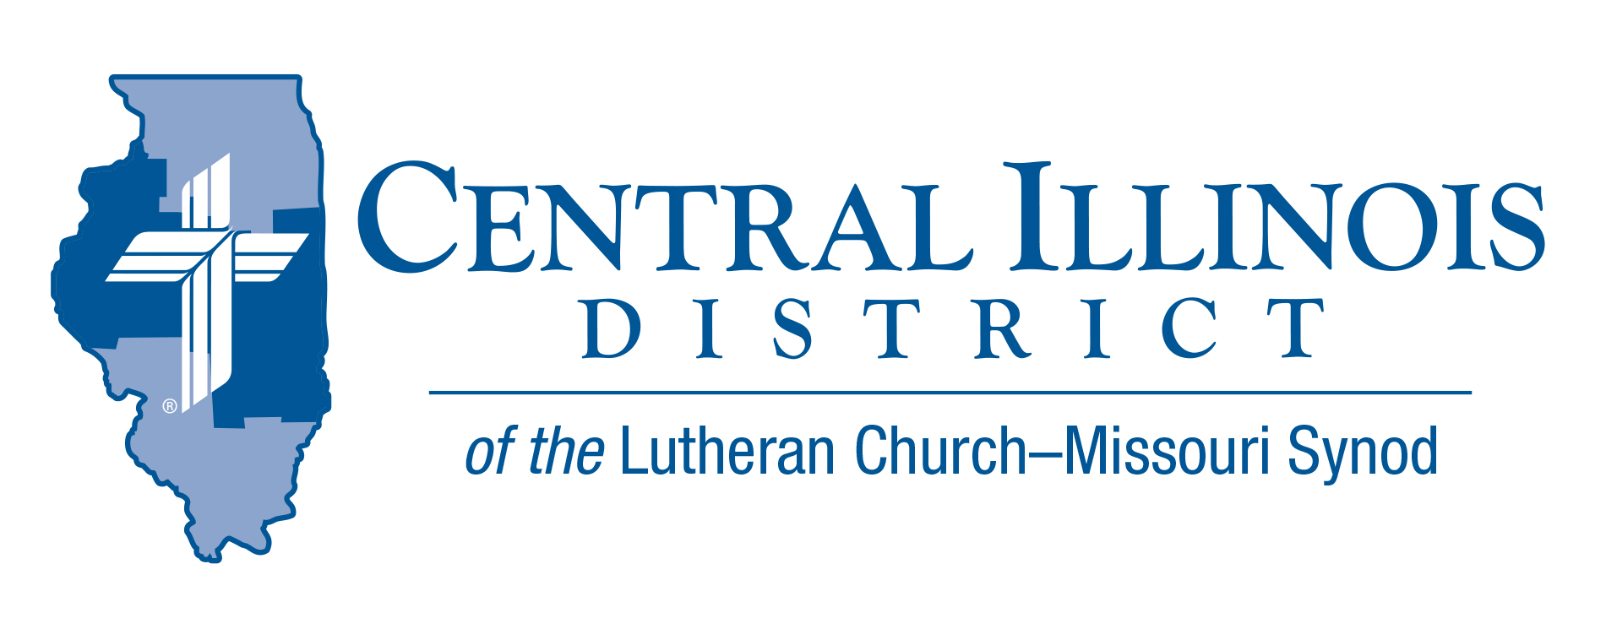
March 2021
News You Can Use

What have you done with your extra time during the covid-19 isolation? What are you going to do with the rest of it? Since the main purpose of curtailing activities with other people was to avoid sickness and death, fill your mind with God’s word. God gave His only-begotten Son so that we would believe in Him and “not perish but have eternal life” (John 3:16). Jesus “healed all those who were sick, that it might be fulfilled which was spoken by Isaiah the prophet, saying: ‘He Himself took our infirmities and bore our sicknesses’” (Matt. 8:17).
If you are not afraid of the results of sickness, because you are sure of eternal life for Jesus’ sake, contact someone you know who is not sure. How scary it must be to be isolated and in fear of sickness and death! Our neighbors in fear or doubt about their future need to hear “the testimony of our Lord” (2 Tim. 1:8) from us Christians: “God, has saved us and called us with a holy calling, not according to our works, but according to His own purpose and grace which was given to us in Christ Jesus before time began, but has now been revealed by the appearing of our Savior Jesus Christ, who has abolished death and brought life and immortality to light through the Gospel” (2 Tim. 1:9-10).
Every Christian can say with St. Paul, “I know whom I have believed and am persuaded that He is able to keep what I have committed to Him until that Day” (2 Tim. 1:12).
So, use your God-given time away from your old routines to imbed the Gospel in your heart and mind, not only so that you can live life without fear and in the hope of eternal life for Christ’s sake, but also so that you can spread this hope. Our world needs to know more about our God and Savior Jesus Christ.
Pastor Mark Eddy – Zion Lutheran Church – Taylor Ridge, IL

Pray For Our Central Illinois District Missions supported by your church’s Mission Dollars to the District. “Finally, brothers, pray for us, that the Word of the Lord may spread rapidly and be honored.” Please remember in your prayers Cristo Rey (Christ the King) Lutheran Church in East Moline, and Pastor Pablo Dominguez, where the ministry is conducted almost entirely in Spanish.

Stay Connected with your District
Looking for additional information visit https://linktr.ee/cidlcms or connect with the following items:
- CID’s GatePost (newsletter)
- Subscribe to the E-GatePost/News You Can Use
- Stay connect with us on Facebook and Instagram -- Central Illinois District-LCMS

ITEMS OF INTEREST TO SHARE
Congregational Voting Results
Results of the request to allowing districts to hold their conventions in either 2021 or 2022, and moving the upcoming national Synod convention from 2022 to 2023? More than the required one-fourth (63.32%) of the Synod’s member congregations registered a vote, and the majority (90.67%) of votes cast favored adoption. The stated extension of the 2019–2022 triennium by a year, allowing district conventions to take place in either 2021 or 2022 and deferring the national Synod convention from 2022 to 2023, is therefore adopted.

LCMS Life Conference
LCMS Life Ministry will host its first-ever virtual life conference March 19–20, under the theme “Making Disciples: Valuing Life.”

- Be equipped to speak up for the sanctity of life within your community and our society
- Gain ideas on how to care for all human life
- Interact with fellow Lutherans on Life Ministry topics
- Be a part of the LCMS Life Ministry community
The Life Conference includes a few live events, but most of this conference’s content can be accessed by registrants on demand. Basic registration for the conference allows access to content any time on March 19 or 20. An announcement is forthcoming concerning the schedule for the live sessions. Conference registration is open now at www.lcms-life.org

Here I Stand Sunday April 18th
More information will be released from the Synodical Office in the future. As a reminder in its 2019 convention, the Synod adopted the following resolution:

4-09, To Declare April 18, 2021, as “Here I Stand” Sunday and to Encourage Multi-Congregation Celebrations
- “Resolved, That April 18, 2021 be declared “Here I Stand” Sunday throughout The Lutheran Church—Missouri Synod, its districts, circuits, and congregations; and be it further
- “Resolved, That these entities be encouraged to gather for worship celebrations to commemorate this event; and be it further
- “Resolved, That a synod wide thank offering be coordinated and collected for this day, to be used toward the continued proclamation of the Gospel throughout the world . . .”
Central Illinois District Youth Bible Bowl (April 18th @ 2:00pm)
CID’s Youth Bible Bowl: The Exodus. Exodus (chapters 1-20, 24, 32-34, & 40). This year we are having an “online” Bible Bowl. No team is too small to participate in the Online Bible Bowl. Contact Pastor Mark Eddy at zionlcms@juno.com if your congregation’s youth might participate in this year’s Bible Bowl.

