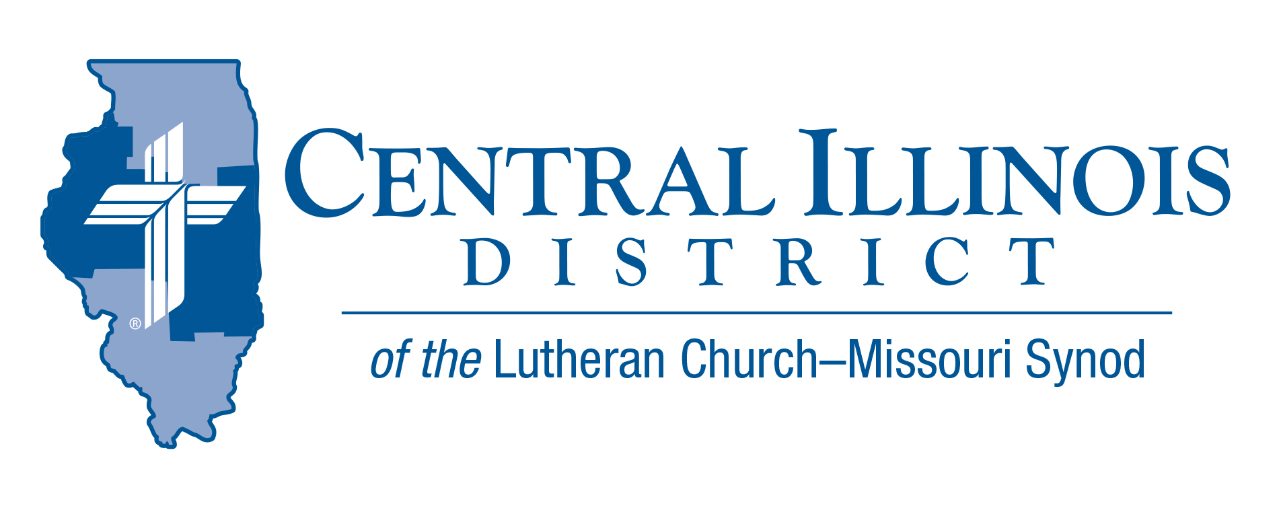
April 2021
News You Can Use
“Why do you seek the living among the dead?”

“Why do you seek the living among the dead? He is not here, He has risen. Remember how He told you…” (Luke 24:6) This little sermon proclaimed by the angel on Easter morning continues to be to be the message proclaimed from our pulpits throughout the year. Jesus paid in full the punishment for our sins by His suffering and death and rose from the dead. Further, it was just as He said. Jesus’ Word is true and trustworthy and to be believed. He not only said He would rise from the dead, he actually did. He even showed Himself to those who would be eyewitnesses to others. Jesus’ resurrection testifies that His sacrifice for our sin is the one accepted by God for all people. It promises that He is indeed present in His Word and Sacraments forgiving our sins, bringing and keeping us in his eternal family, strengthening our faith, defending us from all evil, and assuring us that He will raise our bodies from the dead to dwell with Him and all believers forever.

Rev Rick Milas Pastor Emeritus

Pray For Our Central Illinois District Missions supported by your church’s Mission Dollars to the District. “Finally, brothers, pray for us, that the Word of the Lord may spread rapidly and be honored.” Please remember in your prayers the outreach of Christ Lutheran Church for the Deaf and Pastor Tom Phillips. Pastor Phillips is our CID missionary to the deaf. He serves in Jacksonville, but also spans the District to bring the Good News about Jesus to the hearing- impaired.

New newsletters from CID:
- Keeping Christ on Campus – campus ministry news:
Click on link to Easter 2021 issue at http://www.cidlcms.org/outreach-missions-campus.html
- See? WOW! – news and encouragement for Circuit Witness and Outreach Workers: Click on link for #33 – April 2021 issue at http://www.cidlcms.org/outreach-cwow.html

Stay Connected with your District
Looking for additional information visit https://linktr.ee/cidlcms or connect with the following items:
- CID’s GatePost (newsletter)
- Subscribe to the E-GatePost/News You Can Use
- Stay connect with us on Facebook and Instagram -- Central Illinois District-LCMS

ITEMS OF INTEREST TO SHARE

BASIC LERT (Lutheran Emergency Reponses Training) TRAINING will be conducted at St. John, 1450 30th Ave., East Moline, on Saturday, April 24, 9:00 a.m. to 3:00 p.m. Check-in will be at 8:30 a.m. Participants are asked to register online in advance and also pay a $35 training fee which includes the cost of lunch. For registration, visit Https://form.jotform.com/81215292634959 use the training code:0082. (DEADLINE to Register is APRIL 10th )

“Here I Stand” Sunday April 18th
“Here I stand,” Dr. Martin Luther told the Holy Roman Emperor and all the estates of the empire at a meeting at Worms in Germany, 500 years ago. Answering a demand to recant or take back his writings, Luther said:
“Unless I can be instructed and convinced with evidence from the Holy Scriptures or with open, clear, and distinct grounds and reasoning – and my conscience is captive to the Word of God – then I cannot and will not recant, because it is neither safe nor wise to act against conscience.”
Luther took his stand. He said he could do no other, and he openly prayed for God’s help.

To commemorate the 500th anniversary of Luther’s bold stand on the Word of God, The Lutheran Church—Missouri Synod at its last convention declared Sunday, April 18, 2021 as “Here I Stand” Sunday throughout the Synod, its districts, circuits, and congregations. Helps for the observance may be found at https://www.lcms.org/here-i-stand-sunday
Luther displayed godly courage in his appearance at Worms, but it was far from his last such display. A video presentation by CID staff member Ken Schurb entitled “Luther: A Profile in Courage” explores others. Dr. Schurb’s video presentation is on the CID YouTube channel. It can be found at https://youtu.be/L4G98vt4HPg

Recruiting Pastors and Other Church Workers
Me? In Church Work?
A convocation on church worker recruitment, particularly that of pastors, will be sponsored by the Shelby, Effingham, and Altamont Circuits at St. John Lutheran Church, Effingham on Pentecost, May 23rd, 3 to 6 p.m.
Dr. Dale Meyer, President Emeritus of Concordia Seminary, St. Louis, will be the featured guest speaker. Representatives of the seminaries, Concordia-Chicago, and Concordia-Wisconsin will be there, also folks from LCMS Ministry to the Armed Forces and Camp CILCA.
Register for this convocation by May 7, at www.stjohnsLCMS.net
See the video at https://youtu.be/gpHT0EcWpAU

