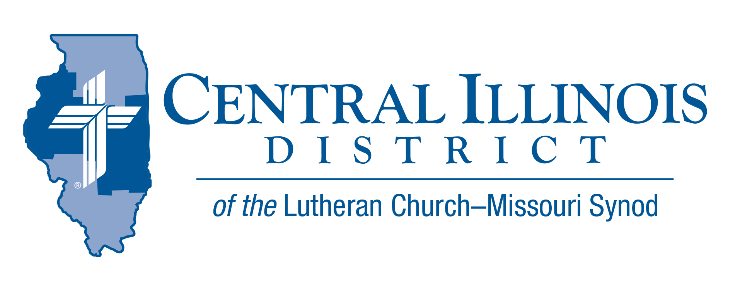
June 2021
News You Can Use

Jesus said, “Pray earnestly to the Lord of the harvest to send out laborers into His harvest.” (Mt. 9:38) He wasn’t speaking of corn, beans, or strawberries. People were His concern. People who were “like sheep without a shepherd.” Perhaps that’s a description of your congregation, as you wait for a pastor.
Regardless of the pastoral status of your congregation now, these are the days in which we can and ought to be praying for more harvest workers. We want our children, grandchildren, and their neighbors to have vibrant and faithful congregations fifty years from now. Thus, we pray and encourage today. That was the theme of our recent Circuit Convocation here in Effingham. It could be the theme of yours, too.
Take heart. We’re not in charge of this effort for recruitment and formation of harvest workers. We’re praying to the Lord of the harvest. Our role is crucial, but not supreme.
“Lord, the harvest is Yours. Send laborers into Your fields! Amen.”
-- Pastor Mike Burdick, Effingham

Pray For Our Central Illinois District Missions supported by your church’s Mission Dollars to the District. “Finally, brothers, pray for us, that the Word of the Lord may spread rapidly and be honored.” Please remember in your prayers our District’s mission work in central Illinois prisons. Rev. Charles Olander, Rev. Stephen Southward, Rev. Rodney Blomquist, and a growing number of CID volunteers, eagerly tell the Good News of Jesus Christ to people who are incarcerated. And pray for additional volunteers!

Stay Connected with your District
Looking for additional information visit https://linktr.ee/cidlcms or connect with the following items:
- CID’s GatePost (newsletter)
- Subscribe to the E-GatePost/News You Can Use
- Stay connect with us on Facebook and Instagram -- Central Illinois District-LCMS
Save the Date:
CID Junior High Lock in
November 12-13th 2021 Five Point – Washington, IL
CID- District Convention (moved to 2022)
July 17- 19, 2022 Crowne Plaza- Springfield, IL

ITEMS OF INTEREST TO SHARE
Prison Ministry Video
The CID video “Prison MinisTRY: Will You TRY?” has just been released. It aims to interest pastors and others in helping with prison ministry.
There is a lot of evangelism work that can be done with those in prisons or jails throughout Central Illinois. This evangelistic frontier can all too easily be overlooked. Let’s not overlook it!
In the new video, veteran CID Prison Chaplain Chuck Olander describes his own involvement with prison ministry. He also offers suggestions for bringing the Gospel to prisoners.
See the video from the CID website: http://www.cidlcms.org/outreach-missions-prison.html
If you have any questions about the video or about prison ministry opportunities, please contact Pastor Rod Blomquist, CID’s new Prison Ministry Coordinator, by e-mailing prisonministry@cidlcms.org

Connect to Disciple: Is your church currently planning for Vacation Bible School, 2021? What about your follow-up? That is, when you meet new pupils and their parents at VBS, have you plans for how they might be moved from this initial connection with your congregation to being disciples who are gathered around Word and Sacrament with you? Connect to Disciple, a module in the Synod’s re:Vitality program, can help. For more information, contact Dr. Ken Schurb at the CID office. Telephone (217) 793-1802 or e-mail kschurb@cidlcms.org

They say good things come to an end…
The Central Illinois District Church Extension Fund (CID-CEF) is Discontinuing its Growth Bond Program. The time has come for the CID-CEF to bring the Growth Bond Program to an end. Anyone who has stamps or partially-filled booklets should present them to the CID-CEF (1850 N. Grand Ave. W., Springfield, IL 62702) by December 31, 2021, for refund at face value. Growth Bonds that have not yet matured will be allowed to reach maturity value, and any Growth Bonds that have matured will be redeemed after a 60-day notification period, with an option to invest in the CID-CEF where qualified and permissible to do so. More information is on the CID-CEF website at www.cid-cef.org.

LERT Chainsaw Training Event
To be held at: Immanuel Lutheran Church
902 Cleveland Avenue
Charleston, Illinois 61920
Saturday, August 7, 2021 9 am to 5:00 pm
The registration fee ($35.00) will include breakfast and lunch.
You must be a certified LERT member to attend this class.

If you are already LERT chainsaw certified, the event is considered continuing education (no charge). Chainsaw Training Registration Online Link: Please click on link below or copy and paste and complete the entire registration form.

https://www.lcms-lert.org/need/detail/?need_id=590681

