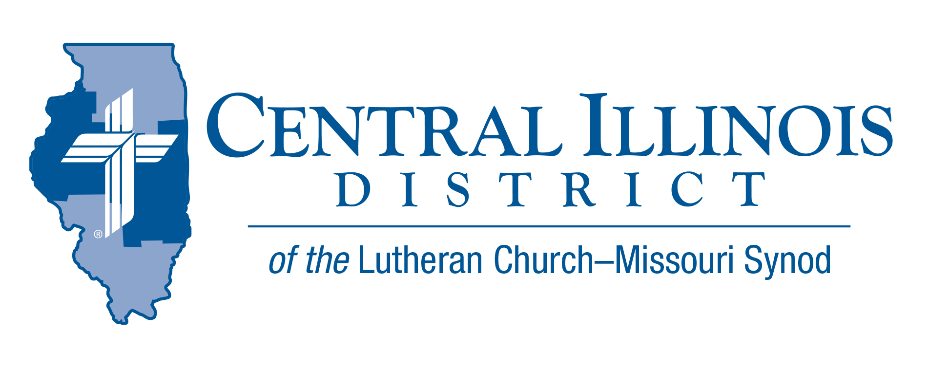
August 2021
News You Can Use

Many years ago several CID pastors had fun with the line from a song that went like this: “freedom’s just another word for nothing left to lose.” I’m sure Janis Joplin meant we’re free to do whatever we please. When I was younger I may have felt that way too. I wanted to rebel against anyone and anything, and be free to do what I wanted to do.
According to the truth of God’s Word, that’s not His plan for us. We do have a free will, which leads us to sin. That freedom does have consequences…everlasting damnation. Yet God still loved us, even in that sinful condition we thought was so freeing, loved us so much He sent His Son to die for us that we might not perish but have everlasting life.
By faith in Christ, we are truly free. Luther says: “One thing, and only one thing, is necessary for Christian life, righteousness, and freedom. That one thing is the most holy Word of God, the gospel of Christ, as Christ says in John 11[:25], ‘I am the resurrection and the life; he who believes in me, though he die, yet shall he live’; as John 8[:36], ‘So if the Son makes you free, you will be free indeed’.”
As you celebrate your freedom as a citizen of the USA this month, remember your freedom from sin, death and devil in Christ Jesus, freedom that will last forever and ever.
-- Pastor James Stuenkel, Immanuel, Springfield

Pray For Our Central Illinois District Missions supported by your church’s Mission Dollars to the District. “Finally, brothers, pray for us, that the Word of the Lord may spread rapidly and be honored.”

Please remember in your prayers all our CID campus ministries, especially Immanuel Lutheran Church & Student Center in Macomb, serving students, faculty, and staff at Western Illinois University. And pray for the “Keeping Christ on Campus” campaign, building endowments to help CID support our campus ministries.

Stay Connected with your District
Looking for additional information visit https://linktr.ee/cidlcms or connect with the following items:
- CID’s GatePost (newsletter)
- Subscribe to the E-GatePost/News You Can Use
- Stay connect with us on Facebook and Instagram -- Central Illinois District-LCMS
ITEMS OF INTEREST TO SHARE
Prison Ministry Video
The CID video “Prison MinisTRY: Will You TRY?” has just been released. It aims to interest pastors and others in helping with prison ministry.
There is a lot of evangelism work that can be done with those in prisons or jails throughout Central Illinois. This evangelistic frontier can all too easily be overlooked. Let’s not overlook it!
In the new video, veteran CID Prison Chaplain Chuck Olander describes his own involvement with prison ministry. He also offers suggestions for bringing the Gospel to prisoners.
See the video from the CID website: http://www.cidlcms.org/outreach-missions-prison.html If you have any questions about the video or about prison ministry opportunities, please contact Pastor Rod Blomquist, CID’s new Prison Ministry Coordinator, by e-mailing prisonministry@cidlcms.org

Receptionist/Office Assistant – The Central Illinois District Office in Springfield is STILL seeking a qualified individual to fill this position on a part-time basis. Hours are flexible. Starting wage is $15/hr. for a 20-hour work week. There are no benefits being offered. The successful applicant will have a background in Microsoft Office, especially, Outlook, Word, and Excel. Will also coordinate Social Media for CID (Facebook, Twitter). For a job description or questions, contact mmiller@cidlcms.org. Applications are available through the CID Office during regular hours 8 am until 4 pm or can be sent by email by request.

College student contact information: Whether or not your congregation’s students are attending a college or university where CID does campus ministry (i.e., U. of Illinois, Illinois State, EIU, WIU, U of Illinois-Springfield or Lincoln Land Community College-Springfield) please help us in the District office to refer them to a nearby LCMS campus ministry. E-mail kschurb@cidlcms.org

Connect to Disciple: What about your follow-up with your visitors from your Vacation Bible School? As you think about the new pupils and their parents at VBS, have you developed plans for how they might be moved from this initial connection with your congregation to being disciples who are gathered around Word and Sacrament with you? Connect to Disciple, a module in the Synod’s re:Vitality program, can help. For more information, contact Dr. Ken Schurb at the CID office. Telephone (217) 793-1802 or e-mail kschurb@cidlcms.org

LCMS Youth Gathering Adult Leader Training All adult leaders are invited to participate in an afternoon training on August 28th from 1-2:30pm at Bethel Lutheran Church in Morton, IL. This training will cover Gathering basics, travel tips, fundraising strategies, how to pick your adult leader team, and Q&A with veteran Gathering leaders! Please RSVP to jonathan@bethelmorton.org if you plan to join!
Save the Date:
CID Junior High Lock in
November 12-13th 2021 Five Point – Washington, IL
CID- District Convention (moved to 2022)
July 17- 19, 2022 Crowne Plaza- Springfield, IL

