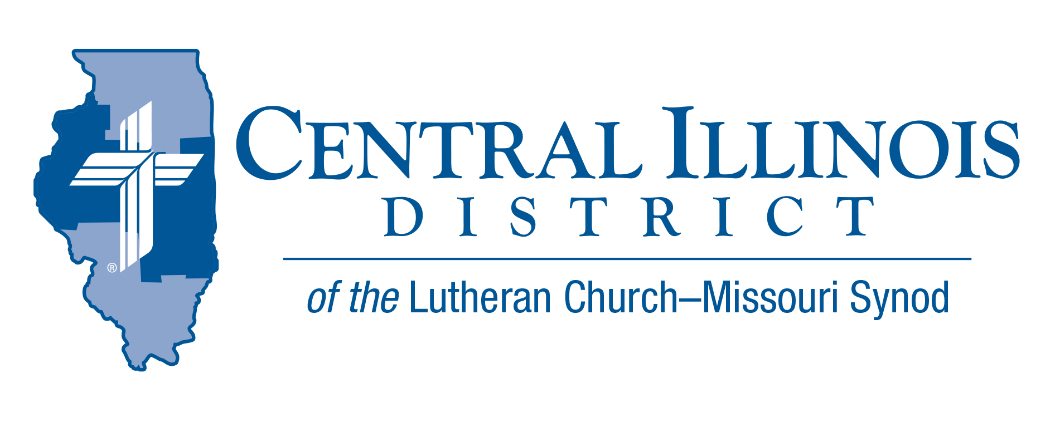
September 2021
News You Can Use
"Do not be deceived
"Do not be deceived: neither the sexually immoral, nor idolaters, nor adulterers, nor men who practice homosexuality, nor thieves, nor the greedy, nor drunkards, nor revilers, nor swindlers will inherit the kingdom of God. And such were some of you. But you were washed, you were sanctified, you were justified in the name of the Lord Jesus Christ and by the Spirit of our God." (1 Cor. 6)

All of humanity shares in one common failing: we are thoroughly sinful from conception. This inherited sin expresses itself in a myriad of ways. If left in that sinfulness and sin, we are doomed—we will not inherit the kingdom of God.

But notice Paul's past-tense wording: "And such were some of you." In your Baptism, God called you out of the kingdom of darkness into His marvelous light. Your Sin is overpowered by the righteousness of Christ, now yours. The greatest sin, turned over to Christ in repentance and faith, is forgiven. The greatest sinner—washed, sanctified, and justified in the name of Jesus—inherits the kingdom of God.

The Rev. Michael Schuermann is pastor of University Lutheran Church, Champaign, IL.

Pray For Our Central Illinois District Missions supported by your church’s Mission Dollars to the District. “Finally, brothers, pray for us, that the Word of the Lord may spread rapidly and be honored.” Our Lord Jesus said, “Pray the Lord of the harvest to send laborers into the harvest.” This month, please remember in your prayers all the students, particularly those from CID, who are studying at our Synod’s colleges and seminaries to be pastors, teachers, and other kinds of church workers – many with the help of scholarship money from CID.

Stay Connected with your District
Looking for additional information visit https://linktr.ee/cidlcms or connect with the following items:
- CID’s GatePost (newsletter)
- Subscribe to the E-GatePost/News You Can Use
- Stay connect with us on Facebook and Instagram -- Central Illinois District-LCMS

ITEMS OF INTEREST TO SHARE

Pastors For the Future
At a Circuit Convocation in Effingham, Illinois, 65 people heard about men prayerfully considering being a pastor. In this video, some of the convocation speakers tell us a bit of what they said.
Pray to the Lord of the harvest to send workers into His harvest fields. Encourage men who might be good pastors. Watch this video on the CID’s website main page or use the following link https://youtu.be/taz9WhtH5kU

Wallace Schulz to preach in CID
Rev. Dr. Wallace Schulz a former associate speaker of the Lutheran Hour, will be the guest preacher at a special service on Reformation Sunday, October 31, 2021 at 3:30PM at St. Paul’s Lutheran Church, 80 Chestnut St., Varna, IL.

Pastor Schulz, a native of South Dakota, has served in various capacities within the LCMS, including as a vice-president of the Synod, a missionary to Russia and other places, and a leader of the Lutheran Heritage Foundation. He is best known for his service to the Lutheran Hour Ministries, where he served as associate speaker from 1977-2002. Today he is the editor of the Good News Journal, a regular publication which instructs laypeople in the basics of the Lutheran faith. A supper is planned for after the events.Everyone is invited! Come and join us as we give thanks to God for His many gifts to us.

Churchworkers Retirement Workshop
On Saturday, November 6, CID’s Human Care Committee hosts a “preparing for retirement” event for church workers. Rev. David Fleming of DOXOLOGY will make a presentation entitled, “Still Bearing Fruit: Retirement as Joyful Receiving and Giving.” CID Gift Planning Counselor Rev. Charles Olander and Mr. Scott Radden of the LCMS Foundation will talk about charitable giving in retirement and beyond.
The workshop will be held at Good Shepherd Lutheran Church, Sherman, starting at 10:30 a.m. and ending at about 2:00 p.m. (Doors will open at 10:00.) Register before November 1 by e-mailing Ken Schurb at CID office, kschurb@cidlcms.org

THE 2021 CID JR. HIGH LOCK IN IS GO!- So FAR!

FRIDAY, NOVEMBER 12 - BEGINNING AT 9 PM!
AT FIVE POINTS IN WASHINGTON, ILLINOIS.

Great Fellowship and Fun – Save the Date

Get your group togther – See you at Five Points

Please note that Five Points Washington will be following the guidelines announced by the Governor of Illinois along with guidance from the CDC and the IDPH.

Five Points WILL NOT ask or require proof of vaccination; however, we do encourage you to continue to use your best judgement to continue to protect your health and that of others. Stay connect to current CID Youth Lock in Information at https://cidyouth.weebly.com/

