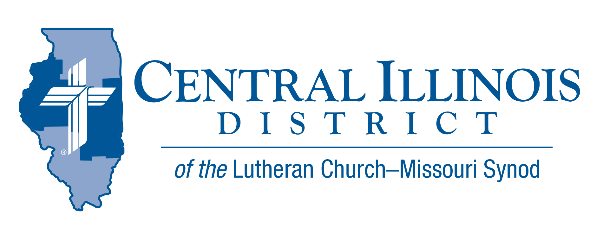
April 2022
News You Can Use
“Destiny”
There came a point at which Jesus would not be dissuaded from accomplishing the mission for which He was sent. After His discussion with Moses and Elijah on the transfiguration mountaintop He did not turn His face away from Jerusalem. In that city our redemption by His crucifixion, death, and resurrection would be “finished”. This was the reason for His earthly and messianic visitation!
We sometimes talk of destiny as if it was a yet unrealized desire or hope, or it was a pathway from which we could not find release, sort of like a Star Trek tractor beam. For Jesus, His destiny, figured out within the conversation of the holy Trinity before the creation, was something that plotted out the reason, meaning, and purpose of His incarnate life. His love must rescue the lost and do it so that fallen mankind’s destiny would become something new and godly.
He did this through His obedient life lived as our substitute. He achieved this by suffering under our iniquities, though innocent, to conquer sin and Satan’s grip on us. He completed it by the shedding of His blood and succumbing to death. His resurrection was the final piece that cemented our victory. This was His destiny, and now the destiny of those condemned by sin is that repenting, and trusting in Jesus, we are headed for heaven and our intended inheritance in His heavenly Kingdom. When your destiny is settled for good and in God, there is found peace found nowhere else! –
Rev. Mark A. Miller, President CID

Pray For Our Central Illinois District Missions supported by your church’s Mission Dollars to the District. “Finally, brothers, pray for us, that the Word of the Lord may spread rapidly and be honored.” Please remember in your prayers the outreach of Christ Lutheran Church for the Deaf and Pastor Tom Phillips. Pastor Phillips is our CID missionary to the deaf. He serves in Jacksonville, but also spans the District to bring the Good News about Jesus to the hearing- impaired.

Stay Connected with your District
Looking for additional information visit https://linktr.ee/cidlcms or connect with the following items:
- CID’s GatePost (newsletter)
- Subscribe to the E-GatePost/News You Can Use
- Stay connect with us on Facebook and Instagram -- Central Illinois District-LCMS
Statistical & Lay Leaders Reports are due April 30, 2022
ITEMS OF INTEREST TO SHARE
60th Regular Convention Central Illinois District July 17-19, 2022
Crowne Plaza Springfield, Illinois (additional information of the CID website under the News and Events tab.(http://www.cidlcms.org/events-2022-district-convention.html)

Small Church Summit
Zion Evangelical Lutheran Church, Farmersville, Illinois, is inviting members of small churches in the Central and Southern Illinois Districts to a “Small Church Summit” on St. Barnabas Day, Saturday, June 11, 2022, from 10:00 a.m. to 2:30 p.m. This free event is for both pastors and laypeople.
What is a small church? “If your church thinks of itself as small, consider yourself invited,” said Pastor Micheal Strong of Zion. “We want to encourage and help one another as Lutheran congregations.”
After opening worship and introductions, participants will talk about positive points concerning their churches as well as challenges. After lunch at the church, they will apply various positives to various challenges identified that morning and consider ways in which future small church summits might prove helpful.
Interested? Please contact the CID office: PHONE: (217) 793-1802
E-MAIL: cid@cidlcms.org

Spring (Church) Planting Season
At its last convention, our Synod resolved “That congregations and circuits be encouraged and supported by their respective districts to investigate and identify new mission plants” (2019 Res. 1-02).
To enable pastors and others to begin talking about church planting, CID is cooperating with the Synod’s Office of National Mission to produce these resources: a.) a brochure, in two parts and b.) a set of four short videos. These tools will help inform and stimulate church plantings conversations in congregations. For more information visit: http://www.cidlcms.org/outreach-church-planting.html
Congregations are urged to use these tools during May, a month we might call “Spring (Church) Planting Season”. Talk church planting at Bible classes on four of the five Sundays in May. Devote time at a regularly scheduled meeting to a discussion of church planting. Hold a special meeting for such discussion. Or encourage church members to view the videos and read the brochure, then talk amongst themselves.
The District will be discussing church planting at its convention in July. Why not “prime the pump” via congregation-level conversations during May?

Celebrate the 175th anniversary of the LCMS! April 26, 2022
Visit the following websites for information on the 175th anniversary of Synod. CID website: http://www.cidlcms.org/news-lcms-175.html Synodical Website
https://resources.lcms.org/175-years

175th Anniversary Hymn Sing
Trinity Lutheran in Springfield is hosting a hymn sing to highlight the works of LCMS composers and lyricists in celebration of the 175th anniversary of the LCMS. All are invited to come on Sunday, May 1st at 3:30pm to Trinity Lutheran Church at 220 S. Second St., Springfield, IL. We will raise our voices to praise God and hear from the Trinity Wind Ensemble for musical interludes between hymns.

