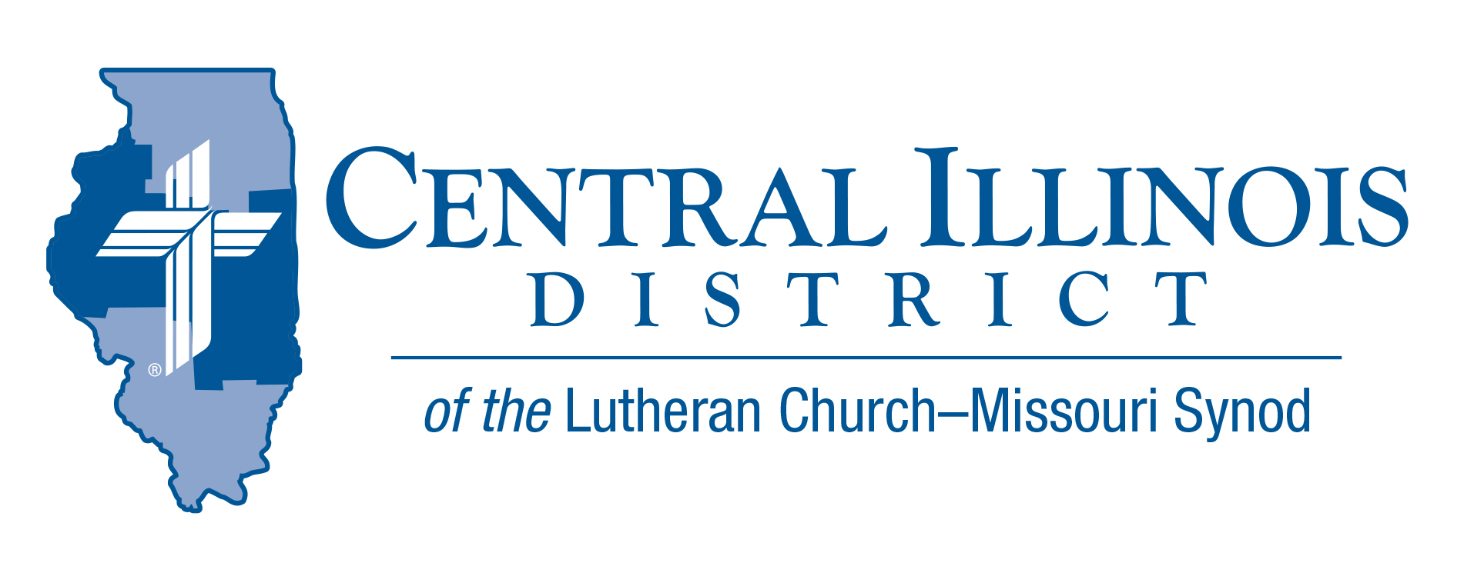
December 2022
News You Can Use

He Has/Is/Will Come
“Amen. Come, Lord Jesus!” – Rev. 22:20b
Advent means “coming.” During this time of the year, the Church prepares for the coming of our Lord. The Advent season begins with our eyes turned to the fact that our Lord will come, returning upon the clouds on the Final Day to usher in the New Creation. With repentance, we mark this season in preparation for that great and final judgement. As the Advent season closes, we transition into the Christmas season, fixing our eyes of faith upon the great good news that our Lord has come – born of flesh and blood, “born of woman, born under the law to redeem those who were under the law, that we might receive adoption as sons.” (Gal. 4:4b-5) In all of this, let us not forget that we are prepared by God for that final day when He will come by His work, from manger to cross to ascension and resurrection, when He had come because He is come to us each and every day in His means of grace. Turn you hearts and minds to His Word. Devote your time and work to receiving His Sacraments. Even as we await His return in glory, He is present with us now by His grace.
President Michael Mohr- Central Illinois District Office

Pray For Our Central Illinois District Missions supported by your church’s Mission Dollars to the District. “Finally, brothers, pray for us, that the Word of the Lord may spread rapidly and be honored.”
We give thanks for the gift of our Savior’s birth, and we pray for the adherents of various world religions who do not believe that in Jesus Christ, the Word became flesh for the salvation of all people. We ask the Lord to shine His saving Gospel light to everyone, and to do so through us. “Thy kingdom come”!

ITEMS OF INTEREST TO SHARE

Small Church Summit:
Zion Evangelical Lutheran Church, Farmersville, Illinois, invites members of small churches in the Central and Southern Illinois Districts to the second “Small Church Summit” on the day after Epiphany, Saturday, January 7, 2023, from 10:00 a.m. to 2:30 p.m. (“Snow date” is Jan. 14.) This free event is open to all. It will work best for your church to send your pastor and one to three laypeople. For more information, see the Gatepost (http://www.cidlcms.org/resources/gatepost/2022.GatePost.3.) pg. 8. To register for this event, please visit https://forms.gle/Z1Xey4BQNiLN533q8

Reimbursements for Prison Ministry Materials
Consider donating printed Gospel-centered materials to a nearby state, federal prison, or county jail. Thanks to a generous grant from central Illinois LWML, members of CID congregations or these churches can make such donations and receive at least partial reimbursement from the District. CID will reimburse up to $200 on a donation.
The printed materials you donate can get into a facility and remain there, even if something like a COVID spike occurs, preventing prison chaplains from entering the facility. These materials make for an ongoing Gospel presence within jails and prisons here in Illinois.
The aim is to provide materials to as many such institutions as possible. CID encompasses half of the counties in Illinois, every one of which has some jail.
There is one other thing to consider. Here we have an opportunity for our congregations to participate in prison ministry, even if they never personally visit an inmate.
Start by contacting a prison or jail near you to learn of their ground rules and procedures for donated materials. Contact CID Prison Ministry Coordinator Rev. Rodney Blomquist if you have questions. Telephone him at (217) 825-6160 or send an e-mail message to prisonministry@cidlcms.org
See the Prison Ministry page of the CID website at
http://www.cidlcms.org/outreach-missions-prison.html. For the present program’s reimbursement voucher, guidelines, and list of approved materials, please see
http://www.cidlcms.org/outreach-missions-prison.html

Are you Looking for supplemental musician?
If there is any interest in our congregations in having some brass instruments played at some worship service or some other function, please call or text Ralph Woehrmann at 217 494 4369 or email at ralphwoehrmann@gmail.com. Mr. Woehrmann is a lifelong trombonist familiar with the Central Illinois music scene and could put something together. Some costs may be involved to cover travel, music, or other expenses. Mr. Woehrmann's services are free of charge but may not be necessarily so for some others. Mr. Woehrmann is a member of Trinity, Taylorville.

Christian Citizenship – Living as Christian Citizens in the Here and Now
In January of 2023, the Illinois General Assembly will conduct a “lame duck” session and begin its regular 2023 legislative session. Visit our District website to read current and updated information regarding your role as a Christian Citizen.
http://www.cidlcms.org/ministry-human-care-christian-citizenship.html

Stay Connected with your District
Looking for additional information, visit https://linktr.ee/cidlcms or connect with the following items:
- CID’s GatePost (newsletter) Subscribe to the E-GatePost/News You Can Use
- Stay connect with us on Facebook and Instagram -- Central Illinois District-LCMS

