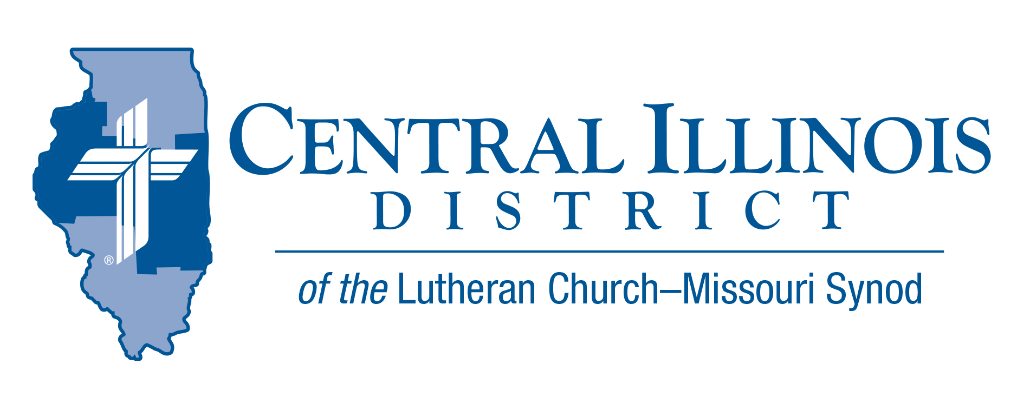
Feb 2022
News You Can Use
These past couple of years have been very challenging for all of us. Sickness and death, loss and isolation have been abundant.
Because of sin, a thousand maladies may afflict us, but as they do, let us confess with Job: “The Lord gives and the Lord takes away, blessed be the name of the Lord” (1:21). We don’t always know specifically why bad things happen, but we do know that God in His infinite love and mercy and power will work all things together for good to those who love Him, who are called according to His purpose (Romans 8:28).
If you have lost someone or something that you love or enjoy, remember that God has not run out of blessings for you. Let the Lord strengthen your faith through His word and sacraments, for He is a very present help in time of trouble (Psalm 46:1), and His mercy endures forever (Psalm 136:1 ff). Live in His grace and peace, and in His joy and hope, love and mercy. Live in the life and salvation he bestows upon you, His beloved child.
When the problems of life come upon you like a storm, scripture would direct you to thank God for His deliverance, and “to think on whatever is true, whatever is honorable, whatever is right, whatever is pure, whatever is lovely, whatever is good and excellent and worthy of praise” (Philippians 4:8). As you do, you will think of Jesus and His love and be comforted.
Hymn writer, Horatio Spafford, within a short time, lost a fortune in the great Chicago fire, lost a four-year-old son to scarlet fever, and lost four young daughters in a shipwreck. It is reported that his wife, alone in England, sent him a telegraph message asking, “What shall I do?” As he traveled across the ocean to join his wife, he wrote the words to the beloved hymn, “Peace Like a River”.

“When peace like a river, attendeth my way
When sorrows like sea billows roll
Whatever my lot, Thou has taught me to know
It is well, it is well with my soul.”
“What shall I do?” but to praise God at all times and in all things.

Yours in Christ, - Rev. Charles Olander- CID Gift Planner

60th Regular Convention Central Illinois District July 17-19, 2022
Crowne Plaza Springfield, Illinois (additional information of the CID website under the News and Events tab.(http://www.cidlcms.org/events-2022-district-convention.html)

- Before March 10th, once you have chosen your congregational lay delegate, please send that name to the District Office at cid@cidlcms.org so that we will have a pool from which to select floor committee members.

ITEMS OF INTEREST TO SHARE
CID Board of Directors’ meeting on January 25, 2022.
With the official resignation of Chairman Pastor Milas as he moved out of the district, the Board formally restructured itself by electing 1st VP Rev. Eddy as the new Chairman and 2nd VP Rev. Mohr as the Vice-Chairman.

The Spring Pastors’ Conference has been scheduled as a one-day convocation at Camp CILCA on May 9. More information will be forthcoming.

In looking at the final financial figures for the past two years, the district finished with slightly more income from congregations that were budgeted to be received. Thanks be to God for His blessings and the faithful stewardship of His people.

The Central Illinois District received a $21k bequest through a congregation. Per district policy, 10% was immediately forwarded to Synod and the remaining funds will be designated towards projects within the district later this year.

The 2022 Budget received its final ratification, as well as the approval of the housing allowances for eligible district employees.

Some updating to the District Bylaws were approved by the Board of Directors to send for Synod approval in anticipation of consideration at this summer’s district convention.

92nd CID Lutheran Layman’s League Convention
March 5th, 2022 at Mt Calvary Lutheran Church, 2055 South Franklin Street Road, Decatur. We are pleased to have as our speaker Dr. Walter Maier III

Registration will begin at 8:30, The Convention will begin 9:30. The registration fee is $20.00. For more information contact Danny Magelitz dmagelitz@hotmail.com. Or (217) 622-7015

Camp CILCA’S Annual Banquet
Sunday, March 20, 5 p.m.-8 p.m. At Camp CILCA's Dining Hall!
Tickets are $40 each. Call the camp office (217-487-7497) or email (camp@cilca.org) to reserve your tickets today! The Annual Banquet is an evening celebrating God's work of Creation and Redemption, especially as those works are enjoyed, proclaimed, and taught at Camp CILCA. Join us for an evening of music, food, great speakers, and friends. This year's speaker will focus on, "Why Beauty Matters."

LWML CID Convention Save the Dates
- April 29th-(Friday) Servant Event- St. John’s Lutheran Church – Chatham
- April 30th (Sat)CID Convention – Our Savior’s Lutheran Church- Springfield
Spring (Church) Planting Season is coming in May-
More information Soon

