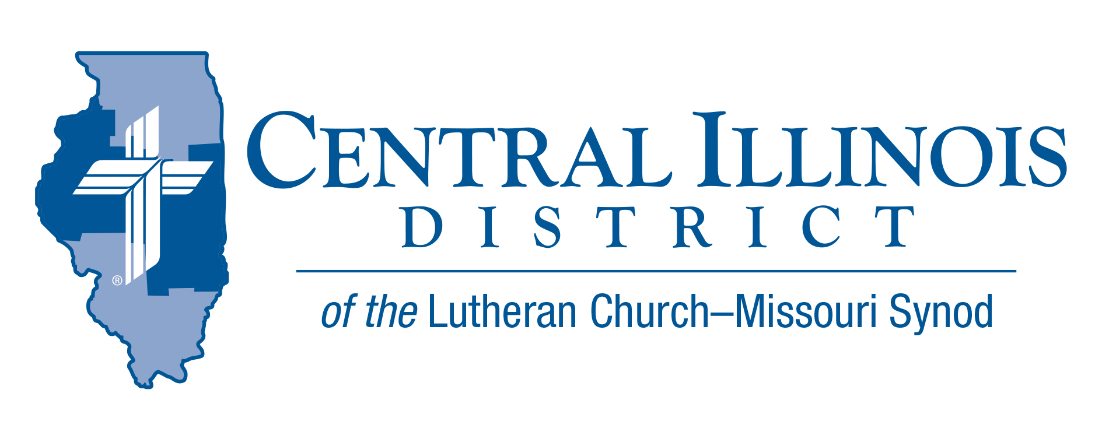
January 2022
News You Can Use
The Light – at the beginning and end.
“Today’s Light.” It has been a blessing to us. I mean both the light we’ve received from the sun each day for the past year, and the Concordia Publishing House journal many of us here at St. John’s in Effingham have used for reading from Isaiah to Revelation the past twelve months. In December we completed Revelation. What a way to end the year, huh? There were some mysterious, even frightening things in there (both the year 2021 and John’s Revelation). But you knew the end of the story -- the true story of history and salvation. Here’s part of it in John’s message:
⁵ He who was seated on the throne said, “Behold, I am making all things new.” Also he said, “Write this down, for these words are trustworthy and true.” ⁶ And He said to me, “It is done! I am the Alpha and the Omega, the beginning and the end. To the thirsty I will give from the spring of the water of life without payment. ⁷ The one who conquers will have this heritage, and I will be his God and he will be my son. ⁸ But as for the cowardly, the faithless, the detestable, as for murderers, the sexually immoral, sorcerers, idolaters, and all liars, their portion will be in the lake that burns with fire and sulfur, which is the second death.” ⁹ Then came one of the seven angels who had the seven bowls full of the seven last plagues and spoke to me, saying, “Come, I will show you the Bride, the wife of the Lamb.” (Rev. 21:5-9)
There are magnificent, encouraging, and victorious things in there. We know the end of the story. Daily and yearly, we have all we need to press on. We know who the Bride in Revelation is.
It’s you, Church.
This year you will suffer and be perplexed at some points. You will also certainly rest in victorious peace, for the Lamb suffered all things for you. He is making all things new. Wait. You’ll see.

- Pastor Mike Burdick. St. John’s Lutheran Church, Effingham.

60th Regular Convention Central Illinois District July 17-19, 2022
Crowne Plaza, Springfield, Illinois (additional information on the CID website under the News and Events tab.(http://www.cidlcms.org/events-2022-district-convention.html)

DATES TO REMEMBER
- January 1, 2022 – anytime after the New Year and before March 10th, once you have chosen your lay delegate, please send that name into the District Office at cid@cidlcms.org so that we will have a pool from which to select floor committee members.
ITEMS OF INTEREST TO SHARE

Members of One Body is the next in a series of re:Vitality modules from the Synod’s Office of National Mission. The subject of this module, currently in its final phases of development, is assimilation of new church members. As part of a pilot project, Dr. Ken Schurb will teach the preliminary Members of One Body Bible study at Trinity, (515 S. MacArthur Ave-Springfield) on a series of four Tuesday evenings: (starting 6:30 pm) February 1 and 15 and March 1 and 15. All are invited! If your church might be interested in Members of One Body, you can take a taste of it, so save the dates now. Please lets us know if you are planning on attending or for more information, contact kschurb@cidlcms.org

Missions Unpacked: Each week, from Jan. 24 to Feb. 20, you’ll have opportunities to learn about LCMS mission work in an overseas region of the world, meet missionaries in a live Zoom presentation, and experience local culture through language, food and more! Get a group together or tune in solo, attend every session or watch some here and there. Registration is free and is open now. Multiple resources and registration are available at international.lcms.org/missions-unpacked

Bring Giving Home
CID’s stewardship and mission education initiative, Bring Giving Home officially started at the District Pastors’ Conference in Spring, 2019. Since then, a number of pastors have entered the Central Illinois District. These pastors have not had the benefit of that conference.

It is possible to play a little “catch-up,” though. This February Pastor Heath Curtis, Coordinator for LCMS Stewardship, will be in Central Illinois to duplicate part of the presentation he made at our Spring, 2019 pastors’ conference. This is the “pastor” portion of what LCMS Stewardship calls its “Philippians” workshop. In it, Pastor Curtis outlines the basic approach that marks all the Synod’s Stewardship materials, including CID’s Bring Giving Home initiative.

Pastors new to CID since spring, 2019 are especially invited to his presentation in February. Also invited are pastors who were in the District in spring, 2019 but somehow or other missed his talk at the conference then. And invited, too, are pastors who heard his talk but would like a “refresher.” Because of a generous grant from Church Extension Fund, the District will reimburse all of them for their mileage to travel to and from Pastor Curtis’s repeat presentation in February.

That’s right – all CID pastors are invited to this presentation, and all can have a mileage reimbursement. The presentation will be at Good Shepherd Lutheran Church in Sherman, from 12:30 to 3:00 p.m. It will take place on Monday, Feb. 7, 2022. If the weather is bad on that day, the alternative date (same time) is Monday, Feb. 21, 2022.

Please register for this presentation by sending a message to Stewardship Executive Ken Schurb before Feb. 1. His e-mail address is kschurb@cidlcms.org

