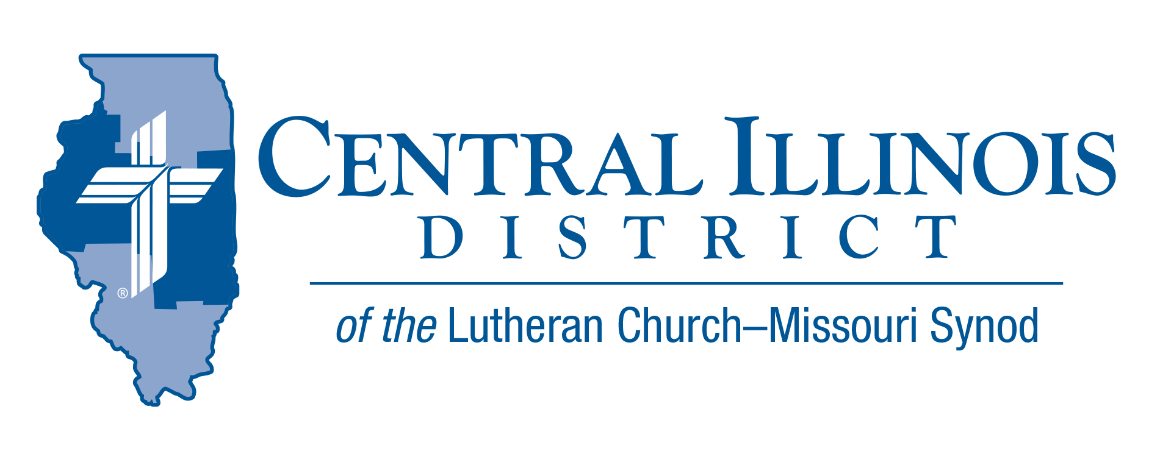
November 2022
News You Can Use
In Acts 27, St. Paul gave thanks. On a ship caught in a terrible storm, buffeted by wind and waves for two weeks, he gave thanks and encouraged the 275 others on board to eat.
It wasn’t their fault that they were caught in the storm, but they were sinners in a sinful world. Sinners need to repent. All sinners need Christ. When we have Him, we need not fear any act of God, not a violent storm or anything else.
When we face storms in life, it is easy to grow self-absorbed and focus on self-reliance. Yet the One Who took all our sins to the cross and left them there when He rose from the dead tells us to cast all our care on Him.
In Him there is hope: the resurrection of the body and the life everlasting. Hope for tomorrow makes us thankful today.

Blessed Thanksgiving! Rev. Dr Ken Schurb- CID Office

Pray For Our Central Illinois District Missions supported by your church’s Mission Dollars to the District. “Finally, brothers, pray for us, that the Word of the Lord may spread rapidly and be honored.”
Please remember in your prayers all our CID campus ministries, especially Rev. William Jensen and Wittenberg Lutheran Center in Normal, serving students, faculty, and staff of Illinois State University and other institutions. And pray for the “Keeping Christ on Campus” campaign, building endowments to help CID support our campus ministries.

ITEMS OF INTEREST TO SHARE
Beyond the Classroom
Beyond the Classroom is from the re:Vitality outreach module Connect to Disciple, which is about moving new people from the initial connection with a congregation and its members to being gathered around Word and Sacrament with the members as a disciple. “Beyond the Classroom” applies Connect to Disciple to churches with Lutheran schools.
CID has been awarded a multi-year LWML grant to bring Beyond the Classroom to our schools. This will be a discussion topic at our upcoming C-WOW meeting. This is an excellent time for Lutheran schools and outreach through them!
  - Training Dates: (second dates are possible snow dates)
    - Feb. 4/11 Springfield Area
    - Feb. 18/25 Quincy Area
    - April 1 Altamont Area
    - April 22 Peoria/Morton Area
    - May 6 Champaign Area

A Dollar for Missions (DFM)
December 1, 2022,is the deadline by which congregations or groups of congregations can propose projects for CID “Dollar for Missions” funding during 2023. For further information, contact Ken Schurb, kschurb@cidlcms.org. CID urges congregations to begin gathering DFM funds in January 2023. See http://www.cidlcms.org/ministry-a-dollar-for-missions.html

Small Church Summit:
Zion Evangelical Lutheran Church, Farmersville, Illinois, invites members of small churches in the Central and Southern Illinois Districts to the second “Small Church Summit” on the day after Epiphany, Saturday, January 7, 2023, from 10:00 a.m. to 2:30 p.m. (“Snow date” is Jan. 14.) This free event is open to all. It will work best for your church to send your pastor and one to three laypeople. For more information, see the Gatepost (http://www.cidlcms.org/resources/gatepost/2022.GatePost.3.) pg. 8. To register for this event, please visit https://forms.gle/Z1Xey4BQNiLN533q8

Reimbursements for Prison Ministry Materials
Consider donating printed Gospel-centered materials to a nearby state or federal prison or county jail. Thanks to a generous grant from central Illinois LWML, members of CID congregations or these churches can make such donations and receive at least partial reimbursement from the District. CID will reimburse up to $200 on a donation.
The printed materials you donate can get into a facility and remain there even if something like a COVID spike occurs and prevents prison chaplains from entering the facility. These materials make for an ongoing Gospel presence within jails and prisons here in Illinois.
The aim is to provide materials to as many such institutions as possible. CID encompasses half of the counties in Illinois, every one of which has some jail.
There is one other thing to consider. Here we have an opportunity for our congregations to participate in prison ministry, even if they never personally visit an inmate.
Start by contacting a prison or jail near you to learn of their ground rules and procedures for donated materials. Contact CID Prison Ministry Coordinator Rev. Rodney Blomquist if you have questions. Telephone him at (217) 825-6160 or send an e-mail message to prisonministry@cidlcms.org
See the Prison Ministry page of the CID website at
http://www.cidlcms.org/outreach-missions-prison.html. For the present program’s reimbursement voucher, guidelines, and list of approved materials, please see
http://www.cidlcms.org/outreach-missions-prison.html

Stay Connected with your District
Looking for additional information, visit https://linktr.ee/cidlcms or connect with the following items:
- CID’s GatePost (newsletter) Subscribe to the E-GatePost/News You Can Use
- Stay connect with us on Facebook and Instagram -- Central Illinois District-LCMS

