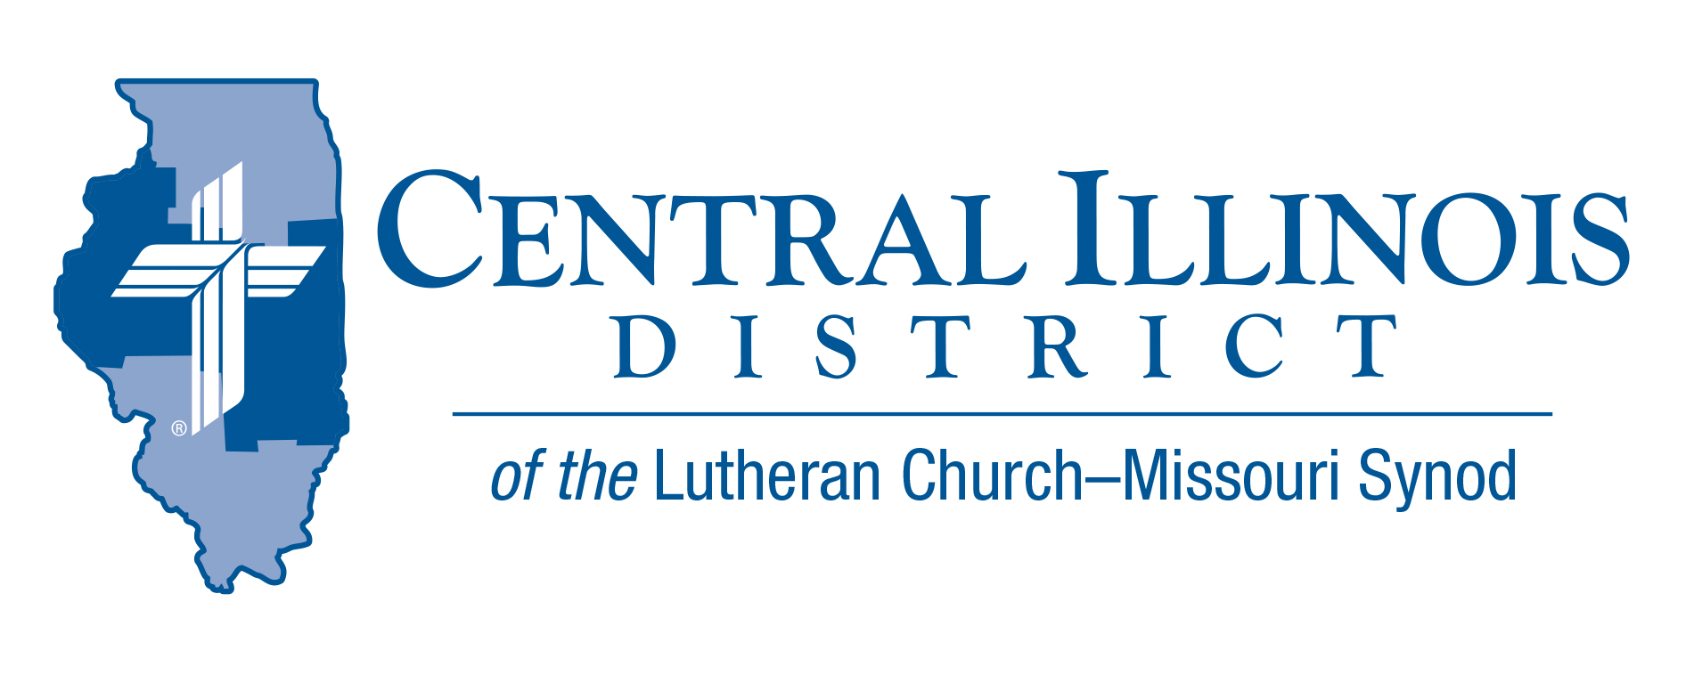
April 2023
News You Can Use
The Easter acclamation “Christ is risen! He is risen, indeed! Alleluia!” are welcome words of joy and comfort in concert with Jesus’ promise, “Because I live, you also will live.” (Jn. 14:19)
St. Paul reminds us that we have been united with Christ’s death and resurrection through our baptism, which is the very power of God doing something mysteriously wonderful to us. United with Christ’s death means that our old sinful self was crucified. (Cf. Rom. 6:2,6) United with His resurrection means that we have been given new lives in the Spirit to live for Him who died and rose again for us. It also means that we will not die, but on the last day be raised from our own tombs to live with our Lord in eternity. (Cf. Rom. 6:8; Jn. 11:25-26) Through baptism, we have been made heirs with Christ to share in His sufferings, here and now, and to share in His glory, then and forevermore.
Let us rejoice in the certain promise of our Lord who says to us, “Because I live, you also will live,” and proclaim: Christ is risen! He is risen, indeed! Alleluia! Alleluia! Amen.
Pastor Kent A. Umbarger

Pray For Our Central Illinois District Missions supported by your church’s Mission Dollars to the District. “Finally, brothers, pray for us, that the Word of the Lord may spread rapidly and be honored.” Please remember in your prayers the outreach of Christ Lutheran Church for the Deaf and Pastor Tom Phillips. Pastor Phillips is our CID missionary to the deaf. He serves in Jacksonville but also spans the District to bring the Good News about Jesus to the hearing-impaired.

Items of Interest to Share
What are CID’s missions?
What projects CID is funding this year through a Dollar for Missions?
How many children were baptized last year through the work of CID’s schools?
How many pupils in our schools have no church home? See Partnership in the Gospel at http://www.cidlcms.org/outreach-brochure.html

Stay Connected with your District
Looking for additional information, visit https://linktr.ee/cidlcms or connect with the following items:
- CID’s GatePost (newsletter) Subscribe to the E-GatePost/News You Can Use. Stay connected with us on Facebook and Instagram --Central Illinois District-LCMS
CID-Board of Directors Meeting Summary March 28, 2023
The meeting was called to order at 9:00 a.m. Minutes from the Jan 24, 2024 meeting were approved.2nd Vice President Pastor Michael Burdick and Secretary Pastor Kent Umbarger excused all others present. Pastor Bruce Scarbeary served as assistant secretary.
The meeting Devotion leader was Pastor Mark Eddy. Text 1 Pet 4:1-11
Pastor Rodney Blomquist addressed the Board concerning CID Prison Ministry.
The CID-CEF currently carries a total of $19.3 million in loans. It was also reported that their 18-month CD would remain at 3 percent interest.
Various efforts continue between the CID Gift Planer and individual congregation and congregation members.
Mr. Lewis Rodgers will serve as the point person for the MinistrySafe program. Various CID congregations are either starting or looking into starting schools.
Dr. Schurb raised the prospect of moving to modified service roughly beginning Sept 1, 2024. Finance & Management will review Dr. Schurb’s request and bring more information to the May BOD meeting.
Plans were approved for the University Lutheran Church (Champaign) to partner with Living Alternatives Crisis Pregnancy Resource Center.
A discussion was held concerning Cristo Rey’s request for financial assistance to resurface their parking lot. CID seeks more information before the May meeting before deciding on their request.
The District Salary Guidelines lines for 2024 were discussed and approved. They will be posted to the District Web page and submitted to the congregations.
Prayer Cards entitled “A Prayer for Wednesday’s Child” concerning the Life of children in the womb are available upon request from Dr. Schurb.
It was noted that the District is currently running behind projected income.
Treasurer Oschwald noted that the District Convention expenses for the 2024 Synod Convention are due soon. Finance and Management noted that District manuals for Personnel, Business, and CID staff need to be updated. BOD accepted the constitution of Trinity-Arenzville, Christ-Peoria, and Zion-Lincoln.
A motion to clarify the Synod concerning Dr. Schurb’s service as both CID’s-BOD and Staff advisory representative to the Synod Convention passed.
President Mohr noted that Redeemer-Peru, IL would be dissolving. A resolution was passed granting Redeemer permission to divest their property at their discretion.
The meeting closed with Prayer and adjourned at 12:50 p.m.
Next BOD meeting is May 23, 2024, at 9 a.m.

Lutheran Heritage Foundation
FREE RESOURCES: Do you know someone who doesn’t speak English as a first language, and you want to introduce them to the Savior? Check out the Lutheran Heritage Foundation’s database of free Lutheran books, translated into more than 140 languages of the world! Resources include children’s Bible storybooks (often also good for adults with lower literacy levels), Luther’s Small Catechism, and devotion booklets in languages like Spanish, Chinese, Hindi and Swahili – all available at no cost to the ministries, short-term mission teams, and individuals who need them. Search the LHF Publication List at www.LHFmissions.org/Publications.

