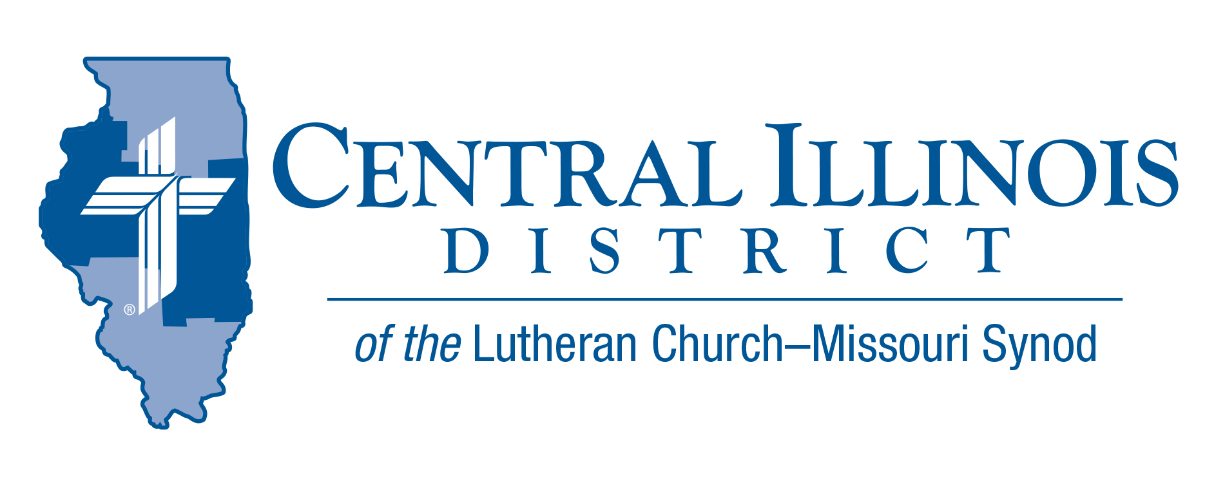
August 2023
News You Can Use
Text: Micah 6: 8
Your Faith Journey

If Judeo-Christian ethics can be summed up in a twitter tweet verse eight of Micah 6 say it well; “Do justice, love kindness, and walk humbly with your God?” Go ahead and put a meme with that.
As the tabernacled Word, Jesus proclaims and demonstrates His faithfulness to our forefathers, fulfills all justice, kindness and humbleness for us. He gives us His Good Friday death and Easter Sunday thereby atoning for our sin. He places His saving name upon us at the font of Holy Baptism and gifts us with the Holy Spirit so that our heart, mind and soul are renewed toward the true goal of discipleship – to live justly, love kindness, and walk humbly.
Daily raised with Christ, through repentance and Absolution, we walk in the newness of life - peace, patience, kindness, goodness, faithfulness, gentleness, and self-control (Gal 5:22-23). Against these things, there is no law. So, go ahead, daily live as walking, talking, breathing, depictions of God’s presence in the world by living justly, loving kindness, and walking humbly.
Rev. Bruce Scarbeary
Pray For Our Central Illinois District Missions supported by your church’s Mission Dollars to the District. “Finally, brothers, pray for us, that the Word of the Lord may spread rapidly and be honored.”

Please remember in your prayers all our CID campus ministries, especially Immanuel Lutheran Church & Student Center in Macomb, serving students, faculty, and staff at Western Illinois University. And pray for the “Keeping Christ on Campus” campaign, building endowments to help CID support our campus ministries.

Items of Interest to Share

Dollar for Missions: A Dollar for Missions invites us to contribute one extra dollar per week for designated mission projects in our Central Illinois District. The current project is to help one of our campus ministries, University Lutheran Church in Champaign, to purchase a 12-passenger van. Project cost: $35,000. [See the short video at https://www.youtube.com/watch?v=aTJMrriQtV8]

Dollar for Missions application deadline: Congregations should submit their applications for Dollar for Missions funds for 2024 by September 1, 2023. DFM funds will be used in this order: to support 1) new church starts; 2) mission-focused augmentations to existing ministries, and 3) present CID missions. If you have questions, contact Dr. Ken Schurb at kschurb@cidlcms.org

CID LLL ANNUAL RETREAT. GOD’S LIVING WORD TODAY

September 9, 2023 9:00 AM- 2:00 PM
CAMP CILCA 4124 CAMP CILCA RD, CANTRALL, IL
Registration $25.00 (INCLUDES LUNCH)
Guest Speaker- Rev. Timothy Scharr– Southern Illinois District President
Register by Sept. 5th by sending the fee to Deloris Blessmann, 24204 CR 1850N Topeka, IL 61567, or emailing delorisblessman@yahoo.com

SAVE THE DATES:

Camp Cilca - September 3: Chicken Fry and Auction
Fresh fried chicken and all the sides.
Auction items up for bid. Preview all auction items at cilca.org/auction-items
Make a weekend of it and camp out with friends from across the state.

Small Church Summit in CID on Saturday, February 3, 2024, or (if the weather is bad) on Saturday, February 10, 2024.

The Illinois March for Life on March 19, 2024 in Springfield. Trinity Lutheran Church, across the street from the state capitol building, will again conduct a Matins service in the morning prior to the march.

Next summer’s LCMS Institute on Liturgy, Preaching, and Church Music, to be held July 9-12, 2024 at Concordia University Nebraska.

CID Church Extension Funds Updates
Following are the rates on all our Certificate offerings:
6 Month​​ 0.75%
1 Year​​​ 2.25%
3 Year​​​ 2.50%
5 Year​​​ 2.75%
18-Month Special​ 4.00%

Rates have also increased on our Flexible Savings Accounts:
Regular Savings​​​ 0.40%
Capital Campaign Savings​ 1.00%

As your Church Extension Fund, we are here to support you as you support our LCMS churches, schools, and organizations throughout our District with your investments. Thank you for partnering with us as together we share in the blessing of growing His Kingdom!

