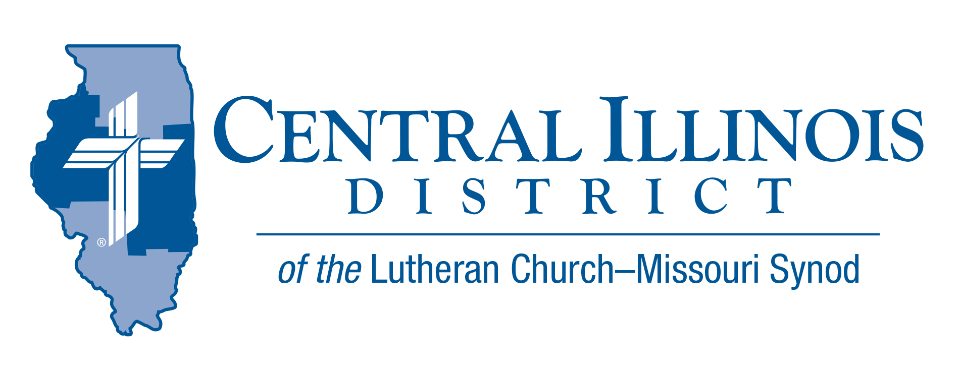
January 2023 Mid Month
News You Can Use
And now these three remain: faith, hope and love. But the greatest of these is love. 1 Corinthians 13:13
Faith is our foundation. “For no one can lay any foundation other than the one already laid, which is Jesus Christ.” 1 Corinthians 3:11 If a house is not built on a solid foundation it will certainly fall. Our solid foundation is Jesus Christ. Faith, which the Holy Spirit gives us through Word and Sacrament, binds us to Christ as anchor bolts fasten the building to its foundation. Without faith we are spiritually dead now and forever.
Hope looks to our destination. “and hope does not put us to shame, because God's love has been poured into our hearts through the Holy Spirit who has been given to us.” Romans 5:5 Our God-given faith gives us hope that does not disappoint. Just as surely as Jesus died and rose, we have the certain hope that when our earthly bodies collapse and stop working, we shall receive new spiritual bodies and live in the house which Christ prepared for us by grace.
Love is our motivation. “And above all these put on love, which binds everything together in perfect harmony.” Colossians 3:14 If we have not love, our faith is void and our hope is in vain. We are unable to love as God loves – perfectly, without reservations or conditions. However, when the Holy Spirit places faith in our hearts and gives us hope in Christ, God pours his love into our hearts so that it naturally overflows and touches those around us.
Rev. Jeff Harter

ITEMS OF INTEREST TO SHARE

Reimbursements for Prison Ministry Materials
Consider donating printed Gospel-centered materials to a nearby state, federal prison, or county jail. Thanks to a generous grant from central Illinois LWML, members of CID congregations or these churches can make such donations and receive at least partial reimbursement from the District. CID will reimburse up to $200 on a donation.
See the Prison Ministry page of the CID website at
http://www.cidlcms.org/outreach-missions-prison.html.

2023 CID Youth Bible Bowl
Announcing the 2023 Central Illinois District LC-MS Youth Bible Bowl: “Judges and Ruth.” In the best way, you know how to study these two biblical books about a difficult period of history for God’s people. And talk within your circuit about holding your Circuit Bible Bowl in the weeks before the District Bible Bowl scheduled for Sunday, April 16, 2023, at 3:00 p.m. at Camp CILCA.

The Bible Bowl provides an opportunity for our youth (6th-12th grade) to be involved in Scripture study and thus to grow in their knowledge of God’s Word and deepen their faith. Each circuit gets to send its top two teams to Springfield. For more information on holding a Bible Bowl in your circuit, please get in touch with Pastor Mark Eddy at Zion Lutheran Church, Taylor Ridge, Illinois. (markeddy@att.net)

Lutheran Hour Sunday – February 5, 2023

I look forward to listening to the “Lutheran Hour” every Sunday. I like to listen to Dr. Rev. Michael Zeigler – the current “Lutheran Hour” Speaker. I appreciate how he shares the love of Christ. Especially how Jesus was willing to suffer and die in my place and how His blood is sufficient to redeem me, a lost and condemned creature. Jesus rose on the third day, and I will arise someday and be with Him in heaven. This past August, we heard rebroadcasts from prior speakers in prior years. One from former “Lutheran Hour” Speaker Dr. Oswald Hoffman preached 50 years ago. It was amazing because that sermon was just as relevant today as it was 50 years ago.

The “Lutheran Hour” is unique because it can be heard in areas where the listeners are driving trucks, in nursing homes or in prison. Besides the “Lutheran Hour” Lutheran Hour Ministries has and I would encourage you to learn about:

- Bible Studies – These can be downloaded for free. If you need a quick Bible Study, you can possibly use one of these.
- Project Connect – These are tracks on hundreds of different topics and interests. There is a Project Connect tree that you can purchase and make these tracks available to everyone.
- Ministry Centers in over 50 countries around the world. LHM finds people that can be trained in a foreign Country. They already know their country's customs, language, and culture.
- Sat 7 – A ministry that can beam the Christian message into Muslim Countries that won’t allow Christians or even Bibles into their Country.
- THRED – A internet connection that reaches teens where they are in the media. A blog where Christians can discuss issues. There is a Lutheran Pastor on that blog.
- Check out LHM.com to learn more.

What can you do? The most important thing is to pray for “The Lutheran Hour.” “The Lutheran Hour” receives no funding except for donations from everyone who wants to make the Word heard - to help the Holy Spirit create faith that they may have eternal life. Please consider a gift to LHM, 660 Mason Center Dr. in St. Louis 63141-8557.
God’s Blessings - Danny Magelitz CID LLL President

