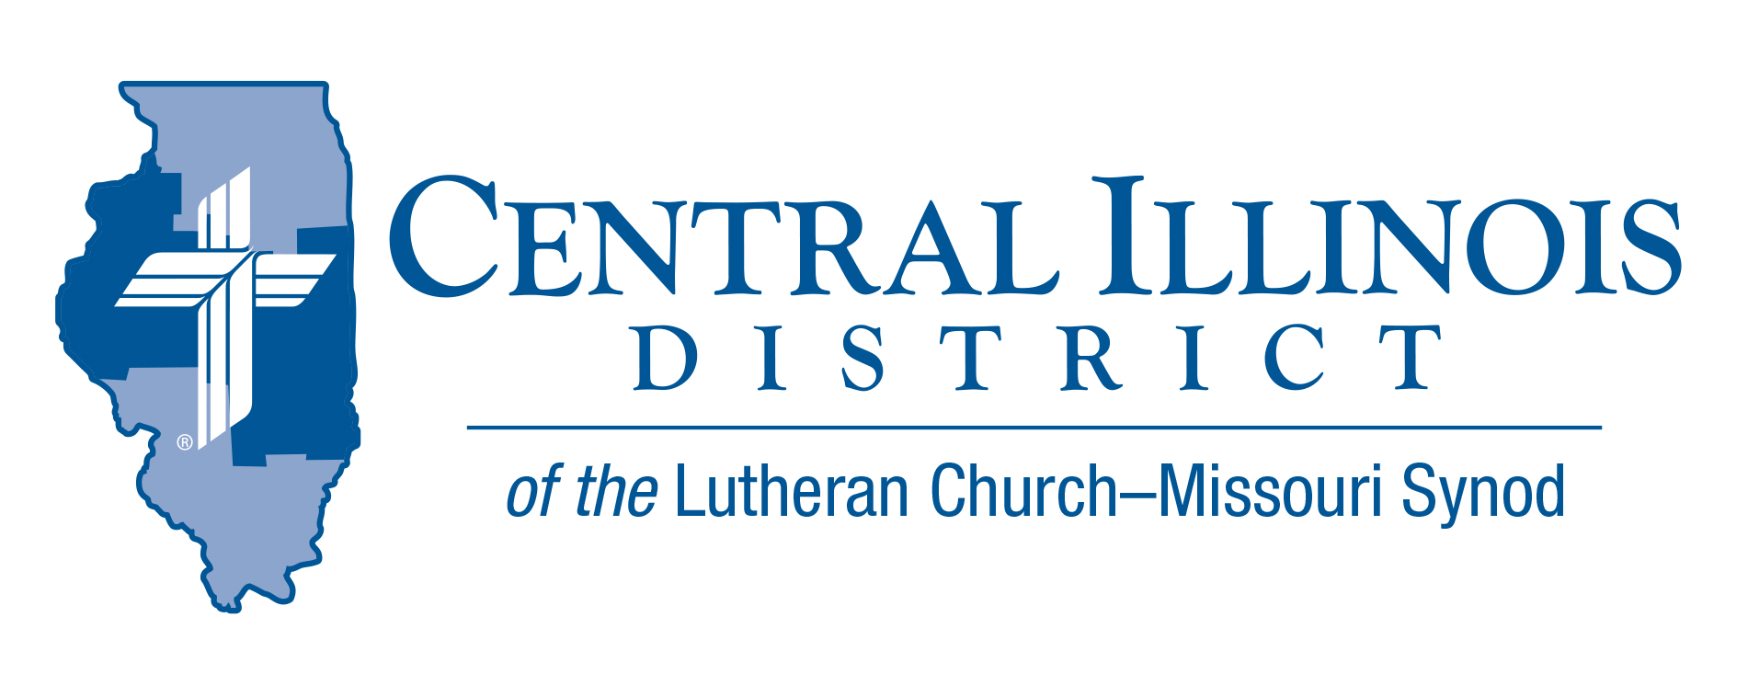
November 2023
News You Can Use
Every November, we come to a couple of things that seem different. At Thanksgiving, we praise God for the bounties of creation, yet as we reach the end of the church year we also contemplate the end of the creation as we know it and Christ’s visible coming as Judge.
The hymn “Come, Ye Thankful People, Come” (LSB 892) shows how these two fit together beautifully. We sing this hymn to give thanks for harvest. It also reminds us that “the Lord, our God, shall come and shall take His harvest home,” His harvest of people who by faith received salvation in Christ. The hymn concludes:
Even so, Lord, quickly come to Thy final harvest home;
Gather Thou Thy people in, free from sorrow, free from sin,
There, forever purified in Thy garner to abide:
Come with all Thine angels, come, raise the glorious harvest home.
A blessed Thanksgiving AND end of the church year!
Ken Schurb- CID Office

Pray For Our Central Illinois District Missions supported by your church’s Mission Dollars to the District. “Finally, brothers, pray for us, that the Word of the Lord may spread rapidly and be honored. Please remember in your prayers all our CID campus ministries, especially Rev. William Jensen and Wittenberg Lutheran Center in Normal, serving students, faculty, and staff of Illinois State University and other institutions. And pray for the “Keeping Christ on Campus” campaign, building endowments to help CID support our campus ministries

Items of Interest to Share

Announcing 2024 Central Illinois District Youth Bible Bowl: “The Gospel according to St. John.” In the best way you know how, study the Gospel according to St. John with your young people so they get to know better the only true God, and Jesus Christ, whom He sent to win eternal life for all believers. The CID Bible Bowl is being planned for a Sunday afternoon in April, at Camp CILCA. Circuit Bible Bowls may be held in March. More information will be forthcoming. The CID Youth Bible Bowl is an opportunity for young people in Senior and Junior High School (grades 6-12) to study a portion of God's word each year, and meet with other young people of their circuit and the District. If you would like more information you may contact Pastor Mark Eddy at Zion Lutheran Church, Taylor Ridge, Illinois (zionlcms@juno.com) or 309-795-1063.

Small Church Summit
Innovating Again

Next time there is a Small Church Summit (SCS), there will be two: one in CID and another in the Southern Illinois District (SID). We are working on making the SCS more accessible to greater numbers of people in each of these Districts.

The next SCS meeting in CID will be held from 10:00 a.m. to 2:30 p.m. on Saturday, Feb. 3, 2024 (or, if weather is bad that day, on Feb. 10) at Faith, Lincoln. CID folks are also invited to attend the SCS in SID on Jan. 6 (bad weather date: Jan. 27) at Messiah, Carlyle. In any case, the day’s programs will resemble one another.

The program will emphasize conversation between participants. Experience has shown that folks from our small churches not only thrive on the Good News of the crucified and risen Lord Jesus Christ; they also love sharing ideas for engaging in the church’s mission with people from other small LCMS churches.

The day’s activities will be designed to highlight discussion. In the morning, people will introduce themselves and briefly tell the group about something their church has done in the last five years. Later in the morning, SID President Timothy Scharr will make a presentation on reaching out to inactive members.

The afternoon will feature time for small group discussion. The topics will include:
- Bible Study in the Small Church, Congregational Partnerships, and Stewardship of Spiritual Gifts
Three other topics will also be offered, six in all. The other three topics on a particular afternoon will be based on what participants said in the morning. Each participant will be able to join in a total of four different discussions from among the six topics. Discussions will run for 25 minutes each.

Remember, if you think your church is small, YOU are invited to the Small Church Summit to talk and listen, to be encouraged and to encourage brothers and sisters in Christ in other small churches. It will work best if you bring two or three others with you from your church.
Register at https://forms.gle/5eEQYVGgAwMdtj4v6
Deadlines for registration
SID’s January 6th SCS (Carlyle) meeting is January 2nd, 2024.
CID’s February 3rd SCS (Lincoln) is January 22nd, 2024.
2024 Legislative Update
The Christian Citizenship page of the CID website carries periodic updates on business that is pending before, or perhaps likely to come before, our state legislature. Watch for an update in late December 2023, or early January 2024 concerning the regular legislative session in 2024. Go to https://www.cidlcms.org/ministry-human-care-christian-citizenship.html

SAVE THE DATE: Illinois March for Life: Wednesday, April 17, 2024
Springfield, Illinois

