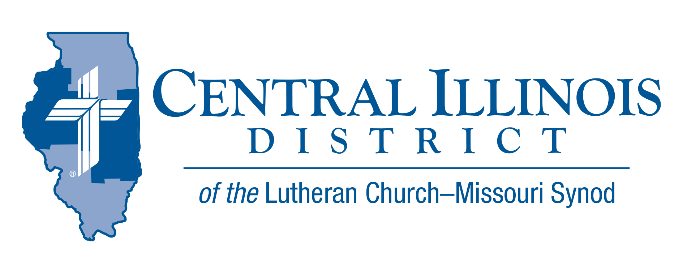
January 2024
News You Can Use
After the layover by the Magi, Herod had murder on his mind, and had power in his arsenal. All Jesus had on earth was a carpenter and a mom – and these were enough to thwart the king’s plan for removing his competition.
Now when they had departed, behold, an angel of the Lord appeared to Joseph in a dream and said, “Rise, take the child and his mother, and flee to Egypt, and remain there until I tell you, for Herod is about to search for the child, to destroy him.” And he rose and took the child and his mother by night and departed to Egypt and remained there until the death of Herod. (Matthew 2:13-15a).
Men and women, married or single, who trust and follow the Word of God have much greater power than a raging king. In this new year, trust and follow the Word of God in your congregation and in your home. The culture will continue to rage and rebel. You will stand safe, even if the Herod-of-the-day temporarily has his way. God’s will shall be accomplished. Rejoice, believers!
Mike Burdick Pastor, St. John’s Lutheran Church, Effingham

Pray For Our Central Illinois District Missions supported by your church’s Mission Dollars to the District. “Finally, brothers, pray for us, that the Word of the Lord may spread rapidly and be honored. Dear Father, we pray Thee, give us thy Word, that the Gospel may be sincerely preached throughout the world and that it may be received by faith and may work and live in us. So we pray that thy kingdom may prevail among us through the Word and the power of the Holy Spirit, that the devil’s kingdom may be overthrown and he may have no right or power over us, until finally the devil’s kingdom shall be utterly destroyed and sin, death, and hell exterminated, and that we may live forever in perfect righteousness and blessedness (from Luther’s Large Catechism).

Items of Interest to Share

Announcing 2024 Central Illinois District Youth Bible Bowl: “The Gospel according to St. John.” In the best way you know how, study the Gospel according to St. John with your young people so they get to know better the only true God, and Jesus Christ. The CID Bible Bowl is being planned for a Sunday afternoon in April, at Camp CILCA. Circuit Bible Bowls may be held in March. The CID Youth Bible Bowl is an opportunity for young people in Senior and Junior High School (grades 6-12) to study a portion of God's word each year, and meet with other young people of their circuit and the District. If you would like more information you may contact Pastor Mark Eddy at Zion Lutheran Church, Taylor Ridge, Illinois (zionlcms@juno.com) or 309-795-1063.
Small Church Summit
Innovating Again

The next SCS meeting in CID will be held from 10:00 a.m. to 2:30 p.m. on Saturday, Feb. 3, 2024 (or, if weather is bad that day, on Feb. 10) at Faith, Lincoln.

The program will emphasize conversation between participants. Experience has shown that folks from our small churches not only thrive on the Good News of the crucified and risen Lord Jesus Christ; they also love sharing ideas for engaging in the church’s mission with people from other small LCMS churches.

The day’s activities will be designed to highlight discussion. In the morning, people will introduce themselves and briefly tell the group about something their church has done in the last five years. Later in the morning, SID President Timothy Scharr will make a presentation on reaching out to inactive members.

The afternoon will feature time for small group discussion. The topics will include:
- Bible Study in the Small Church, Congregational Partnerships, and Stewardship of Spiritual Gifts
Three other topics will also be offered, six in all. The other three topics on a particular afternoon will be based on what participants said in the morning. Each participant will be able to join in a total of four different discussions from among the six topics. Discussions will run for 25 minutes each.

Register at https://forms.gle/5eEQYVGgAwMdtj4v6
The deadline for registration is January 22nd, 2024.

Illinois March for Life: Wednesday, April 17, 2024, this event had been set for about a month earlier, but plans have changed. As last year, Trinity Lutheran Church in downtown Springfield (across the street from the state capitol building) will host a Matins service in the morning, before the rally and march, and a light lunch will be provided at a nominal cost. Precise times are being determined. This year, parking will be available to you downtown at the State House Inn, a block north of the capitol and near Trinity. However, please make plans now to carpool whenever possible.

The 1974 Walkout: Why, and Why Does it Matter? This study, very similar to one offered last fall at Christ, Normal, will unfold over a series of four evenings, January 10, 17, 24, and 31, at 6:00 p.m. at Trinity Lutheran Church’s Parish Center, 515 South MacArthur, Springfield, IL, 62704-1744. (An evening prayer service will precede these classes at 5:30.) Dr. Ken Schurb of the CID office will teach. Participants will be able to purchase copies of the book Rediscovering the Issues Surrounding the 1974 Concordia Seminary Walkout. Assimilation (Incorporation) of New Church Members This study covers biblical material on the church and being members of the body of Christ as well as practical suggestions for how to incorporate new members into your congregation.

