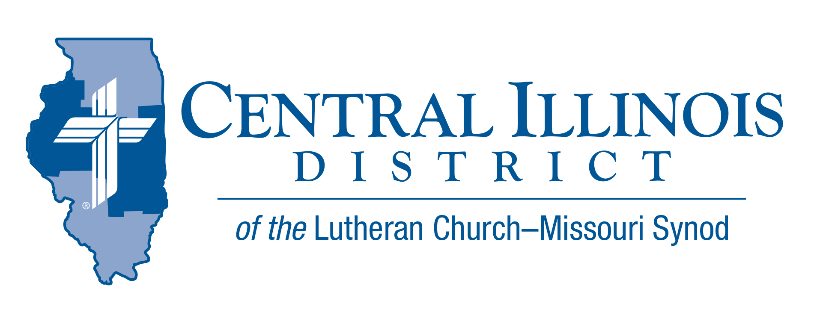
December 2020 part 2
News You Can Use
We may have been hoping that the COVID-19 pandemic would be over by now. But many of us are still experiencing its affects. Even if we aren’t sick, we may be feeling COVID FATIGUE, which may include weariness, loneliness, frustration, fear, anger, and grief.
Yet, in Christ we can still have hope, joy, and peace. Martha Washington was quoted as saying, “The greater part of our happiness or misery depends on our disposition and not on our circumstances.” We do not always have the power to change our circumstances. But we do have the power to change our attitude or outlook. We can adjust our disposition by doing the following:
Remember that just as God has gotten us through difficulties in the past, He can do so again. He has provided and will continue to provide the resources and support we need.
Believe that eventually, according to his timing, God will change our circumstances. We are told that a number of COVID vaccines will soon be available. We can trust that eventually this pandemic will end.
Think positive. Norman Vincent Peale wrote “Change your thoughts and you change your world.” St. Paul wrote in Philippians 4:8 “Whatever is true, whatever is noble, whatever is right, whatever is pure, whatever is lovely, whatever is admirable - if anything is excellent or praiseworthy - think about these things.”
Trust that God works through all situations for the good of those who love him and are called according to his purposes (Romans 8:28). He gives us peace that passes understanding, hope that doesn’t fail us, and strength in Christ. God may be working through our difficulties to help us grow, to rearrange our priorities, or to fashion us for better things.
Trust that God is with us always. David said to his son Solomon in 1 Chronicles 28:20, “Do not be afraid and do not be dismayed, for the Lord God, even my God, is with you. He will not leave you or forsake you.”
Jesus said in John 10:10, “I have come that they may have life and have it to the full.” He gives us a full life of hope, joy, peace, strength, and contentment even when the world seems to be trying to take these blessings away. Jesus assures us in John 16:33, “In this world you will have trouble. But take heart! I have overcome the world.”
Rev. Jeffrey Harter

ITEMS OF INTEREST TO SHARE
Stewardship Speakers: Invite President Mark Miller or Stewardship Executive Ken Schurb to your church to preach and teach on Stewardship some Sunday in 2021. They are both making themselves available as much as possible for this, as part of the CID “Bring Giving Home” initiative.

ACROSS OUR DISTRICT
“Through the Old Testament in a Church Year”- audio resource by Issues, etc. with Ken Schurb
You can find resources that survey the Old Testament in a year. Here, however, is one that does so in a church year. This audio resource will consist of a series of Issues, etc. interviews with CID staff member Ken Schurb during the 2020-2021 church year. The typical interview will run about 25 minutes, closer to 20 minutes if listeners fast-forward through various announcements. The interview recordings will be available on-demand at https://issuesetc.org/archive

The series commenced on Thanksgiving Day, November 26, 2020, with an hour-long premiere that will highlight the biblical teachings of Creation (appropriate for Thanksgiving) and of the Fall and the first prophecy of the coming Deliverer (for the First Sunday in Advent

Responding to Idols- Book Discussion (Zoom format)
Starting on Thursday, January 14, at 3:00 pm
The book The Unholy Trinity: Martin Luther against the Idol of Me, Myself, and I by Michael Lockwood (CPH, 2016) lays out Luther’s multi-faceted case against idolatry and for the one saving God. This book applies the reformer’s biblical insights to our times today.

CID Evangelism Executive Ken Schurb will conduct one-hour Zoom discussions of this book every other week, with a break in February.
These conversations are open to all members of CID churches. Pastors and other rostered church workers are especially encouraged to participate. Send an e-mail (kschurb@cidlcms.org.) expressing interest. We will take that as your registration and reply with the appropriate Zoom link. The sessions will be recorded. If you cannot participate live, you can view the session later.

There is no cost for the sessions. In fact, CID will provide the first 25 registrants for these sessions a gratis copy of the book The Unholy Trinity. (Please reimburse the District $3.00 for shipping costs.) If you register by January 3, 2021, we can mail a copy of the book. Be sure to include both your e-mail address and your postal address in your e-mail message to kschurb@cidlcms.org.

Pray For Our Central Illinois District Missions supported by your church’s Mission Dollars to the District. “Finally, brothers, pray for us, that the Word of the Lord may spread rapidly and be honored.”

- We give thanks for the gift of our Savior’s birth and pray for the adherents of various world religions who do not believe that in Jesus Christ the Word became flesh for the salvation of all people. We ask the Lord to shine His saving Gospel light through us to everyone!

