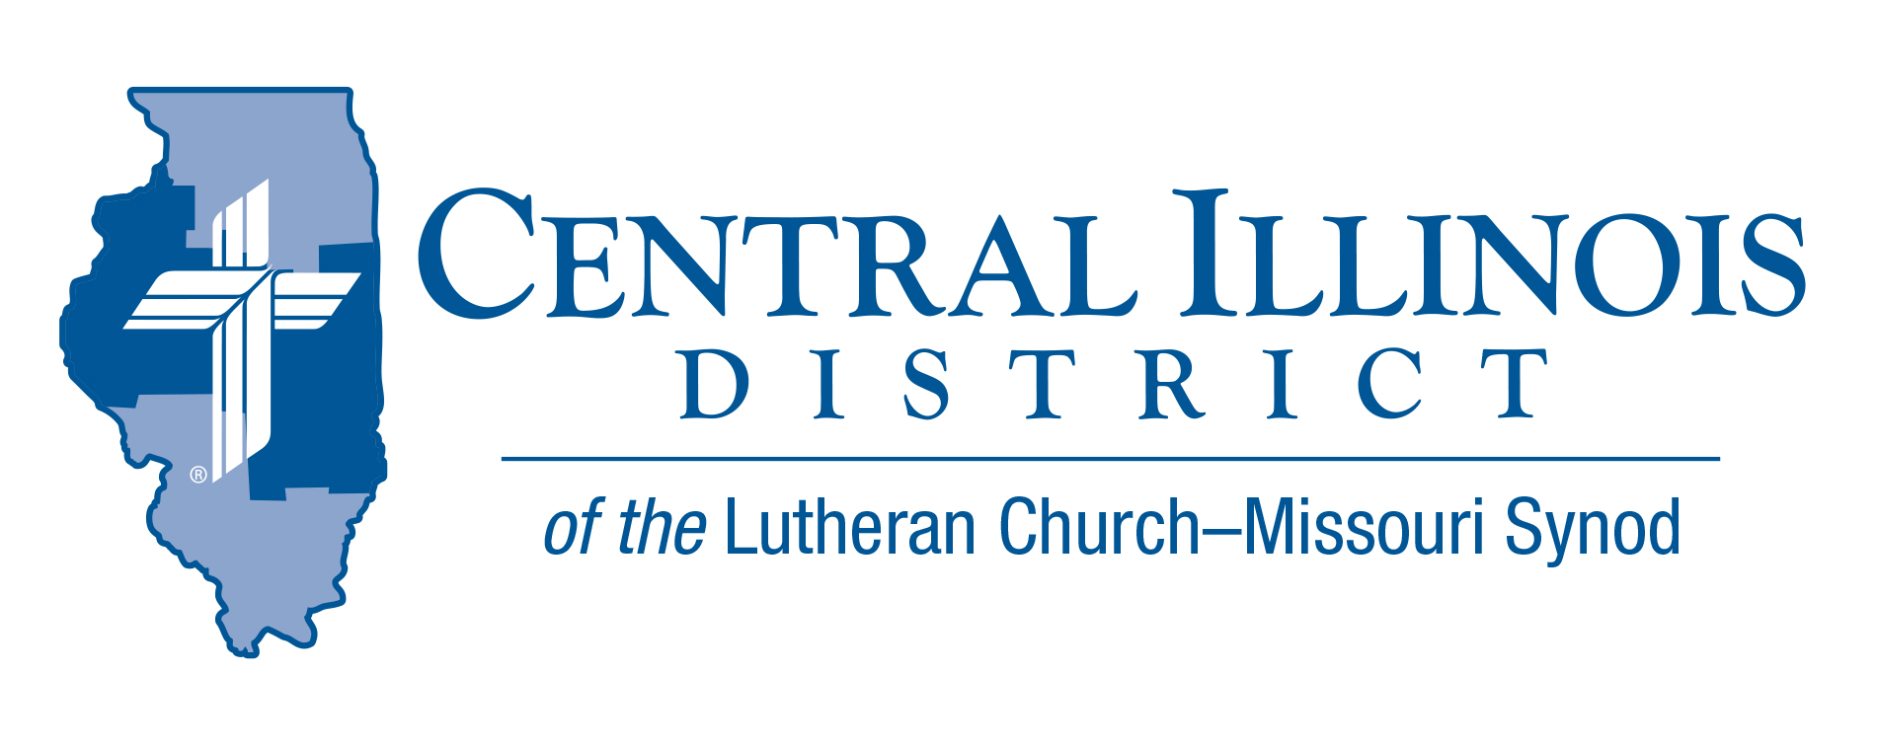
December 2020
News You Can Use
Have you heard the saying, “All politics is local”? Well, all Gospel is universal. The Christmas angel said, “I bring you good news of great joy that will be for all the people. For unto you is born this day in the city of David a Savior, who is Christ the Lord” (Luke 2:10-11). Not just for some people, but for all! Good News of God’s grace for all in the Christ Who came for all!
Yet this Gospel is located. For “the Word became flesh and dwelt among us” in the Person of Jesus, “full of grace and truth” (John 1:14). Jesus is the Gospel in Person, and in action. For “Christ, having been offered once to bear the sins of many, will appear a second time, not to deal with sin but to save those who are eagerly waiting for him” (Hebrews 9:28).
Meanwhile, where do we have access to the universal yet located Gospel? The angel told the shepherds, “you will find a baby wrapped in swaddling cloths and lying in a manger” (Luke 2:12). Today Christ comes to us sinners in His grace through His Word and Sacraments. Around these He gathers His church. “Therefore,” Luther’s Large Catechism says, “everything in the Christian church is so ordered that we may daily obtain full forgiveness of sins through the Word and through signs appointed to comfort and revive our consciences as long as we live,” that is, the sacraments.
A blessed Christmas to you and yours! Celebrate the Christ Who came for all, and do so in church.
Rev. Dr. Ken Schurb- Central Illinois District Office

Pray For Our Central Illinois District Missions supported by your church’s Mission Dollars to the District. “Finally, brothers, pray for us, that the Word of the Lord may spread rapidly and be honored.”

- We give thanks for the gift of our Savior’s birth, and pray for the adherents of various world religions who do not believe that in Jesus Christ the Word became flesh for the salvation of all people. We ask the Lord to shine His saving Gospel light through us to everyone!
DID YOU KNOW?
December 10 is the 500th anniversary of Martin Luther burning the papal bull (pronouncement) that threatened his excommunication in a bonfire that included copies of canon law and various writings of scholastic theologians.
ITEMS OF INTEREST TO SHARE

Central Illinois District Youth Bible Bowl (April 2021)
Introducing the 2021 Central Illinois District Youth Bible Bowl: The Exodus. As, God willing, we have our own exodus from home confinement to meeting together as God’s church in our various congregations, we seek God’s guidance for our exodus by studying the historical portions of the biblical book of Exodus (chapters 1-20, 24, 32-34, & 40). Whether or not we can have an in-person District Bible Bowl. (or via Zoom?), we can study God’s word in our homes and/or churches in the Christian hope of God’s freeing us from the shackles of this world into His promised paradise through Jesus Christ. Contact Pastor Mark Eddy at zionlcms@juno.com if you would like more information about how your congregation’s youth might participate in this year’s Bible Bowl.

ACROSS OUR DISTRICT
“Through the Old Testament in a Church Year”- audio resource by Issues, etc. with Ken Schurb
You can find resources that survey the Old Testament in a year. Here, however, is one that does so in a church year. This audio resource will consist of a series of Issues, etc. interviews with CID staff member Ken Schurb during the 2020-2021 church year. The typical interview will run about 25 minutes, closer to 20 minutes if listeners fast-forward through various announcements. The interview recordings will be available on demand at https://issuesetc.org/archive

The series will commence on Thanksgiving Day, November 26, 2020, with an hour-long premiere that will highlight the biblical teachings of Creation (appropriate for Thanksgiving) and of the Fall and first prophecy of the coming Deliverer (for the First Sunday in Advent

Responding to Idols- Book Discussion (Zoom format)
Starting on Thursday, January 14, at 3:00 pm
The book The Unholy Trinity: Martin Luther against the Idol of Me, Myself, and I by Michael Lockwood (CPH, 2016) lays out Luther’s multi-faceted case against idolatry and for the one saving God. This book applies the reformer’s biblical insights to our times today.

CID Evangelism Executive Ken Schurb will conduct one-hour Zoom discussions of this book every other week, with a break in February.
These conversations are open to all members of CID churches. Pastors and other rostered church workers are especially encouraged to participate. Send an e-mail (kschurb@cidlcms.org.) expressing interest. We will take that as your registration and reply with the appropriate Zoom link. The sessions will be recorded. If you cannot participate live, you can view the session later.

There is no cost for the sessions. In fact, CID will provide the first 25 registrants for these sessions a gratis copy of the book The Unholy Trinity. (Please reimburse the District $3.00 for shipping costs.) If you register by January 3, 2021, we can mail a copy of the book. Be sure to include both your e-mail address and your postal address in your e-mail message to kschurb@cidlcms.org.

