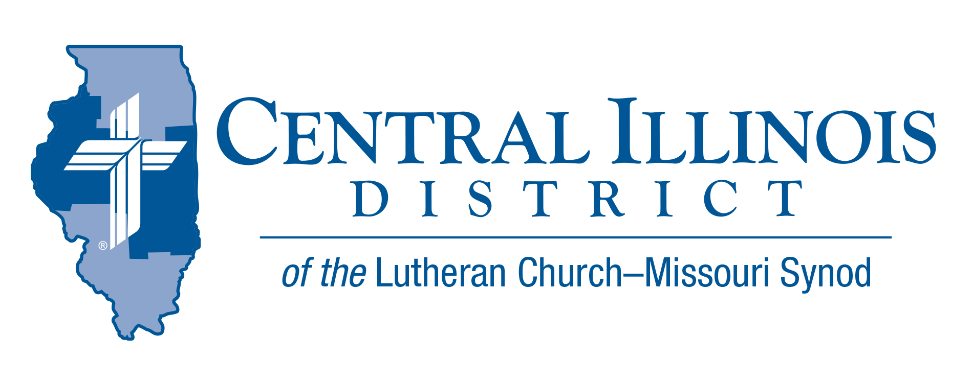
January 2021
News You Can Use

I don’t think that I’m the only one. I’m sure many other people are delighted to be on this side of New Year’s Day, so we can forget all about 2020. But which of us can truly say, as we reflect on the year now past and anticipate the year to come, what Solomon said to God as he contemplated his own future as King. “You have shown great and steadfast love to your servant David my father.” (I Kings 3:6) That may have been true for David, but what about us? Has God really shown us His steadfast love in the past several months?
The answer is a resounding yes! The Lord has not forsaken His people, even though we forsake Him in countless ways. He has forgiven us with the fullness of His grace in the blessed words of absolution. He has come to countless people through the waters of Holy Baptism, and fed His children through the bread and wine of Holy Communion. Despite all the suffering in the world around us, our Lord has been an ever-present help in trouble. 2020 was actually a very good year, and we can count on our faithful Lord to sustain us in the year ahead, come what may. So rejoice! Rev. Peter M. Glock (Zion-Wenona and St. Paul’s -Varna IL)

Pray For Our Central Illinois District Missions supported by your church’s Mission Dollars to the District. “Finally, brothers, pray for us, that the Word of the Lord may spread rapidly and be honored.”

Dear Father, we pray Thee, give us thy Word, that the Gospel may be sincerely preached throughout the world and that it may be received by faith and may work and live in us. So, we pray that thy kingdom may prevail among us through the Word and the power of the Holy Spirit, that the devil’s kingdom may be overthrown, and he may have no right or power over us, until finally the devil’s kingdom shall be utterly destroyed and sin, death, and hell exterminated, and that we may live forever in perfect righteousness and blessedness (from Luther’s Large Catechism).
ITEMS OF INTEREST TO SHARE

Conference on Adult Faith Formation
On January 12-14, Dr. Kent Burreson of Concordia Seminary (St. Louis) and Dr. Rhoda Schuler of Concordia University, St. Paul (MN) will host an online conference called “Treasures Old and New.” Participants will learn of practices adapted from adult catechumenate materials in Roman Catholic circles. It features pastors from three LCMS churches that have been deeply involved in such approaches. The web address to register is https://www.forminglutherans.org/events/
ACROSS OUR DISTRICT

Responding to Idols- Book Discussion (Zoom format)
Starting on Thursday, January 14, at 3:00 pm
The book The Unholy Trinity: Martin Luther against the Idol of Me, Myself, and I by Michael Lockwood (CPH, 2016) lays out Luther’s multi-faceted case against idolatry and for the one saving God. This book applies the reformer’s biblical insights to our times today.

CID Evangelism Executive Ken Schurb will conduct one-hour Zoom discussions of this book every other week, with a break in February. These conversations are open to all members of CID churches. Pastors and other rostered church workers are especially encouraged to participate. To register, click on the link within the article on the Book Discussion at www.cidlcms.org/news.html. The sessions on the above dates. If you cannot participate live, we will be recorded each session.
There is no cost for the sessions. In fact, CID can provide at least some registrants for these sessions a gratis copy of the book The Unholy Trinity. (Please reimburse the District $3.00 for shipping costs.)

SAVE THE DATE!

The CID IL LLL Convention
What - The CID IL LLL Convention
Where - St John’s - Effingham IL
When - March 6th, 2021
Who - Speaker - Lutheran Hour Speaker Rev Michael Zeigler
Please plan to attend - Look for Specific Times and more details to come

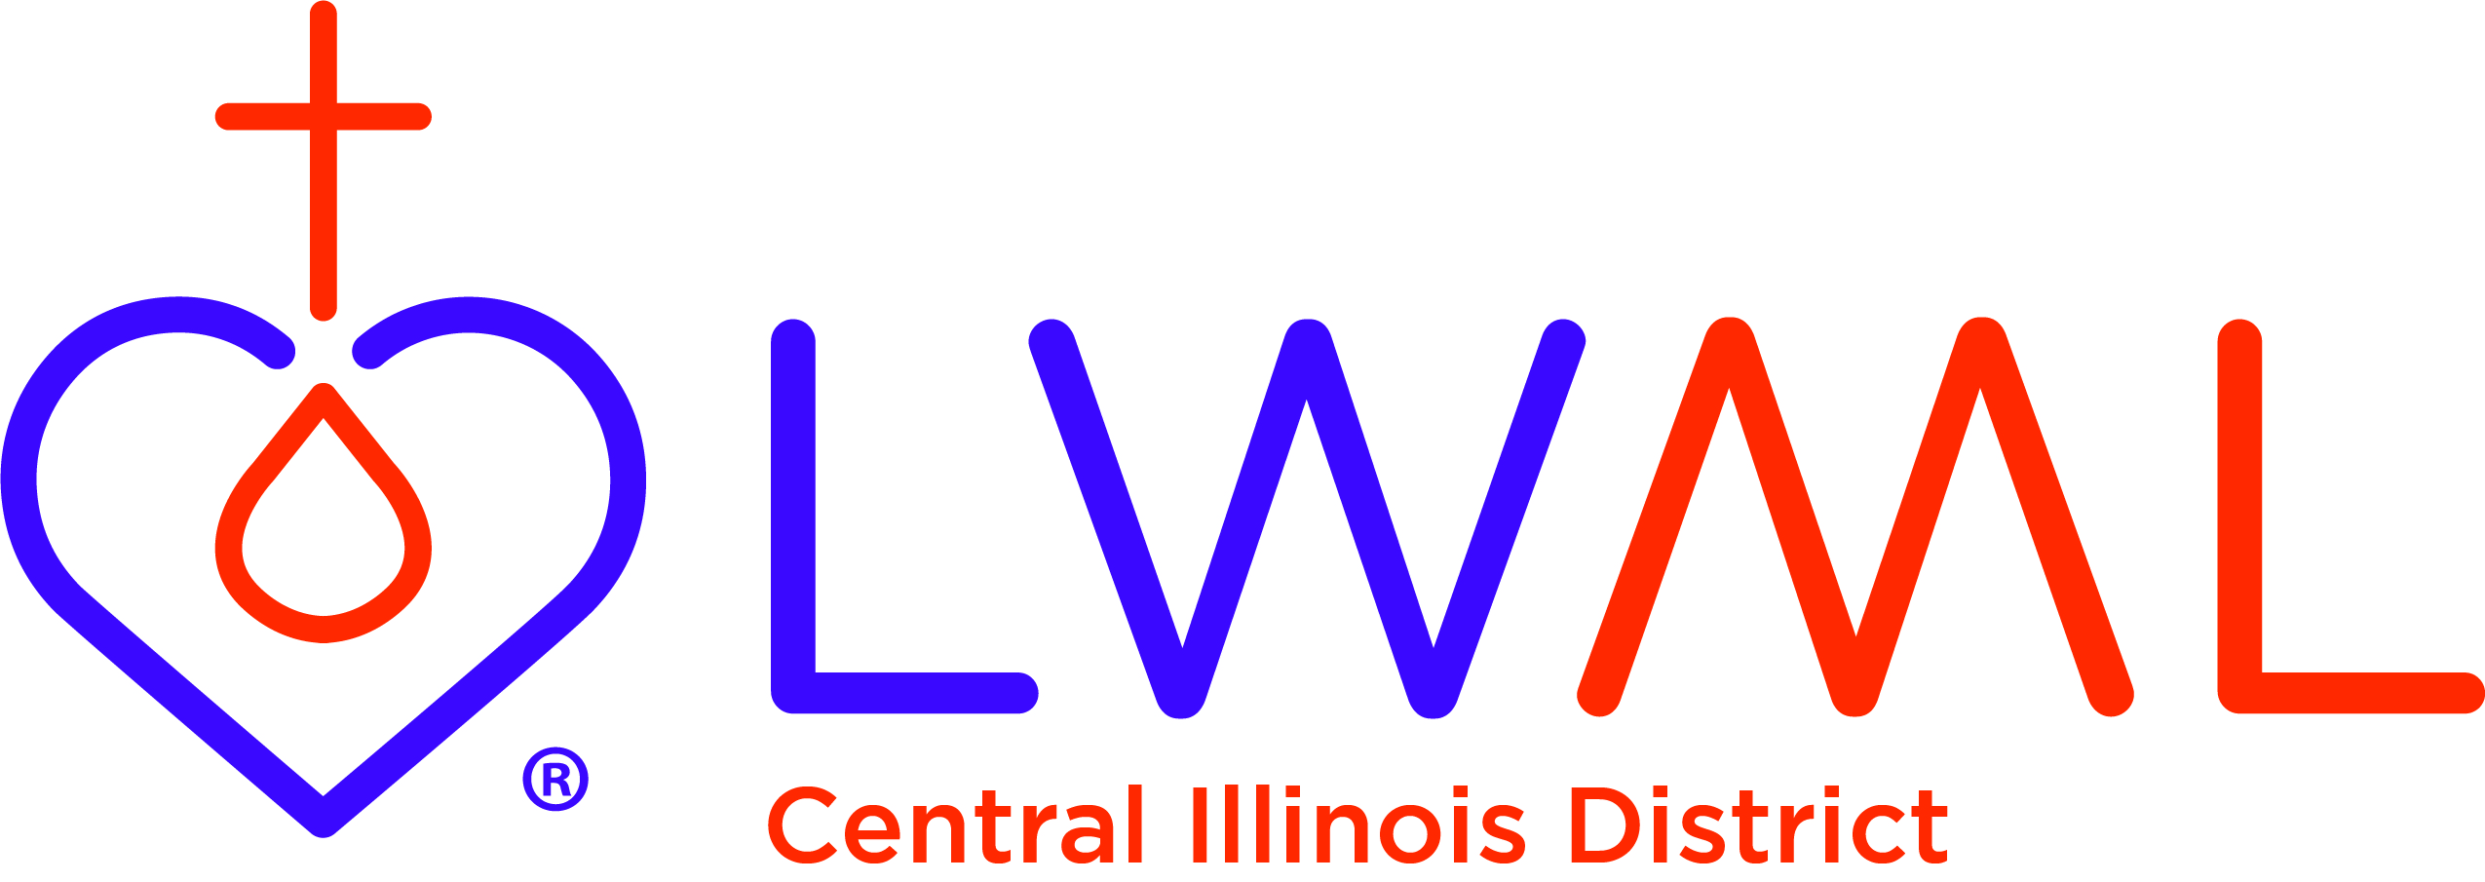
The LWML CID’s 75th convention and 75th Anniversary celebration is scheduled for April 29-May 1, 2021 at Bethel Lutheran Church in Morton. We look forward to seeing everyone there.

CAMP CILCA
- February 27 Men’s Woodcutters Retreat
- March 21 Annual Banquet (Our Savior’s Lutheran Church – Springfield) Contact the Camp Office for more information Phone 217-487-7497

Stay Connected with your District
Looking for additional information visit https://linktr.ee/cidlcms or connect with the following items:
- CID’s GatePost (newsletter)
- Subscribe to the E-GatePost/News You Can Use
- Stay connect with us on Facebook and Instagram -- Central Illinois District-LCMS

