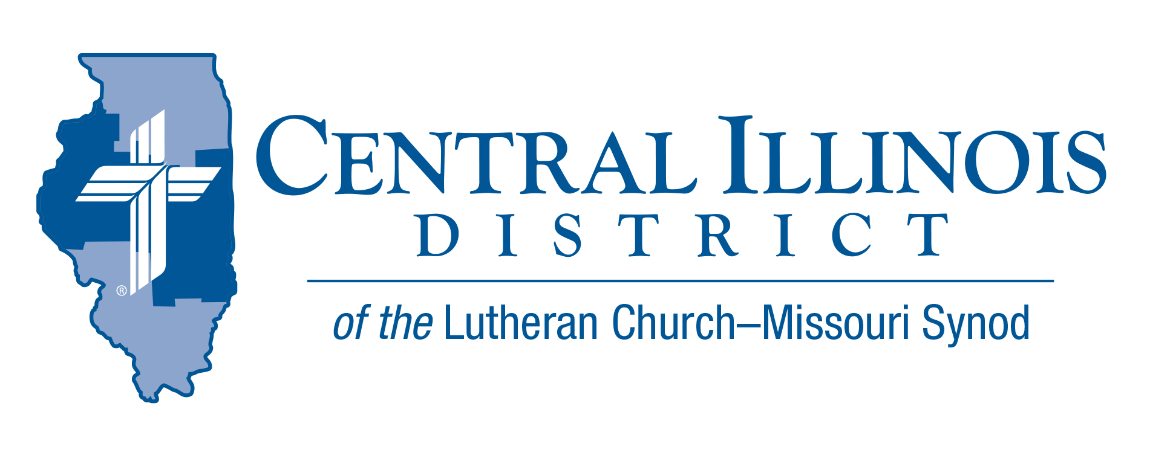
October 2021
News You Can Use
“May the Lord answer you in the day of trouble! May the name of the God of Jacob protect you!” Psalm 20:1

We know various items by their name. Their common name can be what we identify the object and or their purpose. Most of us know a Band-Aid as an item that we use to cover a break in our skin. But Band-Aid is the trademark for an adhesive bandage developed by Johnson & Johnson in the 1920s. We use this term to cover all the bandages that are on the market.

In our world today, many people call on “god” in their everyday conversations. In some cases, these individuals have no real connection to the “god” that they are calling upon. In our reading, there is no doubt who they are counting on for protection. We, as Christians, have the knowledge that the one true God will protect us. We know that even though several names for our God are listed within the Bible, He is the one true God. By faith, we have been called into the family of believers. We know that when we call upon His name, He will hear our prayers. We are blessed to know that He is our God, whose name should be praised.

Trip Rodgers – Assistant to the President for Education and Congregational Life- CID

Pray For Our Central Illinois District Missions supported by your church’s Mission Dollars to the District. “Finally, brothers, pray for us, that the Word of the Lord may spread rapidly and be honored.” Our Lord Jesus said, “Pray the Lord of the harvest to send laborers into the harvest.” This month, please remember to thank God for outreach with the Gospel in Spanish at St. John’s Lutheran Church, Beardstown. Pray for community liaison Maria Guijosa and their new pastor Rev. Brian Homann.

Stay Connected with your District
Looking for additional information visit https://linktr.ee/cidlcms or connect with the following items:
- CID’s GatePost (newsletter)
- Subscribe to the E-GatePost/News You Can Use
- Stay connect with us on Facebook and Instagram -- Central Illinois District-LCMS

ITEMS OF INTEREST TO SHARE

Zoom Training for National Youth Gathering:

All adult leaders, especially volunteer and first-time leaders, are encouraged to join in on a training via Zoom! We'll cover topics about registration, adult leaders, pre-event Bible studies, fundraising, etc.! There are times morning, afternoon, and evening. Join one or join multiple to hear questions and comments from different leaders. If you have any questions, contact Jonathan Guse at jonathan@bethelmorton.org .
- Monday, Oct 11, 2021 02:00 PM
- Tuesday, Oct 12, 2021 08:00 PM
- Wednesday, Oct 13, 2021 09:00 AM
- Monday, Oct 18, 2021 02:00 PM
- Tuesday, Oct 19, 2021 08:00 PM
- Wednesday Oct 20, 2021 09:00 AM

Churchworkers Retirement Workshop
On Saturday, November 6, CID’s Human Care Committee hosts a “preparing for retirement” event for church workers. Rev. David Fleming of DOXOLOGY will make a presentation entitled, “Still Bearing Fruit: Retirement as Joyful Receiving and Giving.” CID Gift Planning Counselor Rev. Charles Olander and Mr. Scott Radden of the LCMS Foundation will talk about charitable giving in retirement and beyond.
The workshop will be held at Good Shepherd Lutheran Church, Sherman, starting at 10:30 a.m. and ending at about 2:00 p.m. (Doors will open at 10:00.) Register before November 1 by e-mailing Ken Schurb at CID office, kschurb@cidlcms.org

THE 2021 CID JR. HIGH LOCK IN IS GO!- So FAR!

FRIDAY, NOVEMBER 12 - BEGINNING AT 9 PM!
AT FIVE POINTS IN WASHINGTON, ILLINOIS.

Great Fellowship and Fun – Save the Date

Get your group togther – See you at Five Points

Please note that Five Points Washington will be following the guidelines announced by the Governor of Illinois along with guidance from the CDC and the IDPH.

Five Points WILL NOT ask or require proof of vaccination; however, we do encourage you to continue to use your best judgement to continue to protect your health and that of others. Stay connect to current CID Youth Lock in Information at https://cidyouth.weebly.com/

