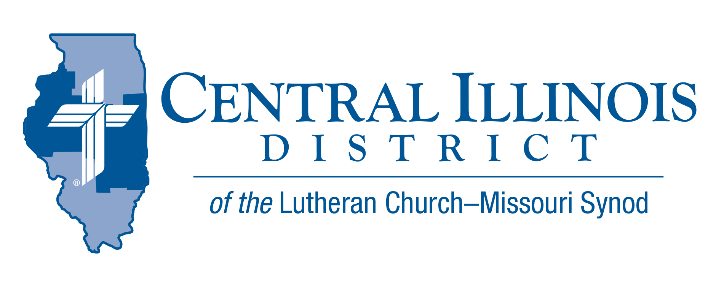
November 2021
News You Can Use
Evangelism and the End Times
Years ago, a famous evangelist made an odd decision. He determined, for once, not to say anything to anyone about Jesus on a stagecoach trip he was taking. Things turned out terribly, he recalled. He had no cross to bear or take up, and soon he went to sleep.
Jesus said: “Be alert, since you don’t know when the master of the house is coming . . . Otherwise, when he comes suddenly he might find you sleeping. And what I say to you, I say to everyone: be alert!” (Mark 13:35-37).
Speaking the Gospel serves as a constant reminder of the eternal life-and-death import of faith or unbelief. This is not only for other people, but also for ourselves.
When we tell someone else the Good News about Jesus, we also have the opportunity to “eavesdrop” on it, hearing it all over again for our own life in the Lord. If we encounter pushback from others, we finally have nowhere to turn except to the returning Christ. In all these ways, we act as wide-awake, alert, and forgiven disciples of the crucified but now exalted and returning Jesus.
Don’t fall asleep! Lift up your head, your voice too. Your redemption draws near.

Rev. Dr. Ken Schurb Assistant to the President for Evangelism & Missions,
Stewardship, Human Care

Pray For Our Central Illinois District Missions supported by your church’s Mission Dollars to the District. “Finally, brothers, pray for us, that the Word of the Lord may spread rapidly and be honored.” Our Lord Jesus said, “Pray the Lord of the harvest to send laborers into the harvest.” Please remember in your prayers all our CID campus ministries, especially Rev. William Jensen and Wittenberg Lutheran Center in Normal, serving students, faculty, and staff of Illinois State University and other institutions. And pray for the “Keeping Christ on Campus” campaign, building endowments to help CID support our campus ministries.

Stay Connected with your District
Looking for additional information visit https://linktr.ee/cidlcms or connect with the following items:
- CID’s GatePost (newsletter)
- Subscribe to the E-GatePost/News You Can Use
- Stay connect with us on Facebook and Instagram -- Central Illinois District-LCMS
ITEMS OF INTEREST TO SHARE

CAMP CILCA INFORMATION
The FALL WORKDAY at Camp CILCA is Saturday, November 13. Volunteers are needed to help get the campgrounds ready for winter. Come anytime between 8:30am and 11:30am. Lunch will be provided for all volunteers.

THE 2021 CID JR. HIGH LOCK IN has been cancelled
Unfortunately, the CID Youth Committee has decided to cancel the CID Jr-High Lock-in. The event was scheduled for November 12th-13th, 2021.
We were disappointed that COVID is still affecting our planning of activities.

Novemberfest and a Gottesdienst Conference
St. John’s - Mattoon, and Immanuel - Tuscola
Sunday evening and Monday, November 14-15, 2021
Conference theme: Reactions to Persecution

In an age of mounting animosity toward the Christian Church in our society, this conference aims to get pastors and laypeople thinking about how we might respond appropriately to such things. For the seminar we are pleased to welcome the Rev. Dr. Adam Koontz, Assistant Professor at Concordia Theological Seminary in Fort Wayne, Indiana as our keynote speaker. Dr. Koontz was recently added to our ranks as a Gottedienst blogger. He’ll be speaking on “Reactions to Persecution in the Early Church.”
We’ll also hear from Rev. Jason Braaten, our editor known for producing The Gottesdienst Crowd, our weekly podcast. Pastor Braaten will speak on “Temptations amid Persecution: Distraction and Indifference"

REGISTRATION: $50 per person — includes picnic, lunch, pizza dinner, and Gemütlichkeit. Log on at www.gottesdienst.org (November 1)

Lutheran Center for Religious Liberty November thoughts
- Veteran Day- we remembered all those who serve and have served in the US military to insure our freedoms. The first freedom mentioned in the Bill of Rights is Freedom of Religion. Dr. Seltz is an advocate for this freedom as he works to make sure all can practice their unique religion free from outside pressure.
- Soon we will pause to commemorate the first Thanksgiving, a time to reflect on the blessings God has granted our nation.
- Black Friday, Cyber Monday, Christmas Sales abound – how blessed we are! As we look forward to the season of giving, you are invited to support the work of the LCRL with your prayers and finances. Thank you for your consideration.
LCRL The Center provides input, education, advice, advocacy, and resources in the areas of life, marriage and religious liberty and seeks to engage in discussions in Washington, D.C., to establish partnerships and resources in our nation’s Capital for the sake of our churches, schools, universities, and seminaries. See www.LCRLFreedom.org for more information

