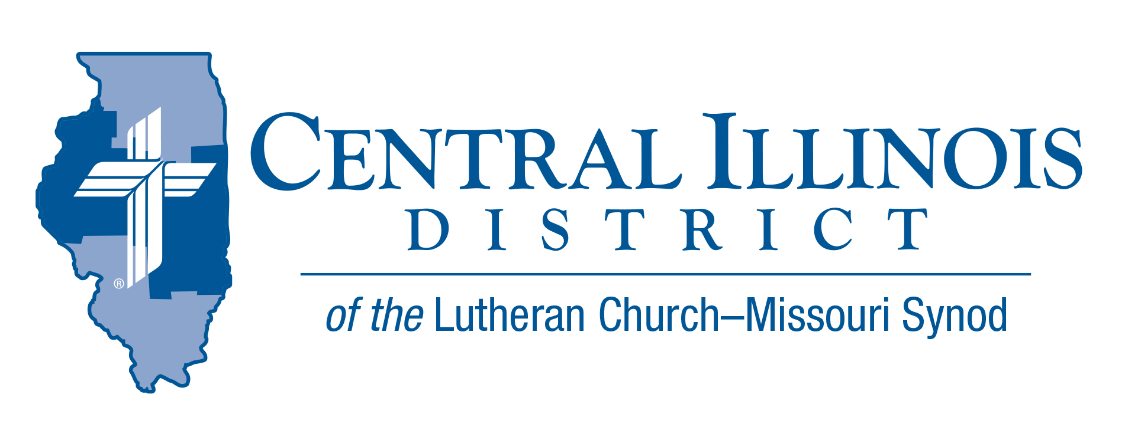
November mid-month 2021
News You Can Use
Uplifted Hands
Moses' hands grew weary, so they took a stone and put it under him, and he sat on it, while Aaron and Hur held up his hands, one on one side, and the other on the other side. So his hands were steady until the going down of the sun. And Joshua overwhelmed Amalek and his people with the sword. Exodus 17:12-13

Life can sometimes feel like a battle. This is true especially for Christians who are trying to honor the Lord by serving others and by proclaiming the Gospel. This is also true for pastors and other professional ministers in our Lutheran churches and schools. The world considers Christians to be intolerant, narrow minded, and out of touch with reality. We can become weary from always “swimming upstream” against the currents of popular opinion and world philosophies.
It is important to remember that Jesus already fought and won the battle against sin and the devil. All we must do is stand (Eph.6). The devil cannot harm us. Yet, still at times, we need people like Aaron and Hur to hold up our hands and the hands of God’s professional workers so they can continue to bless us with God’s Word.
In Exodus 17 we see the account of when Aaron and Hur stood with Moses while Moses blessed the people of Israel as they fought against the army of Amalek. As long as Moses held his hands up in blessing, the Israelites were winning. If he lowered his hands, they began to lose. So Aaron and Hur stood beside Moses and held up his hands.
Are there any “Aarons” and “Hurs” in your congregation? If so, praise God and thank them for their service. If you are an Aaron or a Hur, never forget how important you are! God may be using you to uplift your pastor and other workers so they can continue to bless your congregation and/or school with the powerful and life-giving Word of God.

Rev. Jeff Harter

Stay Connected with your District
Looking for additional information visit https://linktr.ee/cidlcms or connect with the following items:
- CID’s GatePost (newsletter)
- Subscribe to the E-GatePost/News You Can Use
- Stay connect with us on Facebook and Instagram -- Central Illinois District-LCMS

ITEMS OF INTEREST TO SHARE

Bible Bowl- 2022
Announcing the 2022 Central Illinois District LC-MS Youth Bible Bowl topic: Romans and 1 Corinthians. We heard requests for the Bible Bowl to cover Luther’s Small Catechism. This year’s topic is as close to that as it comes. St. Paul discusses the Ten Commandments, the doctrine of God, Christ’s atonement, and the work of the Holy Spirit. Paul deals with the church and proclaims the forgiveness of sins (justification by faith), the resurrection of the body, and the life everlasting. Baptism, the Lord’s Supper, and the Office of the Keys are explained. And prayer is interspersed with these basic Christian doctrines.
Date (Spring 2022) and location for the District Bible Bowl will be announced later. But now is the time to study these important epistles of the Bible with your youth and to talk within your circuit about holding a circuit Bible Bowl in preparation for the District Bible Bowl. Each circuit may send two teams to Springfield. For more information on how you can hold a Bible Bowl in your circuit, contact Pastor Mark Eddy at Zion Lutheran Church, Taylor Ridge, Ill. (zionlcms@juno.com).

The Rock in Shifting Sands
Join us in-person or online for the Making Disciples for Life (MDFL) Winter 2022 Conference
January 10, 2022—January 12, 2022
LCMS International Center
1333 S. Kirkwood Rd
National Mission
St. Louis, MO 63122-7226

- The Rock in Shifting Sands conference is being held in-person and on-line.
- The in-person portion of the conference will be held in the LCMS International Center in St. Louis. It is limited to 150 participants.
- On-line participation is unlimited. An on-line registration can be used by an individual, couple, family, or group. We encourage "watch parties" and invite you to consider how the members of your congregation can participate in this conference together.
- On-line participants will need a computer with a high-speed internet connection. Permission is granted to project the session videos to a large screen for "watch parties"
- The conference sessions are presented live, but are also recorded for future viewing. Your conference registration provides you with access to all recorded sessions for 60 days after the conference ends.
- For more information and registration https://web.cvent.com/event/529ac398-e9fc-4a0d-b042-42991421e33a/summary

