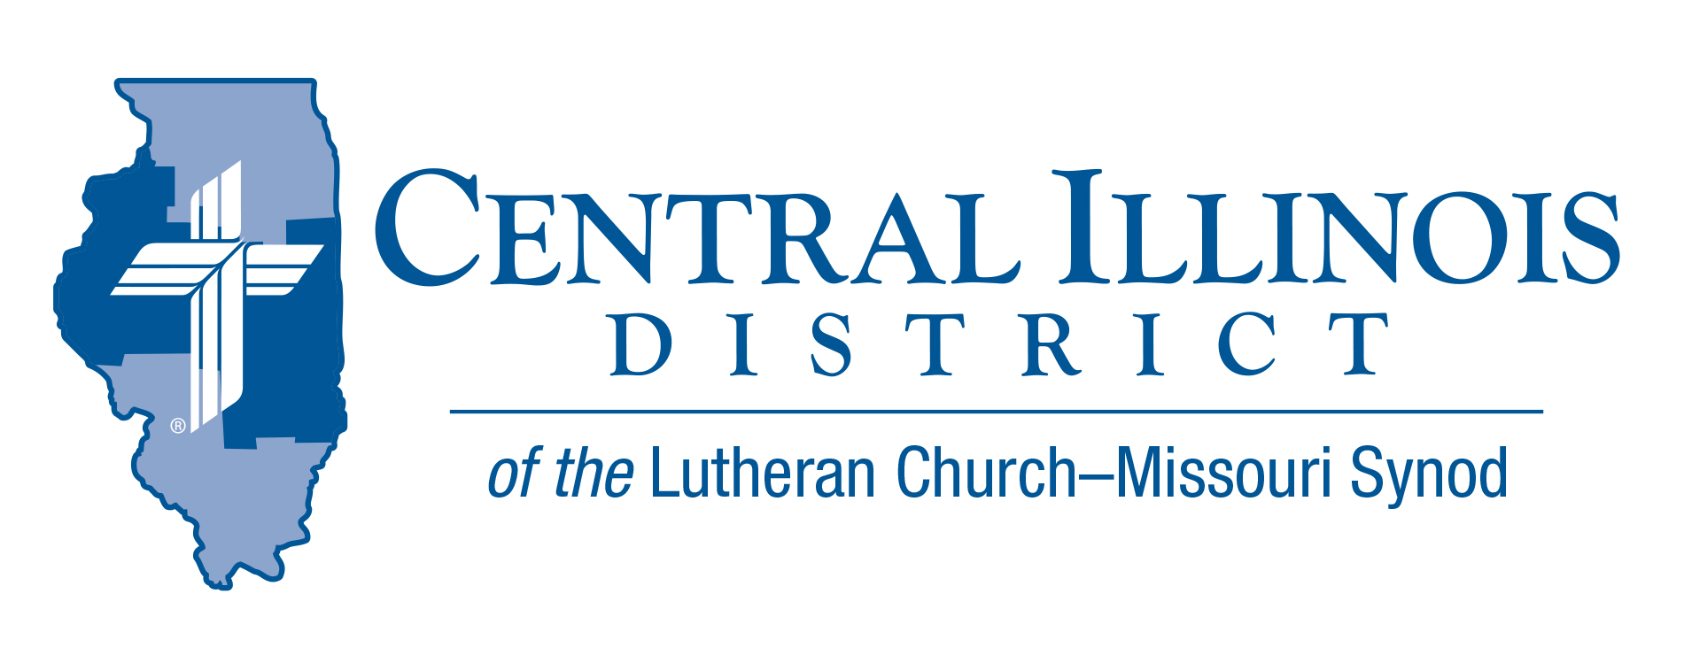
December 2021
News You Can Use
A Joy-Filled Christmas
“I bring you good news of great joy that will be for all the people.” Luke 2:10

The song “We Wish You A Merry Christmas” expresses the merry sentiment we all want at Christmas time. Though we may not always feel merry with COVID continuing to impact our lives with losses, social distancing, and restrictions on gatherings. Yet, even if our Christmas isn’t merry, it can be joy-filled.
Consider the stress and difficulties Mary and Joseph endured. Her pregnancy undoubtedly evoked rumors and accusations from many people. They had to travel over 70 miles to Bethlehem where they had no place to stay except a stable. Yet, they had the joy of knowing God was with them and would take care of them and the baby.

God never promised us continual happiness and glee. But he does promise to give us joy in all circumstances. “Rejoice in the Lord always…the Lord is at hand.” Phil.4:4 I once knew a nursing home resident who defined joy in the Lord as being glad that God is close by. When we feel sad, we should not force ourselves to look happy for the sake of others. Instead, be honest about our feelings, and remind each other that God is near us during our sad times too.

Focus on the reason for the season: Jesus. It is not about food, gifts, candies and cookies. We celebrate that Immanuel has come to us and remains with us always. Verse three of the song “Silent Night” describes our Savior as LOVE’S PURE LIGHT. John 1:9 tells us The true light that gives light to every man was coming into the world. The light of our Savior’s loving presence chases away darkness and fills us with joy in the Lord. We don’t have to stress about making Christmas merry. Instead, we can have a joy-filled Christmas as Jesus shines his love in us and through us!

Chaplain Jeffrey Harter

Stay Connected with your District
Looking for additional information visit https://linktr.ee/cidlcms or connect with the following items:
- CID’s GatePost (newsletter)
- Subscribe to the E-GatePost/News You Can Use
- Stay connect with us on Facebook and Instagram -- Central Illinois District-LCMS
ITEMS OF INTEREST TO SHARE
CID Board of Directors’ Meeting Summary
The Board of Directors met at the district office on Tuesday, November 23.
1st Vice President Rev. Rick Milas has retired and moved away from the district, so it was necessary that he resign his position. 2nd VP Rev. Mark Eddy is now the 1st VP. Rev. Michael Mohr, having received the second highest number of votes at the convention, succeeds Rev. Milas as the Eastern Region VP and is ordered as the 2nd VP. This required Rev. James Stunkel to move from Assistant Secretary to Secretary.
President Miller provided updates on the 19 vacancies in the district. Rev. Doug Minton has been appointed as the Iroquois Circuit Visitor to succeed Rev. Tim Hahn, who accepted a call outside of the district.
Trip Rodgers shared information regarding Senate Bill 818, a comprehensive and aggressive sex education program so that parents in congregations can know what non-Biblical views the state will be requiring of public-school education. Plans continue for various youth groups to attend either the National Youth Gathering or Higher Things conferences this summer. Plans are also in the works for the 2022 District Bible Bowl.
Rev. Dr. Ken Schurb shared news from Financial Secretary Jim Frazee that YTD giving is within $600 (4/100 of 1%) of the anticipated income from congregations. This is the closest we have been in many years.
As financial reports were reviewed, Treasurer Dale Dirks noted expenditures were not as high as anticipated, so the financial picture is even better than previously anticipated.
Following a thorough review, the Board of Directors passed a tentative budget of $1.9 million in anticipated expenses over against $1.8 million in anticipated income (not counting pass-through items like National Youth Gathering funds) and roughly $500k in reserves and cash-on-hand to make a budget balanced according to CID Bylaw 9.01(d).

Members of One Body is the next in a series of re:Vitality modules from the Synod’s Office of National Mission. The subject of this module, currently in its final phases of development, is assimilation of new church members. As part of a pilot project, Dr. Ken Schurb will teach the preliminary Members of One Body Bible study at Trinity, Springfield on a series of four Tuesday evenings: February 1 and 15 and March 1 and 15. All are invited! If your church might be interested in Members of One Body, you can take a taste of it, so save the dates now. Please lets us know if you are planning on attending or for more information, contact kschurb@cidlcms.org

60th Regular Convention Central Illinois District July 17-19, 2022
Crowne Plaza Springfield, Illinois (additional information of the CID website (http://www.cidlcms.org/events-2022-district-convention.html)
DATES TO REMEMBER
- December 31, 2021 – all non-praesidium nominations must be postmarked by this deadline to be considered for placement on the ballot at the convention.
- January 1, 2022 – anytime after the New Year and before March 10th, once you have chosen your lay delegate, please send that name into the District Office at cid@cidlcms.org so that we will have a pool from which to select floor committee members.

