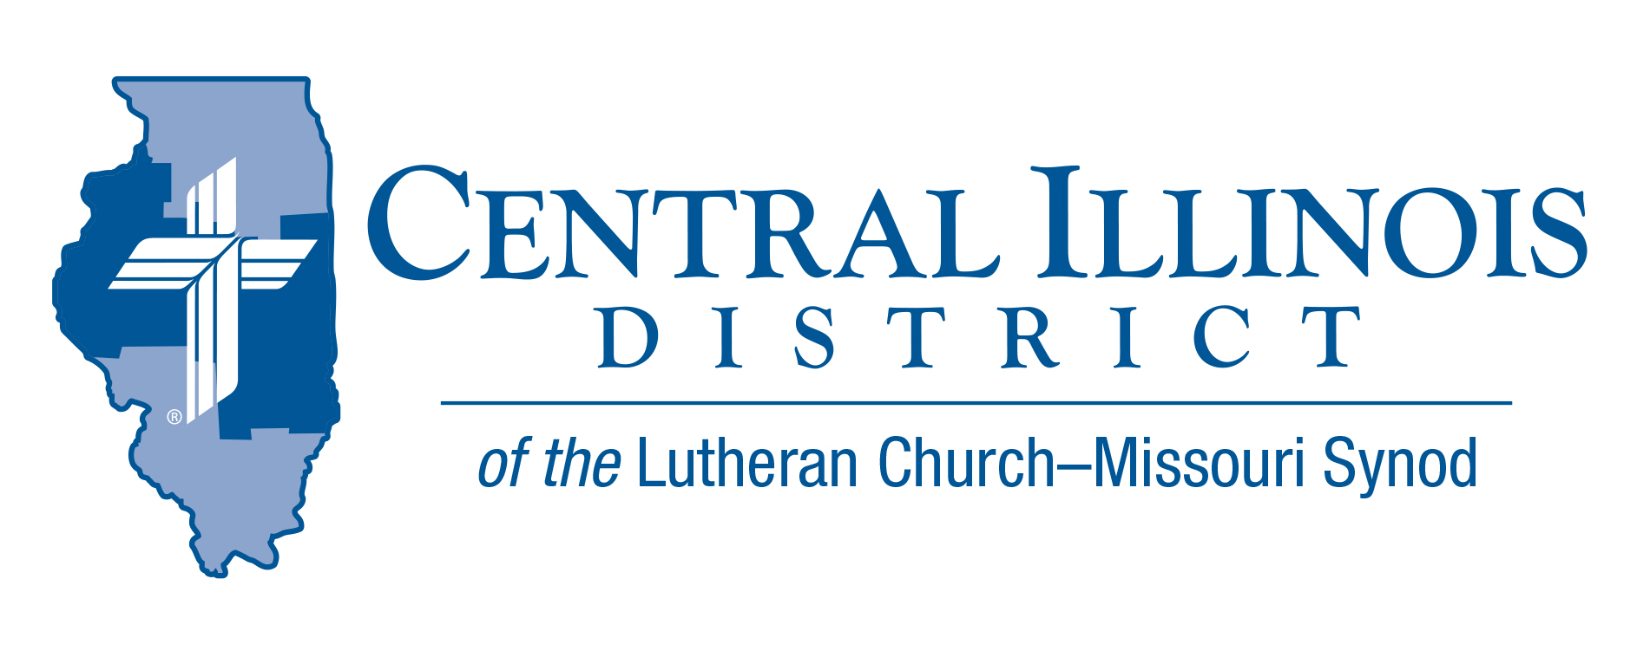
April 2021 mid-month
News You Can Use
“Why Not Me?

“Here I am dying of cancer while wicked people are living healthy and happy lives!” Joan exclaimed in frustration. Many godly people who suffer pain, loss, or misfortune ask, “Why doesn’t God help me the same way as he helps others?”
Job struggled with this question. Elijah prayed in exasperation, “I have been very jealous for the Lord , the God of hosts…and I, even I only, am left, and they seek my life, to take it away.” 2 Kings 19:10. There are no easy answers to the question.
Luther gives us good advice: “If you cannot understand how…then grant the Holy Spirit the honor of being more learned than you are.” (What Luther Says Vol.1 p.93)
How terrible it would be if God knew only what we know! His promises would be contingent on an unknown future. He could not have devised and implemented the wondrous plan of salvation accomplished through a virgin birth and Christ’s resurrection.
God has not promised that we will live 100 years, or have great wealth and possessions. He has promised us greater things than these: to be with us always; to guide and comfort us; to provide for our needs; to forgive us; to give us eternal life. Of these promises we can be certain. St. Paul says in 2 Cor.1:20: For no matter how many promises God has made, they are “Yes” in Christ. And so through him the “Amen” is spoken by us to the glory of God.
Life can be painful and unfair, and the wicked prosper. But God brings justice into an unjust world. We have the joy and hope that Isaiah proclaimed to a lost and hurting people: “Be strong, do not fear; your God will come, he will come with vengeance; with divine retribution he will come to save you.” Is.35:4

Rev. Jeff Harter
Stay Connected with your District
Looking for additional information visit https://linktr.ee/cidlcms or connect with the following items:
- CID’s GatePost (newsletter)
- Subscribe to the E-GatePost/News You Can Use
- Stay connect with us on Facebook and Instagram -- Central Illinois District-LCMS

ITEMS OF INTEREST TO SHARE

Recruiting Pastors and Other Church Workers
Me? In Church Work?
A convocation on church worker recruitment, particularly that of pastors, will be sponsored by the Shelby, Effingham, and Altamont Circuits at St. John Lutheran Church, Effingham on Pentecost, May 23rd, 3 to 6 p.m.
Dr. Dale Meyer, President Emeritus of Concordia Seminary, St. Louis, will be the featured guest speaker. Representatives of the seminaries, Concordia-Chicago, and Concordia-Wisconsin will be there, also folks from LCMS Ministry to the Armed Forces and Camp CILCA.
Register for this convocation by May 7 at https://stjohnslcms.net/harvest/

See the video at https://youtu.be/gpHT0EcWpAU

Connect to Disciple: Is your church currently planning for Vacation Bible School, 2021? What about your follow-up? That is, when you meet new pupils and their parents at VBS, have you plans for how they might be moved from this initial connection with your congregation to being disciples who are gathered around Word and Sacrament with you? Connect to Disciple, a module in the Synod’s re:Vitality program, can help. For more information, contact Dr. Ken Schurb at the CID office. Telephone (217) 793-1802 or e-mail kschurb@cidlcms.org

The National Lutheran Youth Workers Conference is a standalone Youth Ministry practitioner conference, but also provides a wonderful opportunity to prepare for the 2022 LCMS Youth Gathering.

- Are you planning to take a group to Houston in 2022 and want to familiarize yourself with area hotels, facilities, and restaurants?
- Are you a first-time adult leader and desire to connect with other new and seasoned adult leaders?
- Are you looking for training and networks which support your service as a youth ministry practitioner?
- Are young (high school) leaders in your congregation looking for an opportunity to sharpen their skills and meet other LCMS young leaders?

This year’s conference will be held July 11-14, 2021, at the Hyatt Regency Houston and we hope to see you there! The cost is $375 for adults and $250 for students. For more information, go to https://lcmsgathering.com/national-2021/

(Each #NATIONAL21 adult registration and guest room reservation at the Hyatt Regency provides for a complimentary adult leader registration for the 2022 LCMS Youth Gathering.)

This event is organized by LCMS Youth Ministry in Saint Louis, MO. For additional ways to connect to LCMS Youth Ministry, please visit www.lcms.org/youth.

