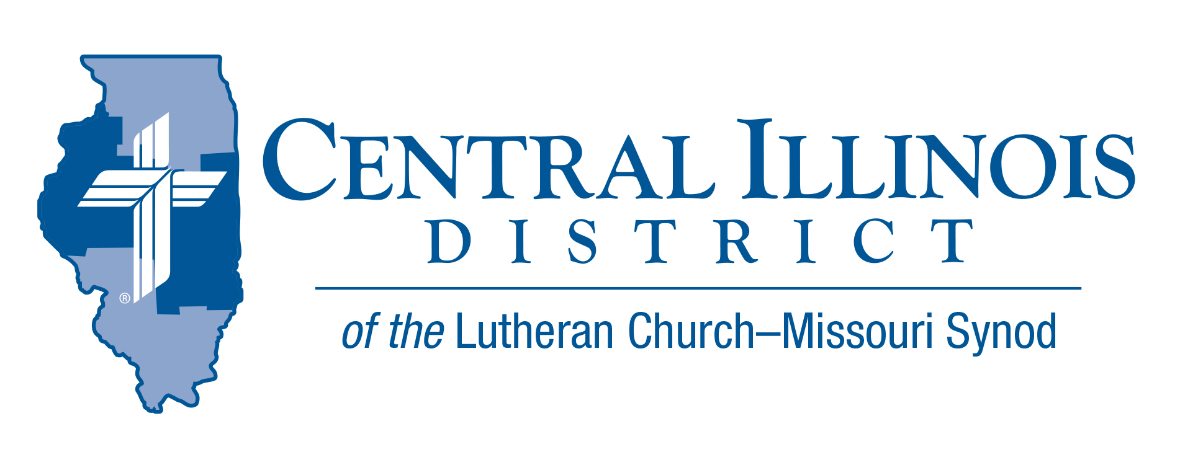
May 2021 mid-month
News You Can Use

"There is one body and one Spirit, just as you were called to one hope when you were called; one Lord, one faith, one baptism; one God and Father of all, who is over all and through all and in all". Eph 4:4-6

Spring has come to central Illinois. May is usually a time for us to return to many of our outside activities. This is especially true this year as we are starting to see many of the COVID restrictions lifted. Just as spring provides us with opportunities to be out and about, we again see the possibilities of family gatherings and celebrations. Our Lutheran Schools and Churches are planning some of our traditional spring events (Confirmation, graduations, and Vacation Bible School).

By God's design, we have realized that we are to be in communities that celebrate and fellowship with each other. God's people are to be together to worship, to celebrate life's joys and sorrows. By this design, God has placed particular individuals who support and develop our mutual Christian faith.

As spring turns into summer, our prayer is that we will continue to return to our "normal" summer activities. May God continue to bless us so that we can share Christ's Love for each other. As is stated in Ephesians 4, we have one God and Father of all, who is over all and through all and in all.

Trip Rodgers – CID Office

ITEMS OF INTEREST TO SHARE
The Great Central Illinois Campout: May 28-31, 2021
Pitch your tent with others from across Central Illinois for a weekend of swimming, fishing, canoe rides, disc golf, squishy-ball, campfire devotions, Christian fellowship, and delicious pulled pork sandwiches at the Sunday Hog Roast. Contact the camp office today to reserve a spot in the campground, a cabin, or a hotel room in the CGC.

Sunday Schedule:
10:30am ~ Matins at the Outdoor Chapel
11:15 ~ Dedication of Dining Hall
11:30-2:00 ~ Hog Roast (Adults, $8; Children, $5)
1-4pm ~ Beach open (weather permitting)
Prison Ministry Video
The CID video “Prison MinisTRY: Will You TRY?” has just been released. It aims to interest pastors and others in helping with prison ministry.
There is a lot of evangelism work that can be done with those in prisons or jails throughout Central Illinois. This evangelistic frontier can all too easily be overlooked. Let’s not overlook it!
In the new video, veteran CID Prison Chaplain Chuck Olander describes his own involvement with prison ministry. He also offers suggestions for bringing the Gospel to prisoners.
See the video from the CID website: http://www.cidlcms.org/outreach-missions-prison.html
If you have any questions about the video or about prison ministry opportunities, please contact Pastor Rod Blomquist, CID’s new Prison Ministry Coordinator, by e-mailing prisonministry@cidlcms.org

Connect to Disciple: Is your church currently planning for Vacation Bible School, 2021? What about your follow-up? That is, when you meet new pupils and their parents at VBS, have you plans for how they might be moved from this initial connection with your congregation to being disciples who are gathered around Word and Sacrament with you? Connect to Disciple, a module in the Synod’s re:Vitality program, can help. For more information, contact Dr. Ken Schurb at the CID office. Telephone (217) 793-1802 or e-mail kschurb@cidlcms.org

The National Lutheran Youth Workers Conference is a standalone Youth Ministry practitioner conference, but also provides a wonderful opportunity to prepare for the 2022 LCMS Youth Gathering. This year’s conference will be held July 11-14, 2021, at the Hyatt Regency Houston and we hope to see you there! The cost is $375 for adults and $250 for students. For more information, go to https://lcmsgathering.com/national-2021/

(Each #NATIONAL21 adult registration and guest room reservation at the Hyatt Regency provides for a complimentary adult leader registration for the 2022 LCMS Youth Gathering.) For additional ways to connect to LCMS Youth Ministry, please visit www.lcms.org/youth.

They say good things come to an end…
The Central Illinois District Church Extension Fund (CID-CEF) is Discontinuing its Growth Bond Program. The time has come for the CID-CEF to bring the Growth Bond Program to an end. Anyone who has stamps or partially-filled booklets should present them to the CID-CEF (1850 N. Grand Ave. W., Springfield, IL 62702) by December 31, 2021, for refund at face value. Growth Bonds that have not yet matured will be allowed to reach maturity value, and any Growth Bonds that have matured will be redeemed after a 60-day notification period, with an option to invest in the CID-CEF where qualified and permissible to do so. More information is on the CID-CEF website at www.cid-cef.org.

We appreciate our youth (many now adults!) who have saved their treasures to purchase the Growth Bonds in support of our churches and schools. We pray you will continue to seek out ways to support the growth of God’s Kingdom!

