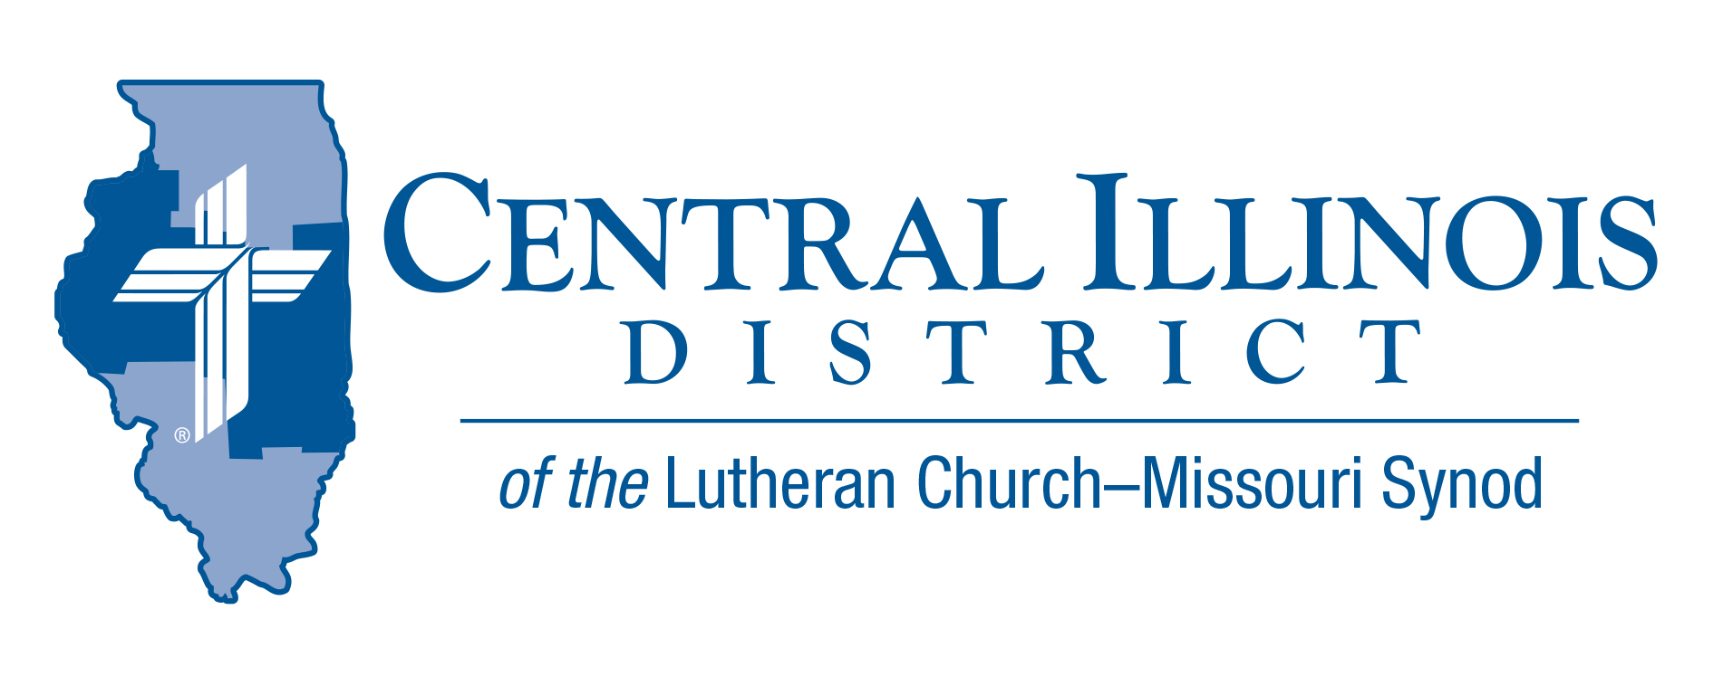
May 2021
News You Can Use

[W]e have confidence to enter the holy places by the blood of Jesus, by the new and living way that he opened for us through the curtain, that is, through his flesh... (Heb. 10:19–20 ESV)
We typically think of the Ascension from our perspective - the day that the resurrected Jesus departed from the earth and was hidden from view by the clouds. Ascension is the arrival of our victorious Lord entering the throne room of heaven to take His place as the King who conquered sin, death, and the power of the devil by His work upon the cross. Because He sits, in His flesh, upon that throne, we have confidence that we too will rise from our graves and sit in that same throne room with Him for all eternity. Join your congregation this coming Ascension, celebrating not just the departure of Christ, but His arrival - the seal and guarantee of our arrival and life with Him forever.
For where the Head is, there as well / I know His members are to dwell / when Christ will come and call them. (LSB #492:1)

Rev. Michael Mohr Holy Cross Lutheran Church- Vandalia, IL

Pray For Our Central Illinois District Missions supported by your church’s Mission Dollars to the District “Finally, brothers, pray for us, that the Word of the Lord may spread rapidly and be honored.” Please remember in your prayers all our CID campus ministries, especially Rev. Kenneth Hoover and Immanuel Lutheran Church in Charleston, serving students, faculty, and staff at Eastern Illinois University. And pray for the “Keeping Christ on Campus campaign,” building endowments to help CID support our campus ministries.

ITEMS OF INTEREST TO SHARE
The Great Central Illinois Campout: May 28-31, 2021
Pitch your tent with others from across Central Illinois for a weekend of swimming, fishing, canoe rides, disc golf, squishy-ball, campfire devotions, Christian fellowship, and delicious pulled pork sandwiches at the Sunday Hog Roast. Contact the camp office today to reserve a spot in the campground, a cabin, or a hotel room in the CGC.

Sunday Schedule:
10:30am ~ Matins at the Outdoor Chapel
11:15 ~ Dedication of Dining Hall
11:30-2:00 ~ Hog Roast (Adults, $8; Children, $5)
1-4pm ~ Beach open (weather permitting)
Recruiting Pastors and Other Church Workers Me? In Church Work?
A convocation on church worker recruitment, particularly that of pastors, will be sponsored by the Shelby, Effingham, and Altamont Circuits at St. John Lutheran Church, Effingham on Pentecost, May 23rd, 3 to 6 p.m.
Dr. Dale Meyer, President Emeritus of Concordia Seminary, St. Louis, will be the featured guest speaker. Representatives of the seminaries, Concordia-Chicago, and Concordia-Wisconsin will be there, also folks from LCMS Ministry to the Armed Forces and Camp CILCA.
Register for this convocation by May 7 at https://stjohnslcms.net/harvest/
See the video at https://youtu.be/gpHT0EcWpAU

Prison Ministry Video
The CID video “Prison MinisTRY: Will You TRY?” has just been released. It aims to interest pastors and others in helping with prison ministry.
There is a lot of evangelism work that can be done with those in prisons or jails throughout Central Illinois. This evangelistic frontier can all too easily be overlooked. Let’s not overlook it!
In the new video, veteran CID Prison Chaplain Chuck Olander describes his own involvement with prison ministry. He also offers suggestions for bringing the Gospel to prisoners.
See the video from the CID website: http://www.cidlcms.org/outreach-missions-prison.html
If you have any questions about the video or about prison ministry opportunities, please contact Pastor Rod Blomquist, CID’s new Prison Ministry Coordinator, by e-mailing prisonministry@cidlcms.org

Connect to Disciple: Is your church currently planning for Vacation Bible School, 2021? What about your follow-up? That is, when you meet new pupils and their parents at VBS, have you plans for how they might be moved from this initial connection with your congregation to being disciples who are gathered around Word and Sacrament with you? Connect to Disciple, a module in the Synod’s re:Vitality program, can help. For more information, contact Dr. Ken Schurb at the CID office. Telephone (217) 793-1802 or e-mail kschurb@cidlcms.org

The National Lutheran Youth Workers Conference is a standalone Youth Ministry practitioner conference, but also provides a wonderful opportunity to prepare for the 2022 LCMS Youth Gathering. This year’s conference will be held July 11-14, 2021, at the Hyatt Regency Houston and we hope to see you there! The cost is $375 for adults and $250 for students. For more information, go to https://lcmsgathering.com/national-2021/

Are you planning to take a group to Houston in 2022 and want to familiarize yourself with area hotels, facilities, and restaurants? Are you a first-time adult leader and desire to connect with other new and seasoned adult leaders?

(Each #NATIONAL21 adult registration and guest room reservation at the Hyatt Regency provides for a complimentary adult leader registration for the 2022 LCMS Youth Gathering.)

