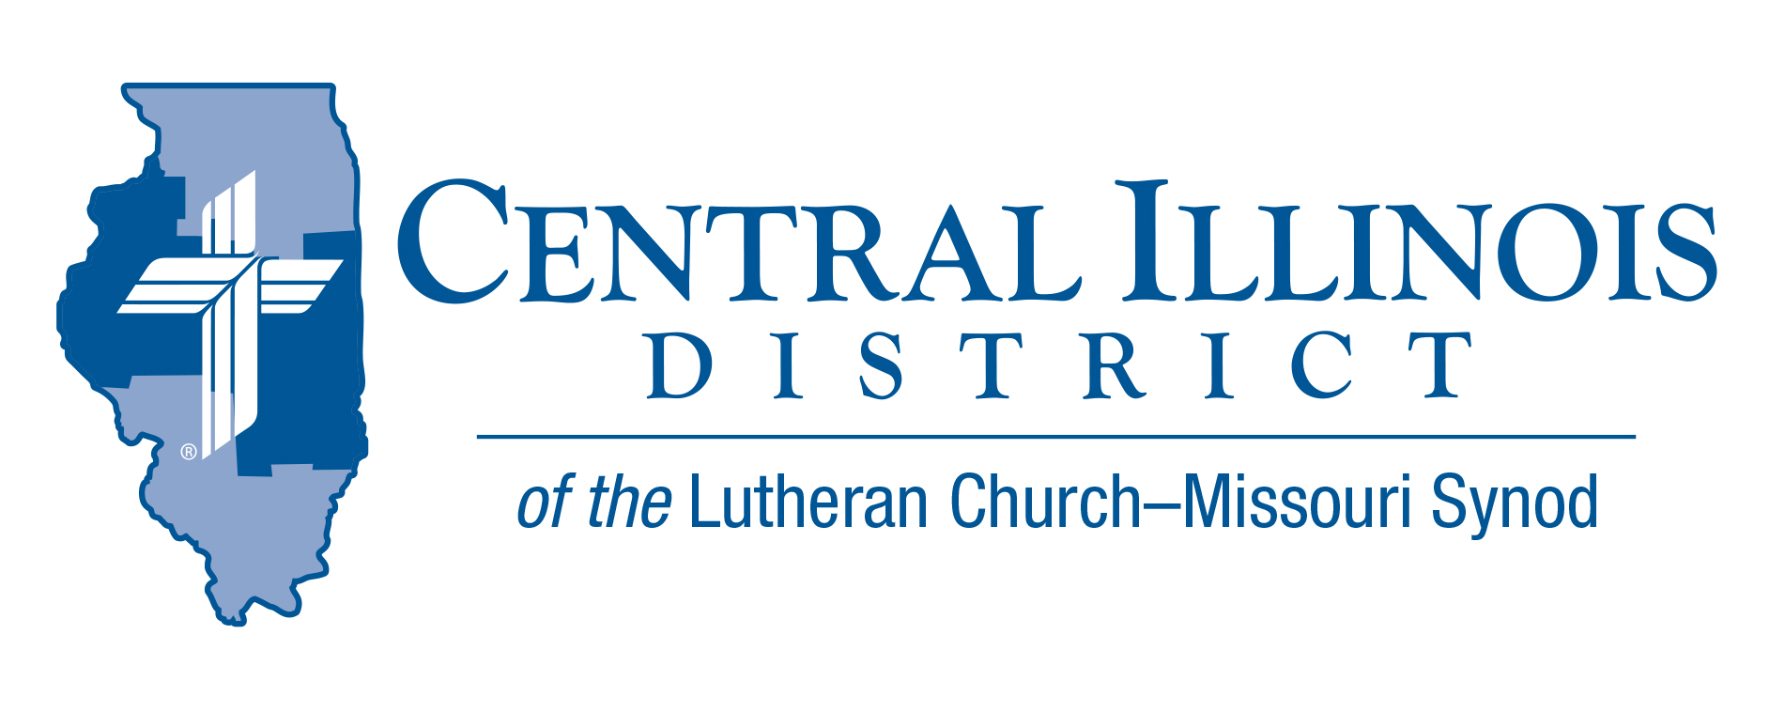
August 2021 mid-month
News You Can Use

Uplifted Hands
Moses' hands grew weary, so they took a stone and put it under him, and he sat on it, while Aaron and Hur held up his hands, one on one side, and the other on the other side. So his hands were steady until the going down of the sun. And Joshua overwhelmed Amalek and his people with the sword. Exodus 17:12-13

Life can sometimes feel like a battle. This is true especially for Christians who are trying to honor the Lord by serving others and by proclaiming the Gospel. This is also true for pastors and other professional ministers in our Lutheran churches and schools. The world considers Christians to be intolerant, narrow minded, and out of touch with reality. We can become weary from always “swimming upstream” against the currents of popular opinion and world philosophies.
It is important to remember that Jesus already fought and won the battle against sin and the devil. All we must do is stand (Eph.6). The devil cannot harm us. Yet, still at times, we need people like Aaron and Hur to hold up our hands and the hands of God’s professional workers so they can continue to bless us with God’s Word.
In Exodus 17 we see the account of when Aaron and Hur stood with Moses while Moses blessed the people of Israel as they fought against the army of Amalek. As long as Moses held his hands up in blessing, the Israelites were winning. If he lowered his hands, they began to lose. So Aaron and Hur stood beside Moses and held up his hands.
Are there any “Aarons” and “Hurs” in your congregation? If so, praise God and thank them for their service. If you are an Aaron or a Hur, never forget how important you are! God may be using you to uplift your pastor and other workers so they can continue to bless your congregation and/or school with the powerful and life-giving Word of God.

Rev. Jeff Harter

Stay Connected with your District
Looking for additional information visit https://linktr.ee/cidlcms or connect with the following items:
- CID’s GatePost (newsletter)
- Subscribe to the E-GatePost/News You Can Use
- Stay connect with us on Facebook and Instagram -- Central Illinois District-LCMS
ITEMS OF INTEREST TO SHARE

Lutheran Laymen’s League Retreat
Saturday September 11th
Camp Cilca – 4124 Camp CILCA Road, Cantrall, IL.
9:00 am- 2:00 pm Doors Open at 8:00 am

Topic: How Critical Race Theory and Wokism Are Their Own Religion
Speaker: Dr. Russell Dawn – President Concordia University- Chicago
$15.00 per person includes Lunch (children are free)

For Registration Information please reach out to Deloris Blessmann (deloriblessman@yahoo.com) or by phone 309.361.1461

Receptionist/Office Assistant – The Central Illinois District Office in Springfield is STILL seeking a qualified individual to fill this position on a part-time basis. Hours are flexible. Starting wage is $15/hr. for a 20-hour work week. There are no benefits being offered. The successful applicant will have a background in Microsoft Office, especially, Outlook, Word, and Excel. Will also coordinate Social Media for CID (Facebook, Twitter). For a job description or questions, contact mmiller@cidlcms.org. Applications are available through the CID Office during regular hours 8 am until 4 pm or can be sent by email by request.

St. John's Fish Fry – Monday, August 30, 4:30 to 7 pm, St. John's Lutheran Church of Bath, Illinois (for Google Maps, search 13961 E CR 1100N): The menu will include breaded Walleye, Catfish fillets, Chicken Strips, and Home fries as well as Cole Slaw, baked beans and deserts. The cost is a donation of your choice. Donations will be forwarded to Lutheran Legacy Foundation for the support of campus ministries in the Central Illinois District. Donations such as this are being matched dollar-for-dollar up to a total of $20,000 by Lutheran Legacy through July 1, 2022.

The Camp CILCA Chicken Fry and Auction will be held Sunday, Sept. 5. Dinner is served from 11:30-2:30. Cost is $8 for adults and $5 for children ages 4-12. The live auction begins at 1pm with a wide variety of items, including gift baskets, weeks of summer camp, a guided youth hunt, and more. Check out all the items at cilca.org/auction-items.

LCMS Youth Gathering Adult Leader Training All adult leaders are invited to participate in an afternoon training on August 28th from 1-2:30pm at Bethel Lutheran Church in Morton, IL. This training will cover Gathering basics, travel tips, fundraising strategies, how to pick your adult leader team, and Q&A with veteran Gathering leaders! Please RSVP to jonathan@bethelmorton.org if you plan to join!

Save the Date:
CID Junior High Lock in
November 12-13th 2021 Five Point – Washington, IL
CID- District Convention (moved to 2022)
July 17- 19, 2022 Crowne Plaza- Springfield, IL

