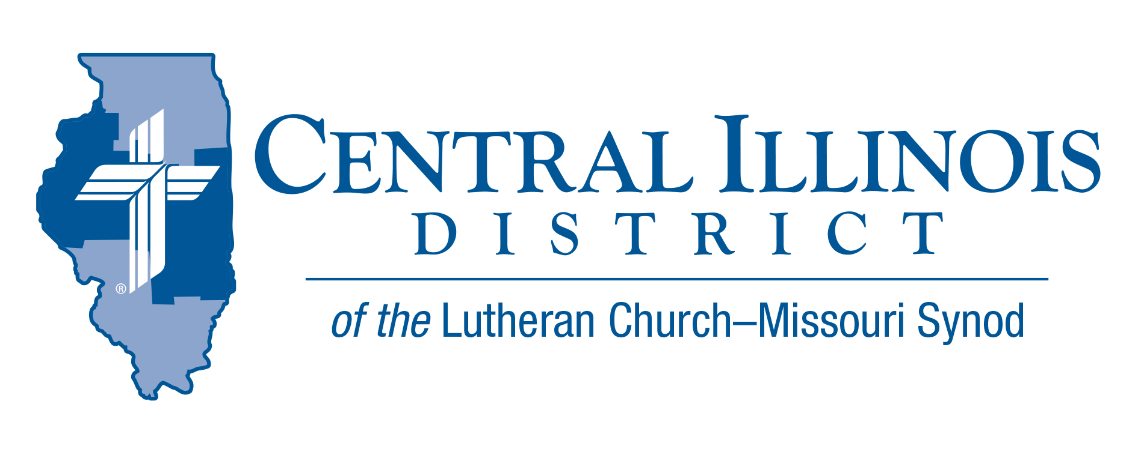
March (Midmonth) 2022
News You Can Use
Sin: A Hole In Our Boat!
“There but for the grace of God go I,” said 16th century reformer and martyr, John Bradford. God graciously leads us around temptation and delivers us from evil. In response to our humble repentance in Christ, our sins are washed away and our just punishment is placed on Christ.
However, no one is less a sinner or more deserving of temporal and eternal punishment than any of us. Jesus warns all who think they deserve God’s favor. “Or those eighteen on whom the tower in Siloam fell and killed them: do you think that they were worse offenders than all the others who lived in Jerusalem? No, I tell you; but unless you repent, you will all likewise perish.” (Luke 13:4-5) We dare never become like the prodigal son’s elder brother who harbored sinful pride in his heart. He sinned as greatly as his brother!
Sin is like a hole in our boat. If I were in the middle of a large, deep lake and had a hole in my boat I would need to fix it or get rescued. The size of the hole is not an important point. With no means to fix it and no one to rescue me, I am going to sink. It would make no sense for me to imagine that if my hole is smaller than someone else’s I am safe. God tells us in James 2:10 “Whoever keeps the whole Law and yet stumbles at just one point is guilty of breaking all of it.” Our good deeds cannot fix the hole, In fact, if we depend on them to fix the hole our situation becomes even worse! St. Paul warns us in Galatians 5:4 “You who are trying to be justified by law have been alienated from Christ; you have fallen from grace.”
So, what shall we do? We must recognize by faith that Jesus is in the boat with us. Jesus repairs the hole by his grace. He bails out the stagnant water of sin. He steadies our boat and keeps it afloat during the most violent storm. We can look to our destination of heaven and confidently say, “There, by the grace of God, go I!” And we can sing: “When at last I near the shore And the fearful breakers roar Twixt me and the peaceful rest, Then, while leaning on Thy breast, May I hear Thee say to me, ‘Fear not, I will pilot thee.’”

God bless!! Rev. Jeff Harter

ITEMS OF INTEREST TO SHARE
60th Regular Convention Central Illinois District July 17-19, 2022
Crowne Plaza Springfield, Illinois (additional information of the CID website under the News and Events tab.(http://www.cidlcms.org/events-2022-district-convention.html)

Spring (Church) Planting Season
At its last convention, our Synod resolved “That congregations and circuits be encouraged and supported by their respective districts to investigate and identify new mission plants” (2019 Res. 1-02).
To enable pastors and others to begin talking about church planting, CID is cooperating with the Synod’s Office of National Mission to produce these resources: a.) a brochure, in two parts and b.) a set of four short videos. These tools will help inform and stimulate church plantings conversations in congregations. For more information visit: http://www.cidlcms.org/outreach-church-planting.html
Congregations are urged to use these tools during May, a month we might call “Spring (Church) Planting Season”. Talk church planting at Bible classes on four of the five Sundays in May. Devote time at a regularly scheduled meeting to a discussion of church planting. Hold a special meeting for such discussion. Or encourage church members to view the videos and read the brochure, then talk amongst themselves.
The District will be discussing church planting at its convention in July. Why not “prime the pump” via congregation-level conversations during May?
On a related note, over the next year or so CID Mission Executive Ken Schurb and his predecessor Joel Cluver are attempting, between them, to visit every Circuit Winkel in the District to encourage discussion of church planting prospects. Central Illinois Church Extension Fund has generously given CID a grant to help pay for these visits. It will also pay for subsequent visits to congregations showing particular interest in church planting.

LERT Training – Basic Class Participants will be introduced to the LCMS Disaster Response program and learn the basic nature of a nature of a disaster, the opportunities to respond to personal needs in such disasters and how a Christians can support families, congregations, and the public, as the hands and feet of Jesus during trying times.
- Location: Trinity Lutheran Church (1201 West Jackson, Auburn)
- Date: May 21, 2022 ( 9:00 am – 3:00 pm) (registration 8:00 – 8:30 am
- Cost: $35.00 per person (includes: continental breakfast, lunch, training materials, certification, and LERT T-shirt) Checks should be made out to Trinity Lutheran Church
- For Additional information see the following website: https://www.lcms-lert.org/need/detail/?need_id=668961
Celebrate the 175th anniversary of the LCMS! April 26, 2022
Visit the following website for information on the 175th anniversary of Synod. http://www.cidlcms.org/news-lcms-175.html

Anniversary Hymn Sing
Trinity Lutheran in Springfield is hosting a hymn sing to highlight the works of LCMS composers and lyricists in celebration of the 175th anniversary of the LCMS. All are invited to come on Sunday, May 1st at 3:30pm to Trinity Lutheran Church at 220 S. Second St. Springfield, IL. We will raise our voices to praise God and hear from the Trinity Wind Ensemble for musical interludes between hymns.

