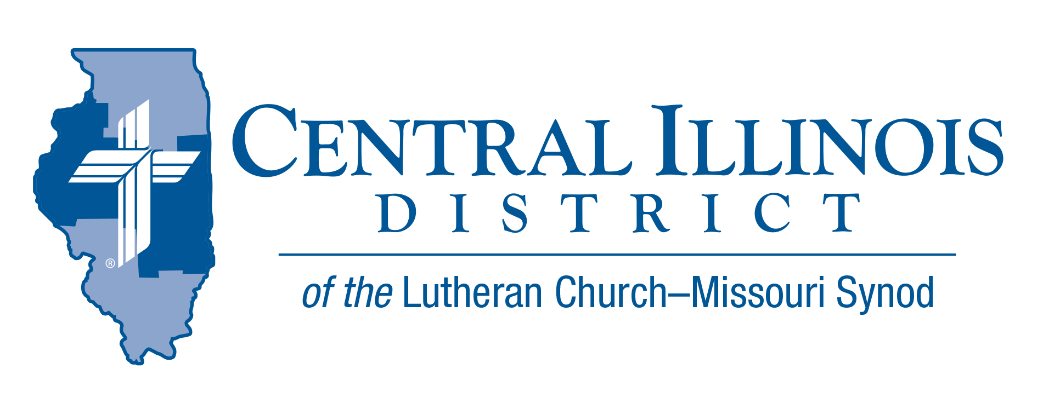
March 2022
News You Can Use
“Speaking the truth in love” (Eph. 4:15) is always a necessity. Just as our brains need to receive true inputs from all our senses in order to tell the body to respond to the world properly, so all the members of the Church, the body of Christ, need to speak the truth to one another, so that we all have correct information to respond to one another in love. And the people of the world need us to speak the truth to them, because they are hearing many untruths from scammers, advertisers, the media, government leaders, and unfaithful religious leaders. We need to speak the truth “in love,” because we do not want to use the truth as a weapon against anyone except the devil and his allies. “We do not wrestle against flesh and blood, but against principalities, against powers, against the rulers of the darkness of this age, against spiritual hosts of wickedness in the heavenly realms” (Eph. 6:12). So we use the strongest weapon against Satan that we know: “the sword of the Spirit, which is God’s word” (Eph. 6:17). God’s “word is truth” (John 17:17). Pray that He will keep all of our words true. We know that when we speak God’s word correctly, in the situations to which God’s Word applies, we will be speaking the truth of God, who loved the world, demonstrating that love not only in words, but by sending His Son to die for us and for our salvation (John 3:16; Rom. 5:8). We want that truth to set people free from slavery to sin and the tyranny of the devil. Jesus taught us how to speak the truth in love: “If you remain in My word, you are truly My disciples, and you will know the truth, and the truth will set you free” (John 8:31-32). Grant this, Lord, unto us all!

Rev. Mark Eddy – Zion Lutheran Church- Taylor Ridge, IL

Pray For Our Central Illinois District Missions supported by your church’s Mission Dollars to the District. “Finally, brothers, pray for us, that the Word of the Lord may spread rapidly and be honored.”
Please remember to thank God for outreach with the Gospel in Spanish at St. John’s Lutheran Church, Beardstown. Pray for community liaison Maria Guijosa.

Stay Connected with your District
Looking for additional information visit https://linktr.ee/cidlcms or connect with the following items:
- CID’s GatePost (newsletter)
- Subscribe to the E-GatePost/News You Can Use
- Stay connect with us on Facebook and Instagram -- Central Illinois District-LCMS
Did you Know that the 175th Anniversary of the Lutheran Church Missouri Synod is April 26th, 2022
ITEMS OF INTEREST TO SHARE
60th Regular Convention Central Illinois District July 17-19, 2022
Crowne Plaza Springfield, Illinois (additional information of the CID website under the News and Events tab.(http://www.cidlcms.org/events-2022-district-convention.html)

- Before March 10th, once you have chosen your congregational lay delegate, please send that name to the District Office at cid@cidlcms.org so that we will have a pool from which to select floor committee members.
Spring (Church) Planting Season
At its last convention, our Synod resolved “That congregations and circuits be encouraged and supported by their respective districts to investigate and identify new mission plants” (2019 Res. 1-02).
To enable pastors and others to begin talking about church planting, CID is cooperating with the Synod’s Office of National Mission to produce these resources: a.) a brochure, in two parts and b.) a set of four short videos. These tools will help inform and stimulate church plantings conversations in congregations. They should be available about Easter time, in mid-April, if not before.
Congregations are urged to use these tools during May, a month we might call “Spring (Church) Planting Season.” Talk church planting at Bible classes on four of the five Sundays in May. Devote time at a regularly scheduled meeting to a discussion of church planting. Hold a special meeting for such discussion. Or encourage church members to view the videos and read the brochure, then talk amongst themselves.
The District will be discussing church planting at its convention in July. Why not “prime the pump” via congregation-level conversations during May?
On a related note, over the next year or so CID Mission Executive Ken Schurb and his predecessor Joel Cluver are attempting, between them, to visit every Circuit Winkel in the District to encourage discussion of church planting prospects. Central Illinois Church Extension Fund has generously given CID a grant to help pay for these visits. It will also pay for subsequent visits to congregations showing particular interest in church planting.

77th LWML CID Convention
The LWML CID ladies and pastors will meet in convention under the theme of "Reunited as Women in Mission", based on Hebrews 10:25a, "let us not give up meeting with each other...but encourage one another." This is the first time in two years that an in-person convention has been held.
- Pre-convention activities will be Friday afternoon, April 29th at St. John's Lutheran Church in Chatham. There will also be a Friday evening dinner, a worship service with Communion, and a presentation by Jan Struck, LWML's favorite humorous interrupter.
- The convention will be held Saturday, April 30th, at Our Savior's Lutheran Church in Springfield.
- Registration information and other materials will be mailed in early-mid March.

