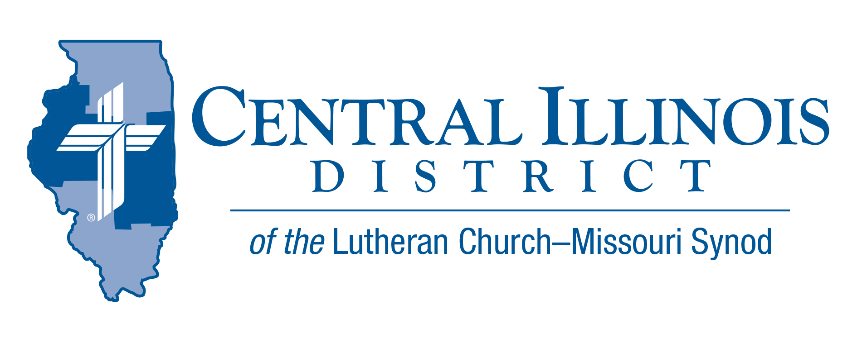
May 2022
News You Can Use

And if I go and prepare a place for you... —John 14:3a ESV

Jesus speaks of going to prepare a place for us. But Jesus came from heaven. He had been there for millennia. Why would He still need to prepare a place? Didn’t He have enough time before?

Jesus did indeed reign with the Father from before the Creation, but He needed to prepare an eternal dwelling for our flesh. His time there before His earthly ministry was entirely according to His divine nature, but the place He prepares is for our human nature. So now He takes His resurrected flesh and blood, as truly human as you or I, into the eternal realms to prepare that place where we will dwell eternally as resurrected, flesh and blood people. Rejoice, for our Lord is ascended for you!

He has raised our human nature / On the clouds to God’s right hand; / There we sit in heav’nly places, / There with Him in glory stand. / Jesus reigns, adored by angels; / Man with God is on the throne. / By our mighty Lord’s ascension / We by faith behold our own. (LSB #494:5)

Rev. Michael Mohr- Holy Cross - Vandalia, IL

ITEMS OF INTEREST TO SHARE
60th Regular Convention Central Illinois District July 17-19, 2022
May 17th (UPDATED) 2022 – Congregational Nominations DEADLINE for District President [Official Nomination Ballots have been be sent to the congregations by the District Secretary] are due at the District Office (must be postmarked by this date).

VIDEO – Prison MinisTRY: Will You Try?
In this video, CID Prison Ministry Coordinator Rev. Rodney Blomquist interviews veteran CID Prison Chaplain Rev. Charles Olander. Pastor Olander describes his route to prison ministry and his observations on its ongoing importance. He offers several suggestions for pastors and others who want to get involved in bringing God’s Word to the incarcerated.

View this video, and tell others about it! You can watch it by clicking here. (https://www.youtube.com/watch?v=xTr-JDmbN2E)

Small Church Summit
Zion Evangelical Lutheran Church, Farmersville, Illinois, is inviting members of small churches in the Central and Southern Illinois Districts to a “Small Church Summit” on St. Barnabas Day, Saturday, June 11, 2022, from 10:00 a.m. to 2:30 p.m. This free event is for both pastors and laypeople.
What is a small church? “If your church thinks of itself as small, consider yourself invited,” said Pastor Micheal Strong of Zion. “We want to encourage and help one another as Lutheran congregations.”
After opening worship and introductions, participants will talk about positive points concerning their churches as well as challenges. After lunch at the church, they will apply various positives to various challenges identified that morning and consider ways in which future small church summits might prove helpful.
Interested? Please contact the CID office: PHONE: (217) 793-1802
E-MAIL: cid@cidlcms.org

Spring (Church) Planting Season
At its last convention, our Synod resolved “That congregations and circuits be encouraged and supported by their respective districts to investigate and identify new mission plants” (2019 Res. 1-02).
To enable pastors and others to begin talking about church planting, CID is cooperating with the Synod’s Office of National Mission to produce these resources: a.) a brochure, in two parts and b.) a set of four short videos. These tools will help inform and stimulate church plantings conversations in congregations. For more information visit: http://www.cidlcms.org/outreach-church-planting.html
Congregations are urged to use these tools during May, a month we might call “Spring (Church) Planting Season”. Talk church planting at Bible classes on four of the five Sundays in May. Devote time at a regularly scheduled meeting to a discussion of church planting. Hold a special meeting for such discussion. Or encourage church members to view the videos and read the brochure, then talk amongst themselves.
The District will be discussing church planting at its convention in July. Why not “prime the pump” via congregation-level conversations during May?

Reimbursements for Prison Ministry Materials
Consider donating printed Gospel-centered materials to a nearby state or federal prison or county jail. Thanks to central Illinois LWML, you or your CID congregation can make such a donation and receive at least partial reimbursement from the District.
This is important work. The materials you donate can get into a facility even if something like a COVID spike occurs and keeps chaplains from getting in. Here is an opportunity for you to participate in prison ministry, even if you yourself never personally visit an inmate. http://www.cidlcms.org/outreach-missions-prison.html

Stay Connected with your District
Looking for additional information visit https://linktr.ee/cidlcms or connect with the following items:
- CID’s GatePost (newsletter)
- Subscribe to the E-GatePost/News You Can Use
- Stay connect with us on Facebook and Instagram -- Central Illinois District-LCMS

