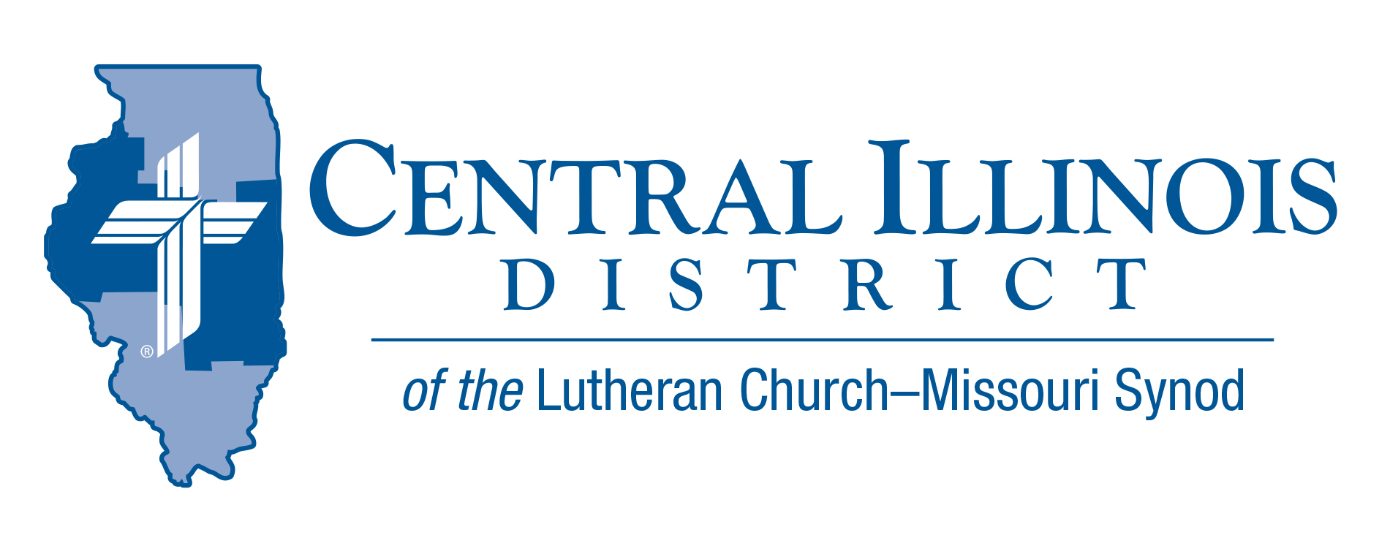
October 2022
News You Can Use

“For as the body is one and has many members, but all the members of that one body, being many, are one body, so also is Christ.” 1 Cor 12:12

The Joy of Being One Body

As I talk with people in many ministries within our District, there is one typical comment: “It is great to be back together”, whether talking about church services, sporting events, family gatherings, or congregational activities. God has created us to be in communities, to come together and celebrate life. As we continue to come out of the fog of COVID, our lives are returning to “normal”. Within God’s design, we are people that need to be together.

Maybe the blessing is that we learned that we need to be together. As our churches are returning to pre-COVID activities, some individuals have not returned or have limited their church activity. As we look around our church family, we should ask who is missing? We are one Body with Christ, but that body is missing a few parts. Some individuals may have gotten out of the “habit” of attending church. Some individuals have lost the “need” to go to church.

How do we help them get back to church? We should pray for those that are not attending church. If we know them, we should reach out and tell them that they are missed. Check with them to see if there is a situation in their life that is preventing them from being part of the church family.

As Christians, we receive many blessings within our worship services. We hear and learn about the Word of God, confess our sins, and receive forgiveness for those sins. Let us join to celebrate the benefits and the joy of being together in God’s house.

Trip Rodgers – CID office

Stay Connected with your District
Looking for additional information visit https://linktr.ee/cidlcms or connect with the following items:
- CID’s GatePost (newsletter)
- Subscribe to the E-GatePost/News You Can Use
- Stay connect with us on Facebook and Instagram -- Central Illinois District-LCMS

ITEMS OF INTEREST TO SHARE
CID BOARD OF DIRECTORS REVIEW REPORT 09/27/22

Pastor Mark Eddy welcomed all elected members of the CID Board of Directors. Those who were not present at the 2022 District Convention were installed by President Mohr. Along with his report, President Mohr also gave an opening statement conserving the tradition of theming his service as District President with a Scripture Passage: “Let it be to me according to your word” (Luke 1:38). He also gave thanksgiving to the District Staff and his predecessors in the office of District President.

CID 2023 Synodical Convention cost was set at $2.85 per communicant member. Guidelines & Resources for Ministries Receiving CID Mission Funding were approved. Dollars For Mission funding procedures were approved so that congregations could begin making requests for DFM. CID 2022 Convention Proceedings were approved. The seven District Commission Committees were filled. Administrative Assistant Mr. Trip Rodgers was reappointed for the next three years.

The Next CID Board of Directors meeting was set for Nov. 29, 2022 at 9 am.

Fall CID Junior High Youth Event
We're changing things up this year for the Jr. High Event! Join us on Saturday, November 12 at St. Paul's Lutheran Church (Decatur, IL) from 9:30a-4:30p for a day of service, music, time in the Word, and fun, including inflatables, nerf war, games, and food! Pizza lunch will be provided!

The cost is $20.00 per person (includes lunch and T-shirt) Non -members can be invited by your students to attend for free. Their cost will be covered by our Church Extension Fund.

Use the link below to register by October 21st! https://cidyouth.weebly.com/

A Dollar for Missions (DFM)
December 1, 2022 is the deadline by which congregations or groups of congregations can propose projects for CID “Dollar for Missions” funding during 2023. For further information, contact Ken Schurb, kschurb@cidlcms.org CID urges congregations to begin gathering DFM funds in January, 2023. See www.cidlcms.org/ministry-stewardship.html

Small Church Summit:
Zion Evangelical Lutheran Church, Farmersville, Illinois, invites members of small churches in the Central and Southern Illinois Districts to the second “Small Church Summit” on the day after Epiphany, Saturday, January 7, 2023 from 10:00 a.m. to 2:30 p.m. (“Snow date” is Jan. 14.) This free event is open to all. It will work best for your church to send your pastor and one to three laypeople. See CID-GatePost for additional information.

