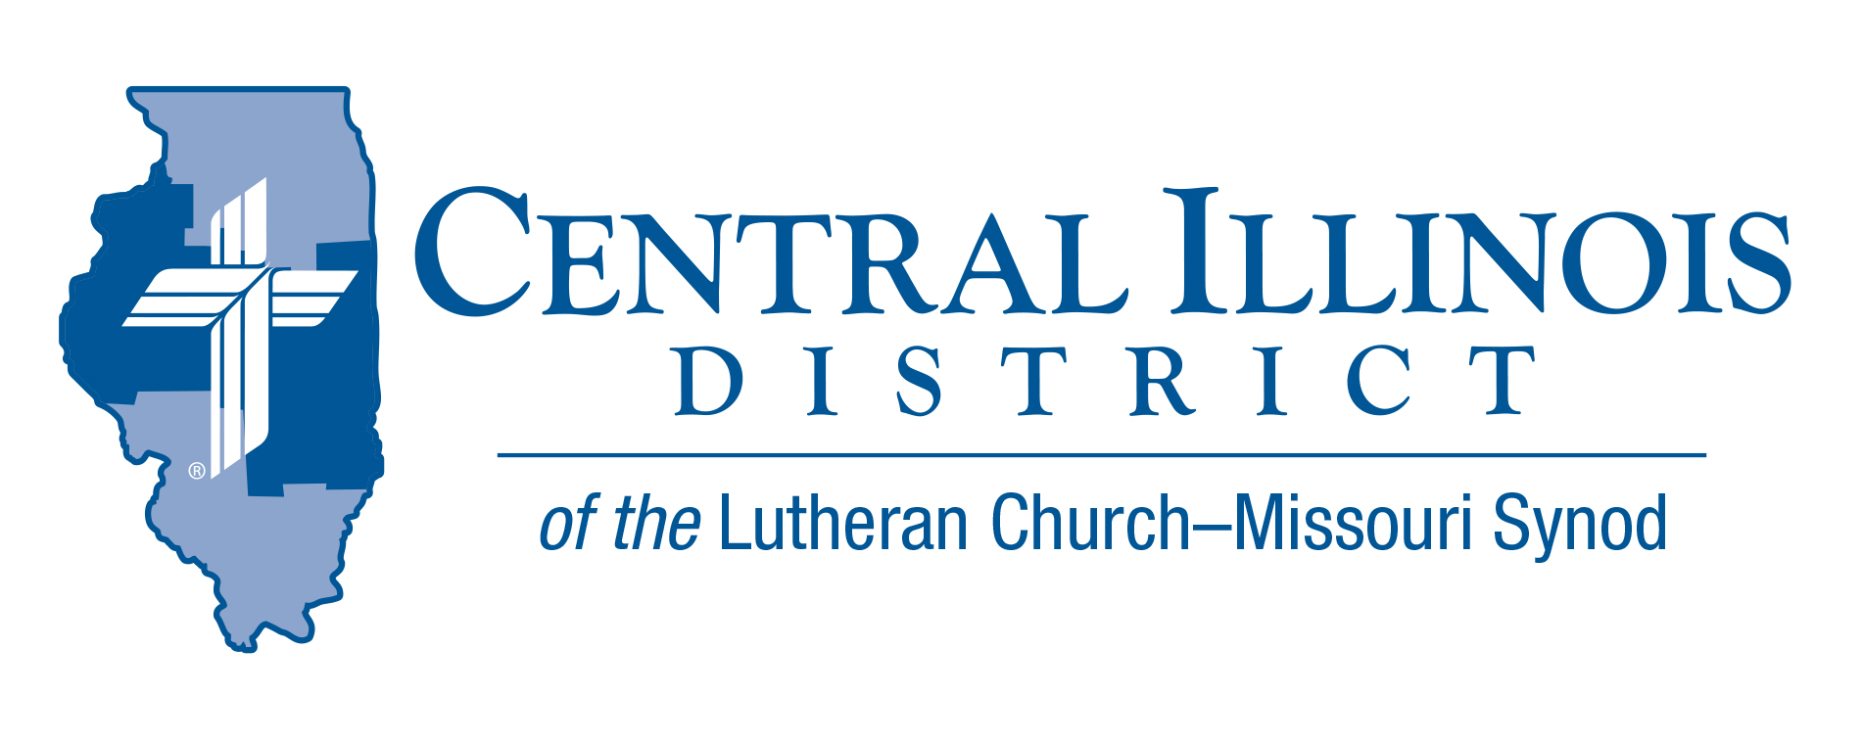
April 2023 mid-month
News You Can Use
The Easter acclamation “Christ is risen! He is risen, indeed! Alleluia!” are welcome words of joy and comfort in concert with Jesus’ promise, “Because I live, you also will live.” (Jn. 14:19)

Pray For Our Central Illinois District Missions supported by your church’s Mission Dollars to the District. “Finally, brothers, pray for us, that the Word of the Lord may spread rapidly and be honored.” Please remember in your prayers the outreach of Christ Lutheran Church for the Deaf and Pastor Tom Phillips. Pastor Phillips is our CID missionary to the deaf. He serves in Jacksonville but also spans the District to bring the Good News about Jesus to the hearing-impaired.

Items of Interest to Share
Lutheran Heritage Foundation
FREE RESOURCES: Do you know someone who doesn’t speak English as a first language, and you want to introduce them to the Savior? Check out the Lutheran Heritage Foundation’s database of free Lutheran books, translated into more than 140 languages worldwide! Resources include children’s Bible storybooks (often also suitable for adults with lower literacy levels), Luther’s Small Catechism, and devotion booklets in languages like Spanish, Chinese, Hindi, and Swahili – all available at no cost to the ministries, short-term mission teams, and individuals who need them. Search the LHF Publication List at www.LHFmissions.org/Publications.

Prison Ministry Materials: Consider donating printed Gospel-centered materials to a nearby state or federal prison or county jail. Thanks to Central Illinois LWML, you or your CID congregation can make such a donation and receive up to $400 reimbursement from the District. (This reimbursement amount has been raised from $200.) See the voucher, guidelines, and list of approved materials at http://www.cidlcms.org/resources/outreach/Vouchers%20and%20Guidelines.pdf

Keeping Christ on Campus: Lutheran Legacy Foundation of Paris, Illinois, has announced that it will make additional financial gifts to match YOUR monetary contributions to endowments funds that support CID’s four established campus ministries: at U. of I., ISU, EIU, and WIU. Lutheran Legacy is now providing a 20% match. If you contribute five dollars to one of these endowment funds, your gift will amount to six dollars! For additional information, see http://www.cidlcms.org/outreach-missions-campus.html

Central Illinois District Scholarship Sunday- May 7, 2023
Fifteen students (10 seminarians, one deaconess, and four undergraduate students) were given grants by our CID Scholarship Committee this year. Thanks to substantial gifts given by the Seider Scholarship Endowment, the CID LWML, and our CID Scholarship Endowment Fund, as well as many generous gifts given by faithful Lutherans like you, $105,500 was awarded to help offset $327,347 worth of unmet financial needs. Unmet needs are the student's responsibility after scholarships, grants, parental assistance, expected congregational gifts, and the like are subtracted from the total cost of education.

You can help ease their burden with your gift to the Central Illinois District Scholarship Sunday appeal. By indicating on your, “Will They Always Be There?” envelope or on your check, you can direct all or part of your gift to go toward helping our 2023-2024 students by designating “CID Scholarship Fund,” or you may choose to make a gift to the “CID Scholarship Endowment Fund.” The income from the CID Endowment Fund will be used to make need-based grants to our students for years to come.

The special “Will They Always Be There?” envelopes are available at your church, or you may send your gift directly to the Central Illinois District Scholarship Fund, 1850 N. Grand Avenue West, Springfield, IL 62702-1626.

Once again, I want to stress the importance of providing these need-based grants to our CID students attending our seminaries and Concordia Universities as they prepare for careers in full-time church work. The ever-increasing cost of education is creating enormous education debt for many of these servants of God. Together, our generosity may be the difference that allows some of them to continue their studies and helps relieve the burden of their educational debt.

If you are considering a major gift, a gift of appreciated assets, or a gift through your estate, you may contact CID Planned Gift Counselor. Rev. Charles Olander, at (217) 416-8842 or by email at c-olander@msn.com for assistance. Thank you.

LERT Chainsaw Training Event
To be held at: St. Peter’s Lutheran Church
200 Cole Street
East Peoria, Illinois 61611
Saturday, May 20, 2023. 9:00 am to 5:00 pm
The registration fee ($35.00) will include breakfast and lunch.
You must be a certified LERT member to attend this class.

If you are already LERT chainsaw certified, the event is considered continuing education (no charge).
Chainsaw Training Registration Online Link:
Please click on the link below or copy and paste and complete the entire registration form .https://www.lcms-lert.org/need/detail/?need_id=785803

