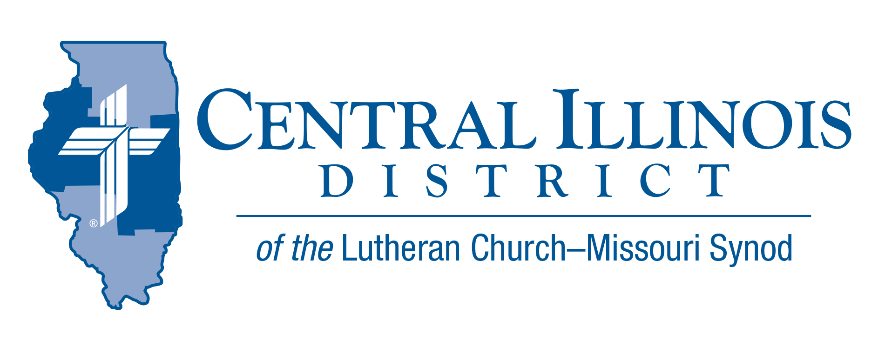
Be Content and Thank God
February 2023
News You Can Use

“Give us this day our daily bread” is the fourth petition of the Lord’s prayer. This petition is preceded by three petitions asking for spiritual blessings and is followed by three petitions asking for deliverance. Here again, the Lord is teaching us to seek first the kingdom of God and then the material stuff, everything that has to do with the support and needs of the body, will be given to you as well.
By nature, our sinful nature, people often want to put material things first, before spiritual blessings, then worry about not having enough, not getting enough, or not being able to keep what they already have. Although scripture teaches us to be content with the food and clothing that God has provided for us today, many people spend their lives trying to accumulate what they cannot keep when God calls them from this life. Contentment is often illusive for those who are caught up in the relentless call of marketing: you must pursue all that is “newer, better, faster.” Looking at what one does not have, the reality of what one does have is obscured.
So today I ask you to look at how greatly God has blessed you and be content. Two hundred years is a very short span of time compared to all the time since Adam and Eve. Yet, even most of the poorer people who live among us in this country, the people who live in the projects, on government assistance or in poverty, still live better than kings did 200 years ago. Whether it is transportation, medicine, entertainment, sources of knowledge and education, food quality, clothing, or almost every other aspect of daily bread we have it really good today in this country.
Be careful not to grumble for God is the giver of every good and gracious gift and your grumbling brings into question your thankfulness and trust in God who is the source of every good and gracious gift. Instead, be thankful and full of praise to God who has blessed you in Christ with forgiveness of sins, life and salvation. Pray earnestly that God will provide for those in need, and look to your abundance as a source of blessings that God will use to bless the needy. May God bless you and bless others through you. Share your daily bread and share your faith with your neighbor who is in need, for your heavenly Father shared His son in order to share His kingdom with you.
Rev. Charles Olander CID Planned Gift Counselor

Pray For Our Central Illinois District Missions supported by your church’s Mission Dollars to the District. “Finally, brothers, pray for us, that the Word of the Lord may spread rapidly and be honored.”
Please remember in your prayers all our CID campus ministries, especially Rev. Kenneth Hoover and Immanuel Lutheran Church in Charleston, serving students, faculty, and staff at Eastern Illinois University. And pray for the “Keeping Christ on Campus campaign,” building endowments to help CID support our campus ministries.

ITEMS OF INTEREST TO SHARE

CID BOARD OF DIRECTORS REVIEW REPORT 01/24/23
The CID January Board of Directors began with their continued devotion on 1 Peter. Rev. Bill Jensen gave a Mission Presentation, Campus Ministry Pastor at Illinois State University, in which he summarized their 2023-2024 school year theme: “Our Talking God.” Reports were given by President Mohr, Mrs. Chris Andersen (CID CEF), Rev. Olander (Gift Planning Counselor), Mr. Trip Rodgers (Congregational Life and Education), and Rev. Schurb (Mission, Stewardship, Evangelism, and Human Care). “Beyond the Classroom” was further explained as a module presented by Trip Rodgers and Rev. Schurb to help train congregations and schools to reach out to unchurched families in school communities. Look for dates and locations for training in your area. Mr. Joel Oschwald was welcomed as our new CID treasurer and gave initial remarks and commitments to CID.

The action was taken to approve the purchase an updated security system at the District Office. The BoD also approved a drafted overture to send to the 2023 Synodical Convention: “To Reorganize the Synod’s Higher Education” (not including Seminaries).

Following the procedures for Dollars for Missions Funding, all of the submitted DFM requests were approved. They are:
  - Immanuel Lutheran Church, Springfield: Delayed Vicar (2023-2024)
  - St. John Lutheran Church, Beardstown: Spanish-speaking delayed Vicar (2023-2024)
  - University Lutheran Church, Champaign: for purchase of 12-passenger van
  - Prison Ministry: Rev. Olander increase stipend for weekly visits
  - Prison Ministry: Payments for other pastors to visit (4) new prisons/jails (2024)
  - Budgeted CID mission efforts
President Mohr and Rev. Schurb will give specification to the ways DFM can support budgeted CID missions.
The next CID Board of Directors meeting will be March 28th, 2023, 9am.

CID LLL District Convention
Saturday, March 4, 2023
Redeemer Lutheran Church 6801 N Allen Rd Peoria, Il 61614
Doors Open at 8:00 am. Convention Begins at 9:00 am
Cost: $25.00 per person (includes Lunch). Checks payable to CID LLL District. The registration deadline is February 28, 2023
For More Information, contact Deloris Blessman at delorisblessman@yahoo.com.

