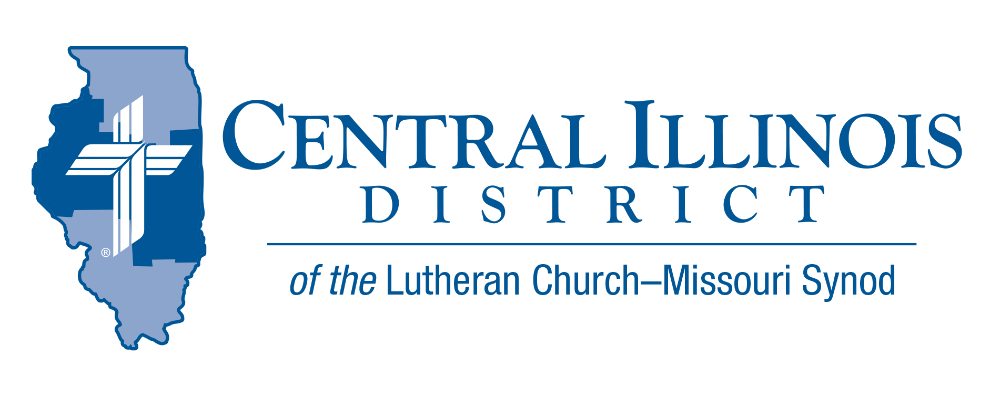
June 2023
News You Can Use
What more could the disciples of Jesus have wanted or needed? For three revolutions around the sun, these men had witnessed the mighty miracles of the Christ. Jesus had spoken to them the powerful words of his “upper room” discourse in John 13–17. Each of them could give firsthand accounts of the resurrected Savior. Jesus breathed out the Holy Spirit upon them, giving them the power to forgive and retain sins (John 20:22–23). And Luke tells us that Jesus even opened their minds to understand the Scriptures! (Luke 24:45).

Surely, these men were ready to get going. Yet, even all of this was not enough. “Stay in the city until you are clothed with power from on high” (Luke 24:49). When that day came, fulfilling Joel 2:28–29 and Isaiah 32:15, those disciples were made ready, by God’s grace and power. The same Spirit has been given to you in Holy Baptism. Comfort and peace in the forgiveness of sins as won by Jesus on the cross is yours, as is the power to share that Gospel with family, friends, and neighbors. “Clothed with power from on high.” That defines you forever through Baptism into Christ. There is nothing more you could want or need.

Pastor Jeff Caithamer

Pray For Our Central Illinois District Missions supported by your church’s Mission Dollars to the District. “Finally, brothers, pray for us, that the Word of the Lord may spread rapidly and be honored.”

Please remember in your prayers our District’s Lutheran Early Response Training (LERT) volunteers, who help churches and individuals affected by natural disasters. Pray for the hundreds of LERT workers in CID and throughout our Synod.

Items of Interest to Share

Dollar for Missions: A Dollar for Missions invites each of us to contribute one extra dollar per week for designated mission projects in our Central Illinois District. The current project is to help one of our campus ministries, University Lutheran Church in Champaign, to purchase a 12-passenger van. Project cost: $35,000. [See the short video at https://www.youtube.com/watch?v=aTJMrriQtV8]

Dollar for Missions application deadline: Congregations should submit their applications for Dollar for Missions funds for the year 2024 by September 1, 2023. DFM funds will be used in this order: to support 1) new church starts; 2) mission-focused augmentations to existing ministries; and 3) present CID missions. If you have questions, contact Dr. Ken Schurb at kschurb@cidlcms.org

CID BOARD OF DIRECTORS REVIEW REPORT 05/23/23
Rev. Mark Eddy called the meeting to order. Rev. Mike Burdick finished our reading of 1 Peter. Minutes from the March 28th meeting were approved with corrections. Rev. Schuermann, the campus pastor at UniLu, highlighted recent years of especially young men being catechized and joining UniLu. He also gave an update on UniLu’s partnership with the local pregnancy resource center to be ready for the 2023-2024 school year.
President Mohr reported that CID received 3 candidates, 2 vicars, and 1 deaconess from our seminaries. He joyfully anticipates the upcoming district installations and ordinations this summer. He asked for prayers for the upcoming Synodical Convention, floor committees, and delegates.
Mrs. Chris Andersen reported for CEF and their services to many in our district. CEF’s 18-month 3% investment offer is still available. CEF awarded 4 Ministry Outreach Grants in April. CID CEF representatives were able to meet for the first time since Covid with the other independent CEFs and LCEF in St. Louis. Mr. Trip Rodgers gave his reports on Congregational Life and Education. The District Accreditation Commission names were approved for the accreditation of our district schools. Rev. Dr. Schurb happily stated that Concordia Historical Institute has published Rediscovering The Issues, a book on the 1974 walkout, to be available this year. Lutheran Legacy Foundation has committed to providing matching funds to our 4 endowment funds that support CID campus ministries for the next 10 years or until a total of $500,000 has been raised. Dollars For Missions (DFM) continues to raise money for approved missions such as UniLu’s 12-passenger van.
Financial Secretary, Mr. Jim Frazee voiced concern for the lack of congregational participation for DFM. Any congregation that is not participating or promoting DFM should speak with Rev. Schurb.
CID has paid Synod for the upcoming LC-MS convention expenses. All should submit their congregational portion for this year’s LC-MS convention. Cristo Rey was approved to improve their parking lot in need of repair. The work week for CID staff was approved and defined as 5 days with two days off each week. Redeemer, Peru has closed and is in process of faithfully selling their property and assets. It was approved that the monies for the dissolution of Redeemer’s property and assets be received into CID General Fund. St. John, Buckley’s and Bethlehem, Petersburg’s updated constitutions were approved.
The next CID Board of Directors meeting was set for September 26, 2023, 9:00 a.m.

Stay Connected with Your District
Looking for additional information, visit https://linktr.ee/cidlcms or connect with the following items:
- CID’s GatePost (newsletter) Subscribe to the E-GatePost/News You Can Use. Stay connected with us on Facebook and Instagram --Central Illinois District-LCMS

