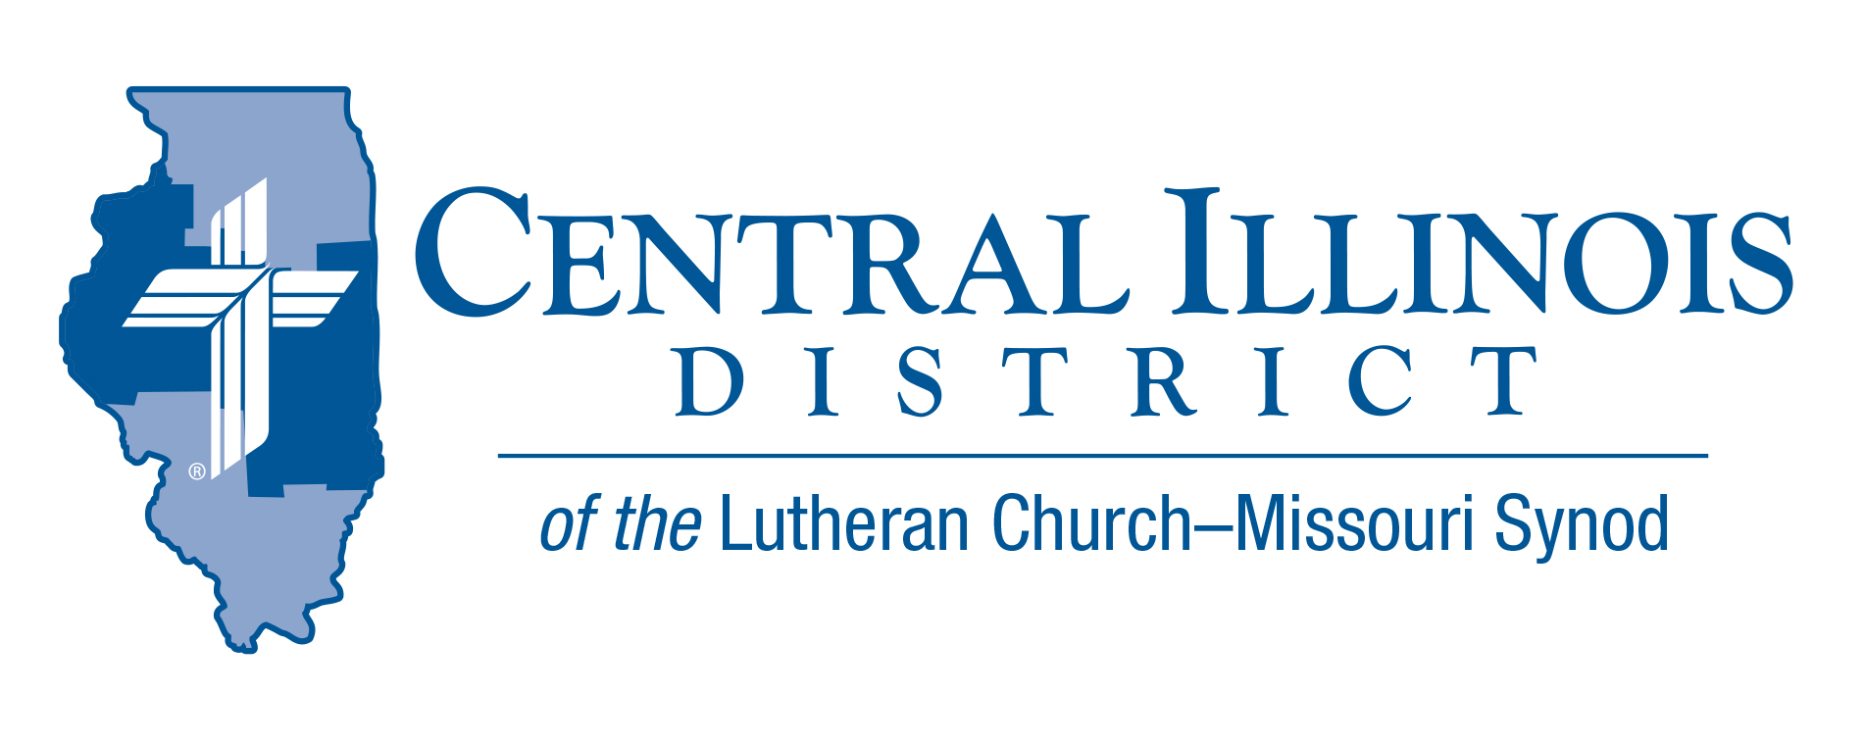
May 2023 mid-month
News You Can Use
“My dad is stronger than your dad!” 12 year old Thomas said to his friends. An argument ensued regarding whose dad was strongest, richest, smartest, etc. Then the children began bragging about the important people their fathers knew. “My dad knows the mayor,” one boy bragged. Another chimed in, “My dad knows a U.S. senator!” A third boy said, “My dad knows the governor!” Thomas didn’t think his dad knew any important people. He didn’t know what to say. Then he remembered that his dad would bring his mom and his two sisters to church every Sunday. His dad would often help with the worship service and sometimes remained afterwards to speak with the pastor. Thomas blurted out proudly, “My dad knows God!” The other boys were silent.
Many people claim to know about God. But not nearly as many truly know God. To know about God means little. James 2:19 tells us that the devil knows that much! To know God is to know him as our Father and creator, and to rejoice that he knows us. To know God is to praise and honor him with our words and our actions. It is to believe what he says in the Bible, to frequently speak to Him in prayer, and to trust that through Jesus we are saved from sin and death.
Those who know God tell others about him. We do not brag about knowing God. Rather, we boast about all the wonderful things he has done and continues to do for us. This Father’s Day, may we boast in the Lord and celebrate that we have a Father who loves us always and forever.

Rev. Jeff Harter

Items of Interest to Share

Dollar for Missions projects: Your congregation is invited to propose a project for Dollar for Missions funding in 2024! The deadline for applications is September 1, 2023. Projects will be funded in the following order of priority: 1.) new church starts; 2.) mission-focused augmentations to existing ministries; and 3.) established CID missions. For more, see the Guidelines and Resources document available at http://www.cidlcms.org/outreach-missions-commission.html or contact Ken Schurb at the District office.

CID Bible Bowl Results.

Congratulations to Mt. Calvary (Galesburg) Team A for their first place first in the CID 2023 District Bible Bowl. The team members were Nikki C., Ezra S., and Seeley K. Second place was the Mt. Calvary B team, and Good Shepherd -Sherman was third place. Please plan on having a team next year; the theme will be released later.

Small Church Summit
June 3rd, 2023
Concordia Lutheran Church (NEW LOCATION)
2300 E. Wilshire Rd -Springfield, IL
10:00 am-2:30 pm (ice Cream social after the event)
Please Register by May 26th.

Small Church Summit provides churches of any size a free opportunity to gather with folks from other small CID and SID churches, to share encouragement and plans, learn together, and hone in on priorities for your church.

The featured presenter will be Pastor Todd Kollbaum, Director of LCMS Rural and Small Town Mission. He will talk about resources and cooperation:
· Helps for small churches
· Ways for various congregations to work together

Trip Rodgers of CID staff will speak briefly concerning the Synod’s national contract with Ministry Safe, a firm that provides churches with background checks and other tools for the safety of children. Your congregation can get involved with Ministry Safe this year at no cost! Please register by May 26th at https://forms.gle/PPzJpC72NJhCZqME8

New Dollar for Missions Project: UniLu Van

A 12-passenger van for University Lutheran Church, Champaign is the current Dollar for Missions project. CID President Michael Mohr has announced that DFM funds received so far and those being received for some time to come will go to this congregation for support of a van purchase.

This project is the next on a list approved by the CID Board of Directors last January. The previous projects turned out to be non-starters when vicars were not assigned to Immanuel, Springfield or for Spanish language work in Beardstown. Placement of pastoral candidates and 2023-2024 vicars occurred at the two LCMS seminaries in late April.

University Lutheran (affectionately called “UniLu”) envisions using a van in two main ways: shuttling students to Sunday services and providing transportation for activities, retreats, and service projects throughout the year.

As of the end of April, a total of $9,483.19 in DFM money has been received at CID office. When this total reaches $35,000, the van project will be funded. Then President Mohr will announce that DFM money from that point on will support the next project, for Prison Ministry.
Visit our website for additional information (http://www.cidlcms.org/ministry-dfm-current-project.html) or visit the “Ministry” Tab on the website for current Dollar For Mission project information.

