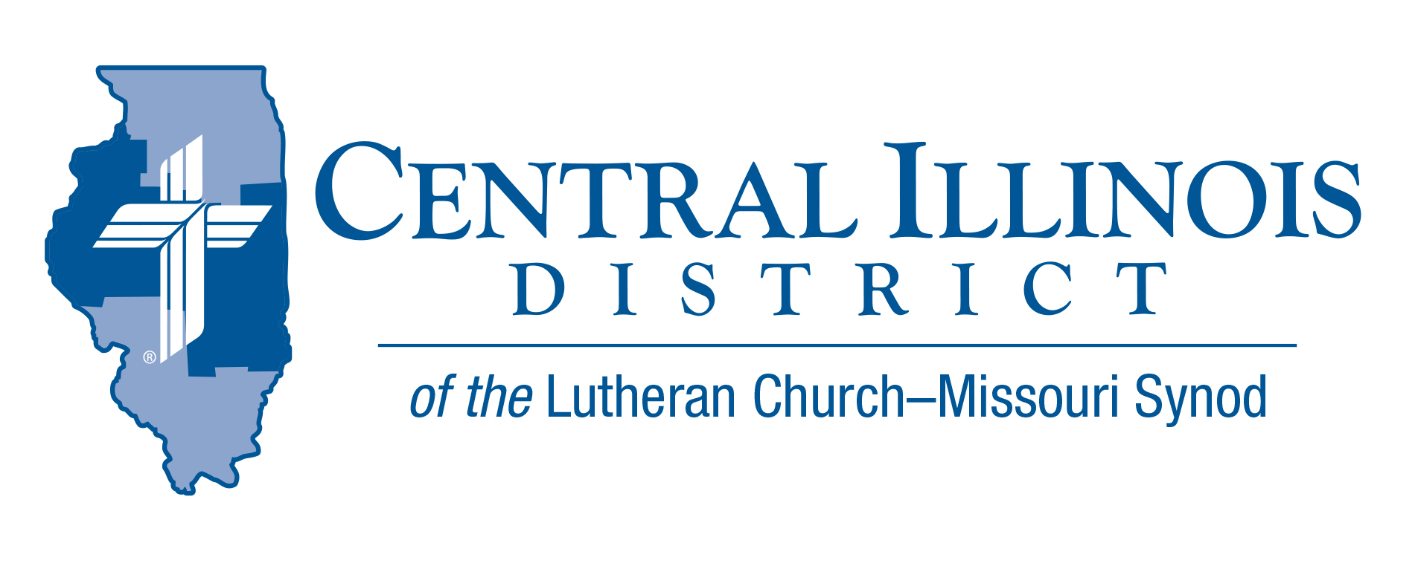
May 2023
News You Can Use
Jesus’ Risen and Ascended Hands Still Bless You Today!
At the conclusion of the Deutsche Messe, Luther makes a seismic change replacing the Roman dismissal, “Ite, missa est,” (“Go, the Mass is ended!”) with the Aaronic Benediction. Just think of the difference: “Go!” versus “The LORD bless you….” The Divine Service concludes predominately with Gospel. Luther explains the use for the Aaronic Benediction in the Formulae Missae, “I believe Christ used something like this when, ascending into heaven, he blessed his disciples [Lk. 24:50-51].”
In faithfully receiving the Benediction, you are united with blest Old Testament Israel who waited for the Lord’s salvation and with the blest Apostles who witnessed Him accomplish it on the cross. The pastor’s raised hands are mimicking Christ’s crucified and risen hands. Jesus raised His hands at His ascension showing the same marks that proved His peace with Thomas and with you. When your pastor raises His hands in blessing, meditate on the bright mysteries of Christ’s “rich wounds” that “give you peace” (Job 19:26; Rev. 1:7; 5:6)!
This year The Ascension of our LORD is May 18th. If your congregation does not celebrate Ascension, find a nearby LC-MS congregation that does and encourage other saints to attend with you (Lk. 24:52). Finally, remember what you get to hear and see at the end of every Divine Service, which others do not have. Some liturgies may just tell you to leave, or some ceremonies could pressure you to raise your hands in a vain attempt to spiritually reach God. You are given the pure Gospel of the Crucified, Risen, and Ascended Lord who reaches out to bless you with the forgiveness of sins, reverently recalled in the raised hands of the pastor, and received through faith according to His word.
-
Rev. Marcus Manley

Pray For Our Central Illinois District Missions supported by your church’s Mission Dollars to the District. “Finally, brothers, pray for us, that the Word of the Lord may spread rapidly and be honored.”
Please remember in your prayers all our CID campus ministries, especially Rev. Michael Schuermann and University Lutheran Church in Champaign, serving students, faculty, and staff of the University of Illinois and other institutions. And pray for the “Keeping Christ on Campus” campaign, building endowments to help CID support our campus ministries.

Items of Interest to Share
New Dollar for Missions Project: UniLu Van

A 12-passenger van for University Lutheran Church, Champaign is the current Dollar for Missions project. CID President Michael Mohr has announced that DFM funds received so far and those being received for some time to come will go to this congregation for support of a van purchase.

This project is the next on a list approved by the CID Board of Directors last January. The previous projects turned out to be non-starters when vicars were not assigned to Immanuel, Springfield or for Spanish language work in Beardstown. Placement of pastoral candidates and 2023-2034 vicars occurred at the two LCMS seminaries in late April.

University Lutheran (affectionately called “UniLu”) envisions using a van in two main ways: shuttling students to Sunday services and providing transportation for activities, retreats, and service projects throughout the year.

As of the end of April, a total of $9,483.19 in DFM money has been received at CID office. When this total reaches $35,000, the van project will be funded. Then President Mohr will announce that DFM money from that point on will support the next project, for Prison Ministry.

Small Church Summit
June 3rd, 2023
Concordia Lutheran Church (NEW LOCATION)
2300 E. Wilshire Rd -Springfield, IL
10:00 am-2:30 pm (ice Cream social after the event)

Small Church Summit provides churches of any size a free opportunity to gather with folks from other small CID and SID churches, to share encouragement and plans, learn together, and hone in on priorities for your church.

The featured presenter will be Pastor Todd Kollbaum, Director of LCMS Rural and Small Town Mission. He will talk about resources and cooperation:
· Helps for small churches
· Ways for various congregations to work together

Trip Rodgers of CID staff will speak briefly concerning the Synod’s national contract with Ministry Safe, a firm that provides churches with background checks and other tools for the safety of children. Your congregation can get involved with Ministry Safe this year at no cost! Please register at https://forms.gle/PPzJpC72NJhCZqME8

Stay Connected with your District
Looking for additional information, visit https://linktr.ee/cidlcms or connect with the following items:
- CID’s GatePost (newsletter) Subscribe to the E-GatePost/News You Can Use. Stay connected with us on Facebook and Instagram --Central Illinois District-LCMS

