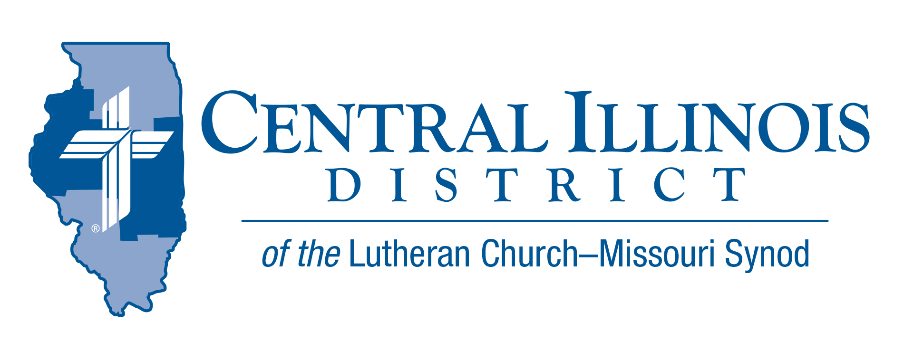
October 2023
News You Can Use
After crossing the Jordan River into the Promised Land, twelve stones were taken from the river and placed as a memorial to the children of Israel (Joshua 4:7). This memorial was set up as a teaching tool for their children. So, when their children would ask about the stones, they could tell them how God cut off the Jordan River so they could cross on dry ground.
What are your teaching tools to teach about God’s blessings in your life? One way to be prepared to talk about your “memorial stones” is to thank God for His involvement in your life. Think about the blessings you have received even during the difficult times in your life. Remember all of the blessings, both great and small. As you pray to God, keep your eyes open to see the blessings that surround you. Think about how God has placed special individuals in your life.
Just as God instructed Joshua to set up the twelve stones, ask God to help you set up your “memorial stones” so that others can ask you about your Hope. “But in your hearts revere Christ as Lord. Always be prepared to give an answer to everyone who asks you to give the reason for the hope that you have. But do this with gentleness and respect,” (1Peter 3:15)

Trip Rodgers – Central Illinois District Office

Pray For Our Central Illinois District Missions supported by your church’s Mission Dollars to the District. “Finally, brothers, pray for us, that the Word of the Lord may spread rapidly and be honored. Please remember to thank God for outreach with the Gospel in Spanish at St. John’s Lutheran Church, Beardstown. Pray for community liaison Maria Guijosa.

Items of Interest to Share
Announcing 2024 Central Illinois District Youth Bible Bowl: “The Gospel according to St. John.” In the best way you know how, study the Gospel according to St. John with your young people, so they get to know better the only true God, and Jesus Christ, whom He sent to win eternal life for all believers. The CID Bible Bowl is being planned for a Sunday afternoon in April, at Camp CILCA. Circuit Bible Bowls may be held in March. More information will be forthcoming. The CID Youth Bible Bowl is an opportunity for young people in Senior and Junior High School (grades 6-12) to study a portion of God's word each year, and meet with other young people of their circuit and the District. If you would like more information you may contact Pastor Mark Eddy at Zion Lutheran Church, Taylor Ridge, Illinois (zionlcms@juno.com) or 309-795-1063.
CID BOARD OF DIRECTORS REVIEW REPORT 09/26/23
Rev. Mark Eddy called the meeting to order. Rev. Mike Burdick began a new series of devotions based on the Gospel of John, focusing on witness and outreach. Rev. Schurb gave the Mission Presentation explaining the resolutions concerning missions passed at this year’s Synodical Convention, such as: congregational training for witness, planting churches, and missions to immigrants and various cultural groups.
President Mohr reported that CID has 32 vacancies and discussed the difficulties for our Illinois districts to call pastors from outside of the state. For example, the Synod congregational vacancy percentage is 9.7%, whereas CID congregational vacancy is near 20%. President Mohr gave a categorized list of Synod convention resolutions with brief descriptions. He pastorally advised the CID Board of Directors. He exhorted all of us to please pray for the leadership of Concordia Texas to fulfill their duty to walk together and reconcile with the LC-MS.
Mrs. Chris Andersen reported for CEF reviewing their loans and investments and reiterated CEF’s mission first to serve the churches and schools of CID. She gave thanksgiving to God, announcing that Buckley Christ High School made the final payment on their mortgage in August. After their building closed last year, CEF continues to work with and support LuHigh. She noted 3 CEF grants for Summer Evangelism Interns 2024, Circuit Visitor Training, and an increase of funds for the CID Creation Science Series.
Rev. Chuck Olander reminded us of the many blessings to the district made through gift planning. He also announced his recent retirement from prison ministry after 41 years.
Mr. Trip Rodgers gave his reports on Congregational Life and Education. He reminds our district that the Ministry Safe resource is already paid for by the LC-MS and will soon be financed by CID. This is a no-cost resource for congregations that can protect you from predators and help provide congregational servants with background checks. He is working on future youth group training. He updated changes with our district-commissioned workers and the Invest in Kids Act, which provides scholarships for our CID schools and lowers their overall expenses.
Rev. Dr. Schurb announced his appointment to the LC-MS Commission on Handbook. Rev. Schurb has several recent resources on Evangelism: a series on Issues Etc, an upcoming sectional at CID pastors conference, and upcoming talks at Concordia Wisconsin and Ft. Wayne. It was approved to send a copy of the adopted CID budget every year to all district commission members and the human care committee.
The Board approved that the funds from the sale of Redeemer, Peru property go to the Endowment Fund to support church worker students.
Zion, Taylor Ridge; St. John, Quincy; St. John, Louisville; and Trinity, Casey, constitution changes were approved.
Rev. Wilfred Karsten was nominated for Ordained Minister for the Board for National Mission from the Central Region of the LC-MS.
The next CID Board of Directors meeting was set for November 28, 2023, at 9:00 a.m.

