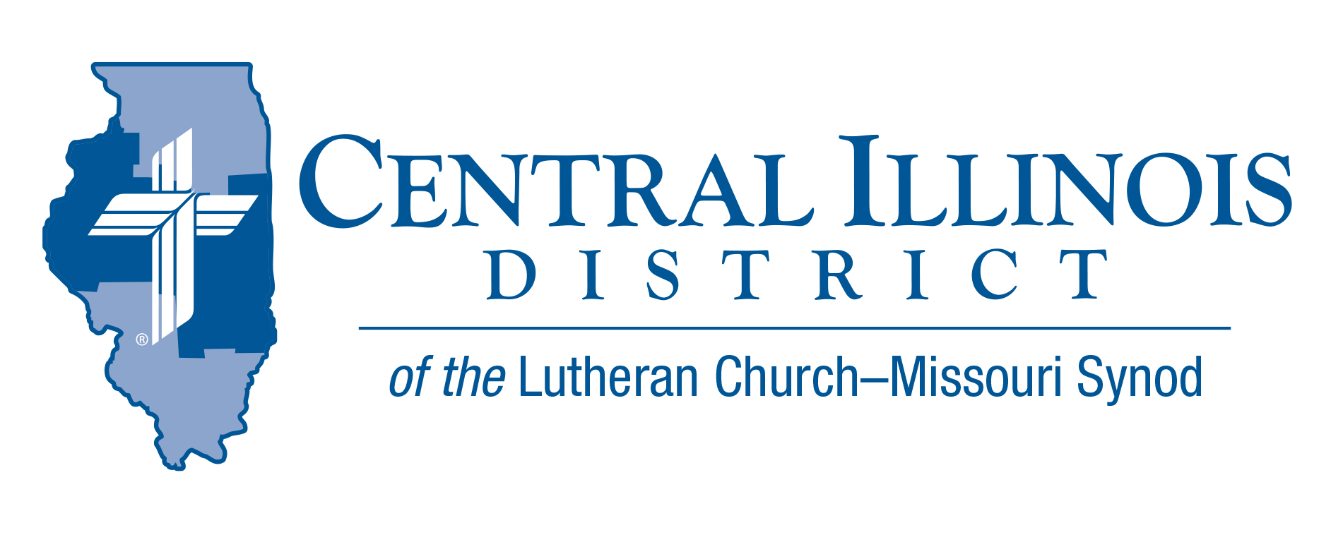
September 2023
News You Can Use
Summer is coming to an end and fall is just around the corner. As we look to the coming of autumn, we realize that the seasons are not the only thing that changes. Everything changes around us. Our children and grandchildren are born, go to school, and before we know it leave the nest. Our country has changed. Technology has changed. Everything changes, including us.
In a world where everything changes, it is good to know that the Lord never changes. As things come and go, it is a comfort to know that the Lord remains the same. We have the assurance in a rapidly changing world that God’s love for us through His Son, Jesus Christ never changes. God’s Word remains the same for it speaks to all people in every generation. God’s promises never change. They are always true. Our foundation is not this world that changes like shifting sand and in time will come to an end. Our foundation is the Lord our God. He is our rock and our fortress. It is the Lord who gives us life and salvation. It is the Lord who gives us peace and joy.

Pastor Kevin Wendorf

Items of Interest to Share

Christ Lutheran Church -Normal, IL (311 N Hershey Rd.) is hosting
“Concordia Seminary Walkout: Why and So What?”
"Rediscovering the Issues Surrounding the
1974 Concordia Seminary Walkout"

Saturday, October 21st from 10:00 am through 4:00 pm
Check-in will start 30 minutes prior to the start of this seminar at 9:30 am

Our guest speaker for this seminar will be Dr. Ken Schurb. He will be speaking about the Concordia Seminary Walkout. Four major topics will be covered: The 1973 LCMS Convention, Gospel Reduction, Historical Critical Method and The Mission Staff Walkout. The latter three are directly from the recently published book: "Rediscovering The Issues Surrounding The 1974 Concordia Seminary Walkout" (specifically from Chapters 1, 3, & 6).

The cost for this event is $20, which includes a light breakfast and lunch (payment will be collected on the day of at event) To sign up for this event and to choose your lunch, please visit here. https://faithevents.jasonsdeli.com/app/events/CUCXD4MAYN

If you have trouble signing up for lunch, don't hesitate to get in touch with our church office at (309) 452-5609.
Best Practices for Ministry: Heartland 2023!
Date: Wednesday, Oct. 11 (3 pm) through Friday, Oct. 13 (Noon)
Location: Cornerstone Lutheran Church Carmel (4850 E. Main St., Carmel IN 46033) Website/Registration: https://cornerstonelutheran.church/bpmh/

With the goal of helping other congregations most effectively use their God-given gifts, Christ Lutheran Church in Phoenix, Arizona, started the Best Practices for Ministry Conference. Since it began, the conference has been presented free of charge to all who attend. Our keynote speakers: Mark Monteith, award-winning sports journalist, radio host, and author; Rev. Dr. Benjamin Haupt, Associate Provost and Associate Professor at Concordia Seminary St. Louis, and his wife, Celina; and Jeff Cloeter, senior pastor at Christ Memorial Lutheran in St. Louis.

To register, visit https://cornerstonelutheran.church/bpmh. You’ll also be able to see the preliminary schedule, register for our 5K, and find links for hotel accommodations. We can’t wait to see you for Best Practices in Ministry: Heartland next month!

Apologetics 101
At Zion Lutheran Church (101 S. Railway, Mascoutah, Il 62258)
Saturday, Oct. 7th 9:00 am- 3:00 pm
Cost $10.00 (to cover Lunch)
Topics:
- The Who, What, Where, Why an When of Apologetics
- The Word They Still Shall Let Remain: The Reliability of Scripture
- Literature and Apologetics: A Bridge to Conversation
- The Reality of the Resurrections: Nothing Else Really Matters.
To register, contact Pastor Clayton at Pastor@ZionMascoutah.org

Current Dollar for Mission Project: Funding for New Approach to Prison Ministry
The Central Illinois District has an opportunity to expand the Prison Ministry. The District paid them or the congregations they served for their time and effort. Now we are moving to a newer model, in which the District will pay a flat $5000 a year to any congregation that allows its pastor to go to a nearby prison or jail once a week, usually for part of a day such as a morning or afternoon. This new approach should enable us to expand prison ministry to a larger number of institutions. For more Information visit The CID website at CIDLCMS.org or https://www.cidlcms.org/ministry-dfm-current-project.html

Pray For Our Central Illinois District Missions supported by your church’s Mission Dollars to the District. “Finally, brothers, pray for us, that the Word of the Lord may spread rapidly and be honored.” Our Lord Jesus said, “Pray the Lord of the harvest to send laborers into the harvest.” This month, please remember in your prayers all the students, particularly those from CID, who are studying at our Synod’s colleges and seminaries to be pastors, teachers, and other kinds of church workers – many with the help of scholarship money from CID.

