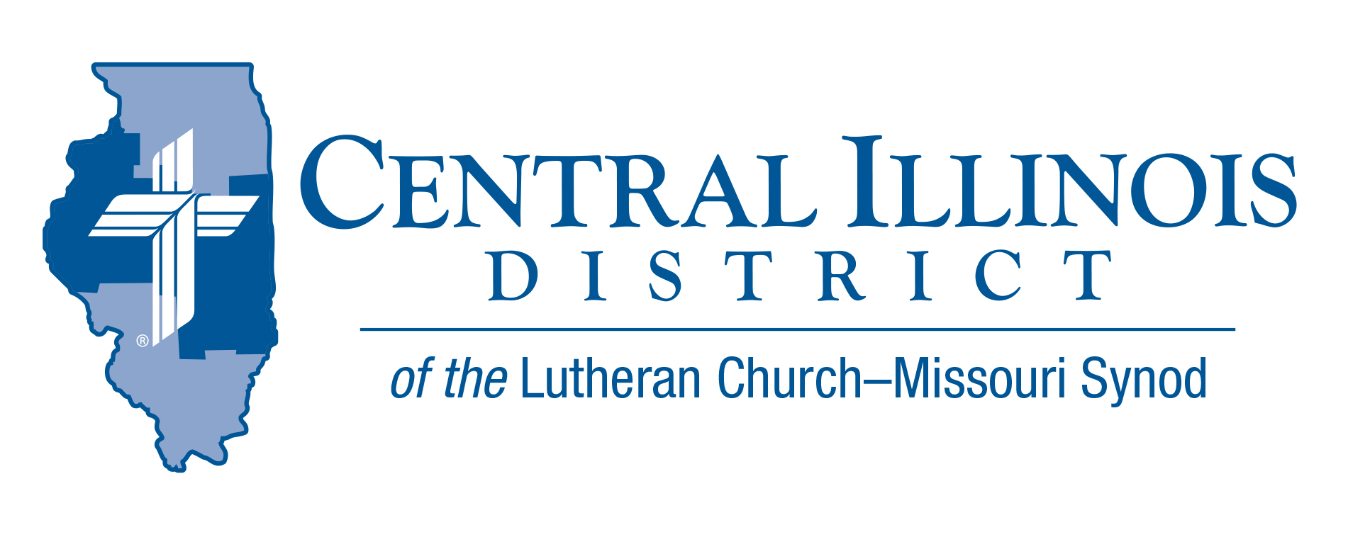
April 2024
News You Can Use
Christ is risen! He is risen, indeed! Alleluia! We have longed to hear and to speak these victorious words in celebration of our Lord’s resurrection.
In our synodical catechism the question is asked: “Why is Christ’s resurrection so important and comforting?” The answer given is that it proves that Christ is the Son of God, that His doctrine is the truth, that God the Father accepted Christ’s sacrifice for the reconciliation of the world, and that all believers in Christ will rise to eternal life.
In his letter to the Romans the apostle adds another dimension to what it means to share in Christ’s resurrection, writing, “We were therefore buried with him through baptism into death in order that, just as Christ was raised from the dead through the glory of the Father, we too may live a new life.” (Romans 6:4) Let us celebrate the present victory we have been given over our slavery to sin, and our Spirit enabled opportunity to live new lives. Our lives have been redeemed for God’s great purpose. We are saved by grace, through faith, and “[re] created in Christ Jesus to do good works, which God prepared in advance for us to do.” (Eph. 2:10) God grant this resurrection victory to us all.

Pastor Ken Umbarger St. John-East Moline

Pray For Our Central Illinois District Missions supported by your church’s Mission Dollars to the District. “Finally, brothers, pray for us, that the Word of the Lord may spread rapidly and be honored.”
Please remember in your prayers the outreach of Christ Lutheran Church for the Deaf and Pastor Tom Phillips. Pastor Phillips is our CID missionary to the deaf. He serves in Jacksonville but also spans the District to bring the Good News about Jesus to the hearing-impaired.

Items of Interest to Share
The 2024 Illinois March for Life will be in Springfield on Wednesday, April 17. Southern Illinois District President Timothy Scharr will preach at a Matins service at Trinity Lutheran Church (220 South Second St., Springfield, 62701) at 10:00; a light lunch will be available at the State House Inn ballroom (101 East Adams St.) at 11:00 (recommended donation: $5; please bring a $5 bill); rally commences at noon on capitol front lawn; actual march steps off at 1:00 p.m. Free parking for those attending Matins and the following activities is available in State House Inn’s parking lot, in the block west of the hotel building, across First Street. We have limited parking spaces so, please carpool.

Dollar for Missions (DFM) Update: After three months of 2024, CID has completed its first two DFM projects this year: 1) mileage money to support Pastor David Dunlop’s Prison Ministry visits to Lincoln, Illinois every week ($1,800) 2) funding for St. John, Beardstown to purchase a few Spanish language hymnals ($300) and 3) funding $2,100 to provide Pastor Pablo Dominguez of Cristo Rey, East Moline honoraria as he conducts Spanish languages services and Bible classes in Beardstown twice a month for the second half of this year. Thanks to all CID churches participating in DFM!
The current DFM project is to make sure new prison ministries that are beginning in 2024 can continue being funded as described above into 2025, or if possible, to start wholly new prison ministries during 2025. Congregations make a big difference for this and other projects when they gather from their members one dollar a week over and above regular church giving.
Many small contributions add up and enable important mission work. This is happening right now!
For more, see https://www.cidlcms.org/ministry-a-dollar-for-missions.html

Assimilation Study Dr. Ken Schurb of CID office will teach a four-session study on Assimilation (better: Incorporation) of New Church Members at Trinity Lutheran School, 515 S. MacArthur, Springfield, IL 62704. The study will be held on Wednesday evenings, April 10, 17, 24, and May 1 from 6:00 to 7:15 p.m. All are invited!

2024 Institute on Liturgy Preaching and Church Music Scholarships
July 9-12, 2024
Concordia University, Seward, Nebraska
Thanks to a generous grant from the Central Illinois District Church Extension Fund, 35 full scholarships (early bird registration fee) are available for church musicians. For more information on the conference and application, see the CID website News and Events tab or visit the following link; https://www.cidlcms.org/resources/gatepost/2024.GatePost.1.pdf

Prison Ministry materials reimbursement extended: central Illinois LWML has extended the time in which CID can use funds it granted to provide reimbursements to congregations or individuals who provide Bibles, devotional books, catechisms, etc. to nearby prisons or county jails. If you have been meaning to do this, it is not too late to receive a $400 reimbursement! For details, see https://www.cidlcms.org/outreach-missions-prison.html

National Youth Gathering – Summer 2025 – New Orleans
Plans are already underway to bring your youth and adults a fantastic experience. The theme for this upcoming Gathering is Endure, based on Hebrews 12:1-3.

Jonathan Guse is the DCE from Bethel Morton, and Christy Malinowski is the DCE from Trinity Bloomington, and they will be the District Coordinators for CID! Both have had many years experience in not only leading a group, but each has also had experience as District Coordinators!

We wanted to make sure you are connected to the LCMS Youth Gathering website: https://www.lcmsgathering.com. There you can find information, FAQ, resources, zoom link sign-up for monthly meetings, and more.

