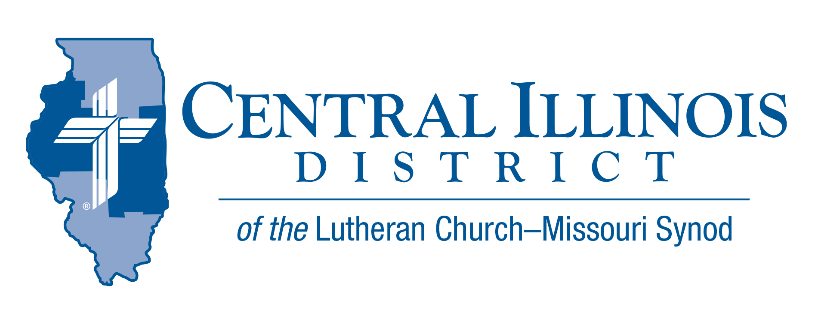
March 2024
News You Can Use
“Change and decay in all around I see”
(LSB 878:4).
Plants which died in the fall decay rapidly in spring. Human beings can die at any time of year, followed by our own decay. The ethical decay around us “stinks to high heaven.” Our sinful nature is so decayed that “I do not do the good I want to do, but the evil I do not want, that I do” (Rom. 7:8).
But God provides the antidote to decay. Psalm 16:10 expresses our Christian hope: “You will not leave my soul for sheol; You will not allow Your Holy One to see decay.” St. Paul (following St. Peter’s Pentecost sermon) explained this: “David, after assisting with the plan of God in his own generation, fell asleep and was added to his fathers and saw decay. But He whom God raised [Jesus Christ] did not see decay. So, it should be known to you, brothers, that through Him forgiveness of sins is announced to you; and from all things from which you could not be justified in the law of Moses, in Him everyone who believes is justified” (Acts 13:36-39).
The sinless Son of God “died for our sins” (1 Cor. 15:3) “and was raised for our justification” (Rom. 4:25), so that “everyone who believe in Him would not perish but have eternal life” (John 3:16). “In Him we live and move and exist” (Acts 17:28). “Oh, Thou who changest not, abide with me!”
Rev Mark Eddy – CID Board of Directors- 1st Vice President and Zion Lutheran Church, Taylor Ridge, Illinois

Pray For Our Central Illinois District Missions supported by your church’s Mission Dollars to the District. “Finally, brothers, pray for us, that the Word of the Lord may spread rapidly and be honored.” Please remember in your prayers Cristo Rey (Christ the King) Lutheran Church in East Moline, and Pastor Pablo Dominguez, where the ministry is conducted almost entirely in Spanish.

Items of Interest to Share
Dollar for Missions (DFM) Update: After two months of 2024, CID has completed its first two DFM projects this year: 1) mileage money to support Pastor David Dunlop’s Prison Ministry visits to Lincoln, Illinois every week ($1,800) and 2) funding for St. John, Beardstown to purchase a few Spanish language hymnals ($300). The current DFM project is for $2,100 to provide Pastor Pablo Dominguez of Cristo Rey, East Moline honoraria as he conducts Spanish languages services and Bible classes in Beardstown twice a month for the second half of this year. Thanks to all CID churches participating in DFM! For more, see https://www.cidlcms.org/ministry-a-dollar-for-missions.html

The latest CID GatePost issue, released at the beginning of Lent, contains important information about decline in the District’s capacity to continue supporting missions here and through the national Synod. Every CID congregation is receiving a letter from the District President, Chairman of the Board of Directors, Treasurer, and Financial Secretary on this important subject. Watch for it! (see News and Event Tab on CIDLCMS.org website or see https://www.cidlcms.org/resources/gatepost/2024.GatePost.1.pdf )

Every-weekday Lenten Services continue at Trinity, Springfield (across the street from the state capitol) through Good Friday, 12:15-12:40 p.m. Short sermons are on “The Life of All the Living – Jesus,” telling the story of Christ winning salvation for us, with applications to life today. If you know people who work in downtown Springfield or have other reasons to go there, please suggest that they attend – and bring friends!

Illinois March for Life: Wednesday, April 17, 2024, As last year, Trinity Lutheran Church in downtown Springfield (across the street from the state capitol building) will host a Matins service in the morning, before the rally and march, and a light lunch will be provided at a nominal cost. Precise times are being determined. This year, parking will be available to you downtown at the State House Inn, a block north of the capitol and near Trinity. However, please make plans now to carpool whenever possible.

2024 Institute on Liturgy Preaching and Church Music Scholarships
July 9-12, 2024
Concordia University, Seward, Nebraska
Thanks to a generous grant from the Central Illinois District Church Extension Fund, 35 full scholarships (early bird registration fee) are available for church musicians. For more information on the conference and application, see the CID website News and Events tab or visit the following link: https://www.cidlcms.org/resources/gatepost/2024.GatePost.1.pdf

2024 Central Illinois District Youth Bible Bowl: “The Gospel according to St. John.” In the best way you know how, study the Gospel according to St. John with your young people so they get to know better the only true God, and Jesus Christ. The CID Bible Bowl is planned for Sunday, April 14 at Camp CILCA. Circuit Bible Bowls may be held in March. If you would like more information, you may contact Pastor Mark Eddy at Zion Lutheran Church, Taylor Ridge, Illinois (zionlcms@juno.com) or 309-795-1063.

National Youth Gathering – Summer 2025 – New Orleans
Plans are already underway to bring your youth and adults a fantastic experience. The theme for this upcoming Gathering is Endure, based on Hebrews 12:1-3.

Jonathan Guse is the DCE from Bethel, Morton, and Christy Malinowski is the DCE from Trinity, Bloomington, and they will be the District Coordinators for CID! Both have had many years experience in not only leading a group, but each has also had experience as District Coordinators!

We wanted to make sure you are connected to the LCMS Youth Gathering website: https://www.lcmsgathering.com. There you can find information, FAQ, resources, zoom link sign-up for monthly meetings, and more.

