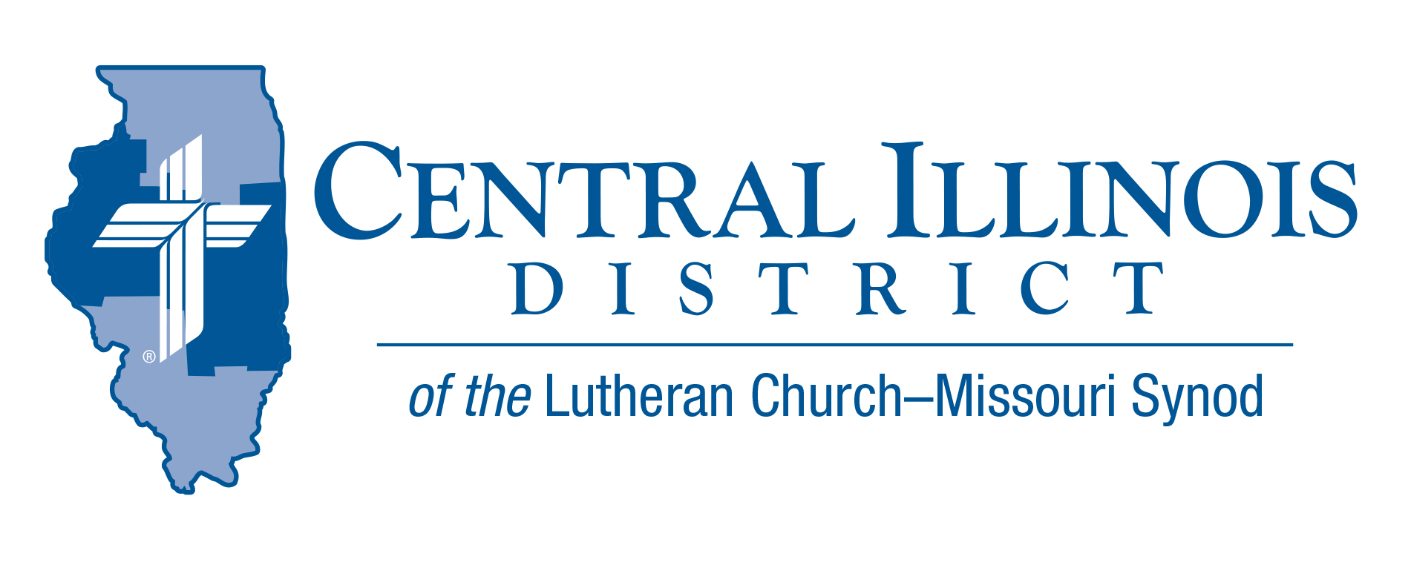
May 2025
News You Can Use
Alleluia! Christ is risen!
A congregational chairman told a meeting: “I have bad news: the church needs a new air conditioner. There’s good news, though: God has provided the money for it, in your pockets.”

There’s something to this little joke. As Lutherans, we don’t talk money without talking about God’s provision. He has given us not only our temporal gifts, but even more: Christ. Jesus’ resurrection will overcome every difficulty on Earth, including church maintenance. You have in your “pocket” not only money, but also the fact of Christ’s resurrection and its eternal effect.

We Christians can see not only our “gains” but also our potential “losses” dwarfed by Jesus’ resurrection. Our faith in Christ, who has overcome all sin and death, puts everything into perspective. See Philippians 3:7-11.

As you await your resurrection, you have God-given gifts to support Gospel proclamation here and now. Power of positive thinking? No, the power of Christ’s resurrection!

– Rev. Marcus Manley, Bethlehem and Zion Evangelical Lutheran, Altamont

Pray For Our Central Illinois District Missions supported by your church’s Mission Dollars to the District.
Please remember in your prayers all our CID campus ministries, especially Rev. Michael Schuermann and University Lutheran Church in Champaign, serving students, faculty, and staff of the University of Illinois and other institutions. And pray for the “Keeping Christ on Campus” campaign, building endowments to help CID support our campus ministries.

Items of Interest to Share
Mission Education Toolkit part 2
With the District’s next convention on the horizon, July 13-15, an opportunity lies at hand for members of CID congregations to become informed concerning the District’s mission program now and into the future. For your help, “Mission Education Toolkit part 2” is now available on CID website at https://www.cidlcms.org/ministry-stewardship.html Find links there to the entire Mission Commission convention report, plus a couple of documents shared at recent Circuit events about prospects for mission work here in central Illinois.
The Small Church Summit - June 7, 2025-
Trinity Lutheran Church,
1010 N. Webster Street, Taylorville, IL 62568-1277
The deadline to register is May 31.
The day will start on Saturday, June 7, with sign-in at 9:00 a.m. The opening devotion will begin at 9:30 a.m. The Rev. Dr. Alexey Streltsov is the Rector of our sister church’s seminary in Siberia. He will be the featured presenter at the Small Church Summit. Rector Streltsov will have the morning to present and answer initial questions.
After lunch, there will be several short sectional sessions, all of which will be offered a total of twice:
1. Further discussion with Rector Streltsov
2. Congregational Assessment Tools
3. LCMS Specific Ministry Pastor Program and Small Congregations
4. Mutual Help Right Under Your Nose: Circuit Forums and Circuit Convocations
To register for the Small Church Summit, go to https://forms.gle/2odPUnCrW66hpf9o6

2025 Central Illinois District Youth Bible Bowl Results
The Central Illinois District Youth Bible Bowl took place on Sunday afternoon, April 6, 2025 in the gym of Mount Calvary Lutheran Church, in Galesburg, Illinois. Teams from the Rock Island and Quincy circuits participated by answering questions about “The Life of David.” After a round robin style tournament, the champions were team “A” from Mount Calvary Lutheran Church, Galesburg, with a record of 5 wins and 2 losses. Nikki Cansino, Ezra Sommerer, Seeley Koch, and Calie Cansino were team members.

The second-place team was team “B” from Mt. Calvary, with a record of 4 and 2. Team members were Daniel Sommerer, Natalie Cansino, Oliver Koch, and Micah Sommerer.

The third-place team came from Immanuel Lutheran Church, Macomb. Team members were Lonny, Manny, and Ty Hull. Pastor Mark Eddy from Zion Lutheran Church, Taylor Ridge, was the quizmaster. Pastor Steven & Melanie Sommerer from Mount Calvary served as scorekeepers. Pastor Christopher Hull from Immanuel served as time keeper (and fill-in quizmaster). The host church provided refreshments. Thanks to everyone who attended and/or helped in any way. The Bible Bowl is open to 6th-12th graders from any congregation in the CID. A new Bible topic is chosen for each year. Since this year’s topic came from the Old Testament, the 2026 Bible Bowl will be on part of the New Testament. More information will be announced in the fall of 2025.

National Youth Gathering -WAYS TO CONNECT
- CID Lutheran Youth Facebook Group – Latest District updates and information www.facebook.com/groups/249327678480252
- LCMS Youth Ministry Facebook Group – Gathering related content and collaboration, but all things youth ministry, too! www.facebook.com/groups/LCMSYouthMinistry
- National Youth Gathering Website – Tons of information, worksheets, budgeting sheets, etc. www.lcmsgathering.com

