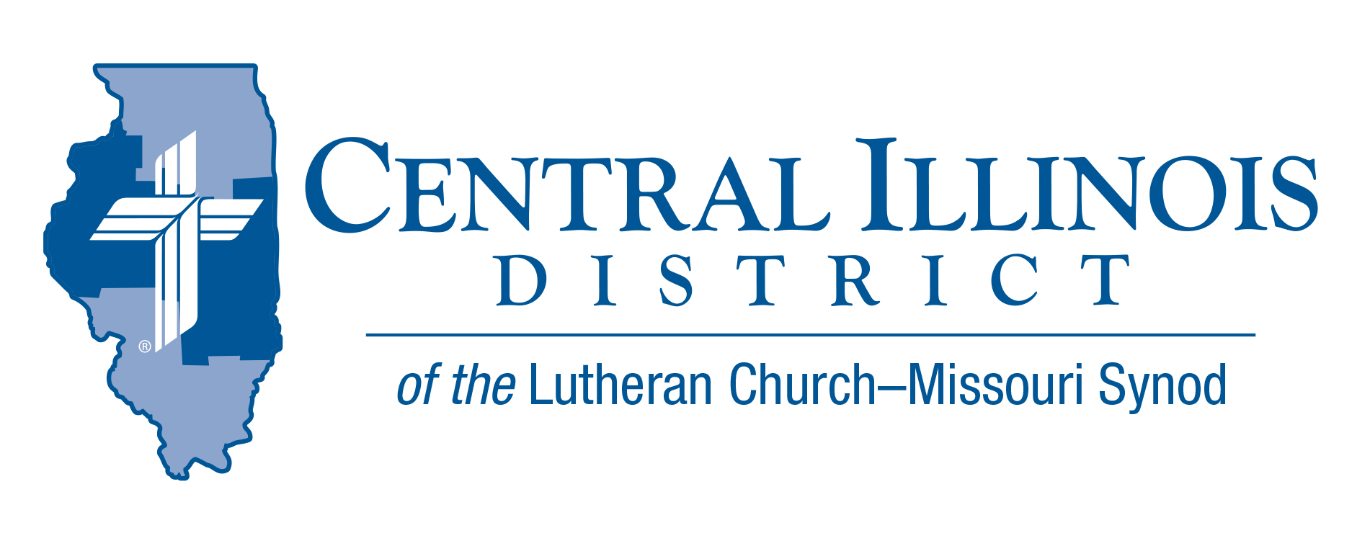
October 2025
News You Can Use

“. . . all that Jesus began to do and teach . . .” – so Luke characterized the contents of his Gospel. It starts before Jesus was conceived. It includes His ministry, His death and resurrection, ending with His ascension.
All of this was the beginning. Jesus continued to act and to teach through His church.
Acts tells that story, yet not all of it. Acts ends with Paul under arrest in Rome, teaching of Christ openly and unhindered. Unsatisfying, perhaps, to end a biography of St. Paul . . . but Luke was not telling Paul’s story. He was writing of what our Lord Jesus continued doing and teaching.
This St. Luke’s Day, October 18, recall that you fit into this story. Jesus came to seek and save the lost. Once you were lost, yet now found by the grace of God and the work of Christ. Jesus continues to act and teach through His church to this day.

Ken Schurb, CID staff

Pray For Our Central Illinois District Missions supported by your church’s Mission Dollars to the District.
Please remember in your prayers Central Illinois Lutheran Deaf Outreach, CID’s District-wide parish, conducting Word and Sacrament ministry in American Sign Language to bring the Good News about Jesus to the deaf and hearing-impaired. Most deaf people are non-churched. They need Christ!

Items of Interest to Share
CID Junior High Youth Event – Save the Date
Theme: “Make A Joyful Noise”
Saturday, November 8th, 2025, at Camp Cilca
Time 9 am – 4 pm (sign-in will start at 8:30 am)
Cost $40 per youth --- $0 for adult leaders
(includes lunch, t-shirt, and a full day of activities)

Start planning now to attend this Junior High Youth Event. Registration, long-sleeve t-shirt orders, and additional information will be found at the following link: https://forms.gle/KaSiitVeioUgLBQU9

- Deadline for registration is October 20th.
- After that date, individuals can still register up to October 30th, but will not receive a t-shirt.
CID BOARD OF DIRECTORS REVIEW REPORT 09/23/25
The meeting began by appointing Bob Dalton as Financial Secretary and installing all board members who were not already installed at the District Convention. The board started its study of the Formula of Concord.

The Board approved:
      - A new Synod convention assessment for 2026 that factors in both communicant membership and average worship attendance.
- The District Office to update their phones to include remote voicemail access and an update to security cameras.
- The 2025 CID District Convention Proceedings with corrections.
- The members of the district’s commissions were appointed.
The next CID Board meeting is scheduled for November 25, 2025.

OAFC Adult Teams:
Our District, along with two others (South Wisconsin and Southern Illinois) has been awarded a grant by the Bolick Foundation to partner with the Ongoing Ambassadors for Christ organization to develop adult teams of 3 to 5 people per District. These teams would travel to District congregations and offer either a 2-and-a-half-day or 5-day event that would provide evangelistic practice by a) canvassing neighborhoods; b) engaging in “dry run” practice of witnessing skills with church members; and c) helping a congregation to begin or to augment its evangelistic efforts in a nearby nursing home.
- Would you be interested in serving on such a team yourself? Do you know someone else who would?
- Might your congregation be interested in hosting such a team to work in your midst?
- If the answer is “yes” to any of these questions, or if you would like more information, please contact Evangelism Executive Ken Schurb. (kschurb@cidlcms.org)

Announcing the 2026 Youth Bible Bowl
Date: Will be in the spring of 2026. We are still working on the date.
Topic: "The Gospel According to St. Matthew"

The Gospel according to St. Matthew gives a summary of what we need to know in order to have salvation from sin, the devil, and death. St. Matthew's Gospel records the most important teachings of Jesus and the key events in Jesus’ life. Plan to study "the Gospel according to St. Matthew" with youth (junior and senior high [grades 6-12]) as thoroughly as you can, to prepare them to answer questions in your Circuit and at the District Bible Bowl in the spring, and (most importantly) so that by God’s grace and the power of the Holy Spirit they grow in their faith that Jesus truly is the Son of God and our Savior.

