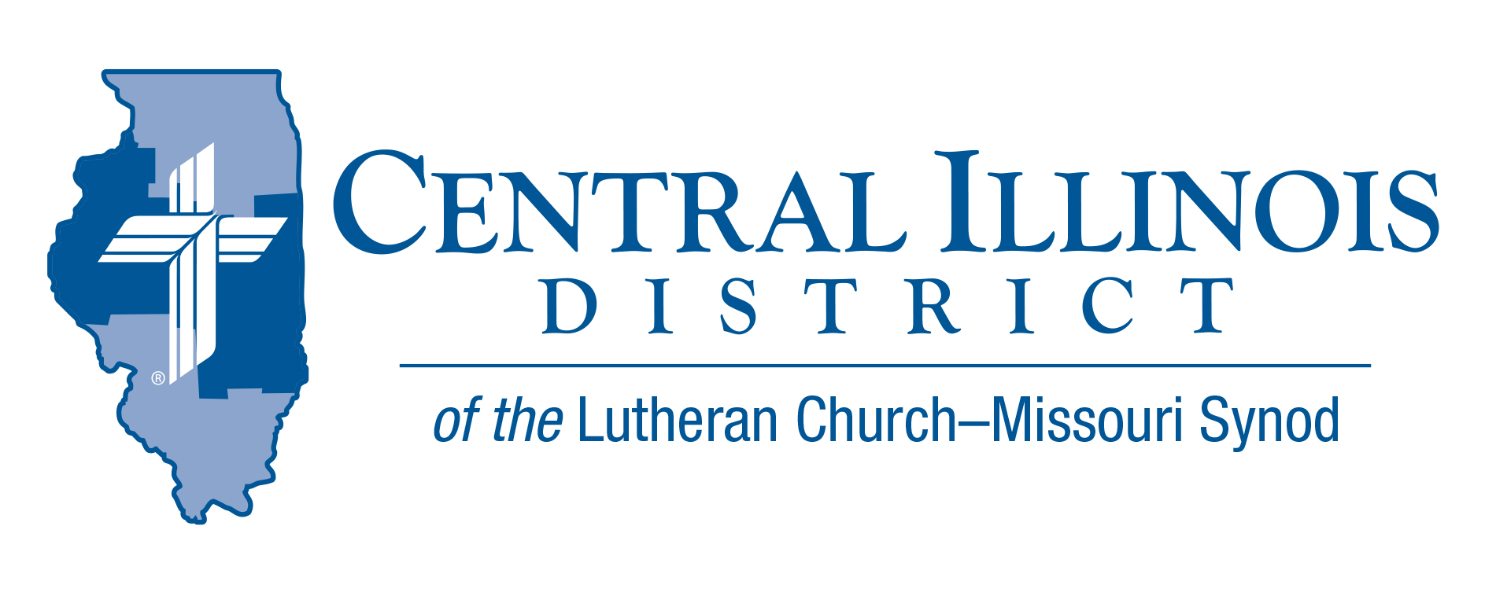
September 2025
News You Can Use

No harvest is completed without hard work. Near our cities and next door to our rural congregations, fields will soon be swarming with machinery and manpower to bring in the corn and beans. It will take work.
“The harvest is plentiful,” Jesus said (Matthew 9:37). We know He was speaking not about corn and beans, but boys and girls, precious men and women. They don’t come automatically. It takes work. The work of the Holy Spirit through the Word. The Word spoken by you … after you have listened attentively.
There’s help available for the witnessing work you’re expected to do. In your church there are probably four posters displayed that are titled “Witnessing Helps.” They’re also available on our District website. These four posters offer us practical help for the work done by our ears, hearts, minds, and mouths. The harvest is plentiful! The work is hard … but not too hard. God will do His work – through you.
-Pastor Mike Burdick
St. John’s Lutheran Church, Effingham

Pray For Our Central Illinois District Missions supported by your church’s Mission Dollars to the District.
Our Lord Jesus said, “Pray the Lord of the harvest to send laborers into the harvest.” This month, please remember in your prayers all the students, particularly those from CID, who are studying at our Synod’s colleges and seminaries to become pastors, teachers, and other kinds of church workers – many of whom are supported by scholarship money from CID.

Items of Interest to Share

Dollar for Missions Project: Replace original kitchen equipment in the sexton's apartment at Immanuel Lutheran Student Center, Macomb
Immanuel Lutheran Student Center in Macomb was dedicated in 1969, but some of the equipment in the kitchen of the apartment for the live-in student who takes care of the student center (the sexton) has not been replaced since then. DFM funds would be used to replace the original kitchen equipment.
Amount to be funded: $11,000

Worker Wellness:
In cooperation with Concordia Plans, which is providing a $10,000 grant to CID, the District’s Committee for Human Care and Worker Wellness has developed two goals for 2025-2026:
- To raise gold/platinum status participation in Vitality from 11.5% to 15%
Watch for forthcoming information on a possible District-wide “get you moving” challenge that may accompany this goal.
- To train at least one person for certification as an MHFA (mental health first aid) trainer.
- Are you interested in taking such training?
- Are you simply interested in promoting Church Worker Wellness in general?
- If your answer is “yes” to either of the above, contact Pastor Michael Schuermann at pastor@uniluchampaign.org

OAFC Adult Teams:
Our District, along with two others (South Wisconsin and Southern Illinois) has been awarded a grant by the Bolick Foundation to partner with the Ongoing Ambassadors for Christ organization to develop adult teams of 3 to 5 people per District. These teams would travel to District congregations and offer either 2 and a 2-and-a-half-day or 5 5-day events that would provide evangelistic practice by a) canvassing neighborhoods; b) engaging in “dry run” practice of witnessing skills with church members; and c) helping a congregation to begin or to augment its evangelistic efforts in a nearby nursing home.
- Would you be interested in serving on such a team yourself? Do you know someone else who would?
- Might your congregation be interested in hosting such a team to work in your midst?
- If the answer is “yes” to any of these questions, or if you would like more information, please contact Evangelism Executive Ken Schurb. (kschurb@cidlcms.org)

CID Junior High Youth Event – Save the Date
Theme: “Make A Joyful Noise”
Saturday, November 8th, 2025, at Camp Cilca
Time 9 am – 4 pm (sign-in will start at 8:30 am)
Cost $40.00 (includes Lunch, T-shirt, and a full day of activities)

Start planning now to attend this Junior High Youth Event. Online Registration information (including t-shirt orders) will be available soon.

Stay Connected with your District
Looking for additional information, visit https://linktr.ee/cidlcms or connect with the following items:
- CID’s GatePost (newsletter) Subscribe to the E-GatePost/News You Can Use. Stay connected with us on Facebook and Instagram --Central Illinois District-LCMS

