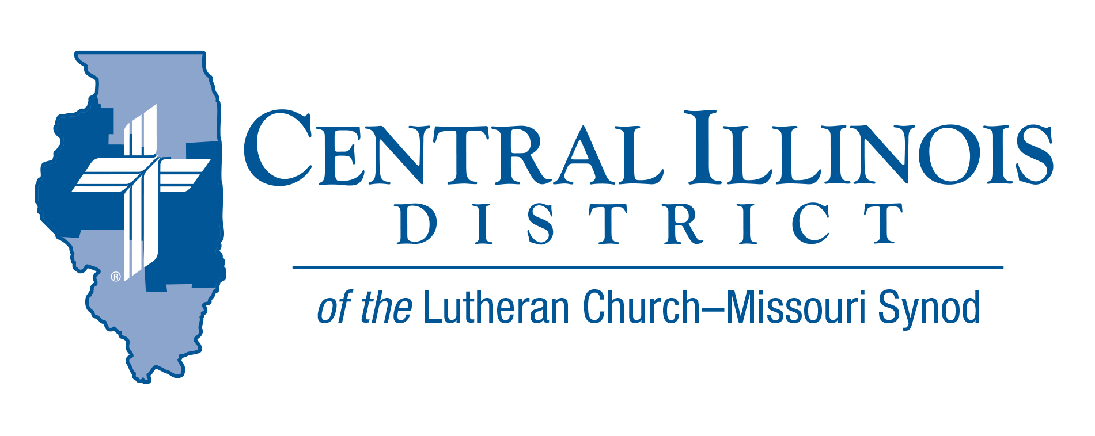
March 2026
News You Can Use

“I do not do the good which I want; however, the evil which I do not want, this I practice” (Rom. 7:19). Our sinful nature, “dead in trespasses” (Eph. 2:5), was “buried with [Christ] through baptism into death, in order that as Christ was raised from the dead through the glory of the Father, so also we should walk in newness of life” (Rom. 6:4). The death of Jesus took away the sin of the world, and for His sake God “forgives all my sins and the sins of all believers.” But, like the ground squirrels in my church’s cemetery, our sinful nature keeps trying to dig itself out of the grave. As a result, “I am a miserable human being. Who will rescue me from this body of death?” The entire New Testament answers, “Thanks be to God through Jesus Christ our Lord!” (Rom. 7:24-25) God’s Son came in human flesh, and “Christ died for our sins, according to the Scriptures” (1 Cor. 15:3). So, “if we confess our sins, [God] is faithful and righteous, that He would forgive us these sins and cleanse us from all unrighteousness” (1 John 1:9). All of us need to recognize our wretchedness, confess our sins, hear what God’s Son did “for us and for our salvation,” and by the power of the Holy Spirit receive God’s gracious pardon. Lent leads us to all that, and leads us to why we know it is all true: “Just as He is risen from the dead, lives, and reigns to all eternity, this is most certainly true.”
CID President Mark Eddy

Pray For Our Central Illinois District Missions, supported by your church’s Mission Dollars to the District. Please remember in your prayers Pastor Pablo Dominguez and Cristo Rey (Christ the King) Lutheran Church in East Moline, where the ministry is conducted almost entirely in Spanish, as well as St. John’s Lutheran Church in Beardstown, where Pastor Dominguez travels twice a month to preach and teach in Spanish.

Notice and Explanation of District Leadership Changes

Elected at Convention

District President: Rev. Michael Mohr

1st Vice-President: Rev. Michael Burdick

2nd Vice-President: Rev. Mark Eddy

As of February 17, 2026

District President: Rev. Mark Eddy

1st Vice-President: Rev. Jason Braaten

2nd Vice-President: Rev. Karl Eckhoff

At the 61st Regular Convention of the Central Illinois District of The Lutheran Church—Missouri Synod held July 13–15, 2025, the above were elected to serve three-year terms in their respective offices by the district voting delegates. Seven months later, the leadership of the district has changed significantly, and this change requires an explanation to our pastors, church workers, and congregations.

On Wednesday, January 28, 2026, District President Mohr was arrested on criminal charges by federal law enforcement. Prior to being held in custody, Mohr was given the opportunity to speak with First Vice-President Burdick and in keeping with district governance temporarily transferred the duties of district president. On Monday morning when the first special session of the Board of Directors met, Rev. Burdick notified the Board that in light of the anticipated duration and demands of the office, he asked to resign from the position of First Vice-President. This resignation removed him from the Board of Directors and elevated Second Vice- President Eddy to First Vice-President and in turn, Acting District President.

With Rev. Burdick vacating his position, the Central IL District Bylaws (2.15(b)) state, “A vacancy in the First Vice-Presidency shall be filled by advancing the Second Vice-President. A vacancy in the Second Vice-Presidency shall then be filled by the President from the reserve list of nominations, that is from the nominees left after the previous election, according to the number of votes received…” Rev. Burdick represented the Eastern Region, so the second-place nominee at the convention for the Eastern Region was Rev. Jason Braaten of Immanuel – Tuscola. He was then appointed as Vice-President for that region by the Acting District President.

When Mohr resigned from his position and as a member of the LCMS roster, Acting District President Eddy succeeded Mohr as District President and vacated the office of First Vice-President. This resulted in Rev. Braaten serving as First Vice-President and a second appointment according to Bylaw 2.15(b) (cited above) of the third-place nominee for the Western Region, Rev. Karl Eckhoff of Christ - Peoria. This final succession and appointment were ratified by the Board of Directors on February 17, 2026, at a second special session of the Board.

While this situation required careful interpretation of our governing documents, the Board acted in accordance with district bylaws, in consultation with Synod and legal counsel. We thank all who have reached out to offer support and wisdom as well as to all who have granted patience as the Board worked through these processes. We remain committed to serving Christ and His Church faithfully in this district, and it is by grace alone that we serve our people and the congregations of the Central Illinois District.
2026 Youth Bible Bowl
Date: Sunday, March 22, 2026
Location: Camp CILCA
Topic: "The Gospel According to St. Matthew"

Those holding either a circuit Bible bowl, or with team(s) planning for the District Bible Bowl, please contact Trip Rodgers (trodgers@cidlcms.org) a.s.a.p. so we know how many to plan for. Thanks.


Dollars for Mission Online
Our first project for 2026 is support for Hispanic Ministry in Beardstown, IL. $1800 will be collected to support travel costs for Rev. Pablo Dominguez. Reminder that online one-time and recurring donations can now be made at
https://www.aplos.com/aws/give/LCMSCentralIllinoisDistrict/D4M
or by using the QR code.

