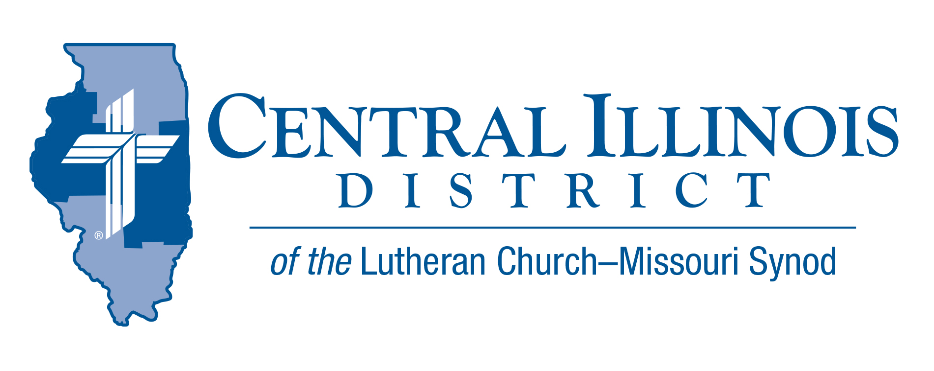
May 2026
News You Can Use
¹Blessed is everyone who fears the Lord,
who walks in his ways!
² You shall eat the fruit of the labor of your hands;
you shall be blessed, and it shall be well with you.
Ps. 128: 1-2
Time of Celebration
We are in a season of celebrations, gathering together to honor individuals at their confirmations and graduations at many levels. These milestones are a wonderful opportunity to reflect on the many blessings we have received.
Psalm 128 reminds us that these blessings are not based on luck, but flow from a personal relationship with God, who is intimately involved in our lives. God is faithful to His children, and in His time, He will provide the fruit of His blessings.
As we celebrate, let us not rush these moments — but pause, savor them, and receive them with a thankful heart.
Mr. Trip Rodgers – CID Office
Pray for Our Central Illinois District Missions, supported by your church’s Mission Dollars to the District. Please remember in your prayers all our CID campus ministries, especially Rev. Michael Schuermann and University Lutheran Church in Champaign, serving students, faculty, and staff of the University of Illinois and other institutions. And pray for the “Keeping Christ on Campus” campaign, building endowments to help CID support our campus ministries.

St. Paul Lutheran Church – Pittsfield – celebrating 80 years
St. Paul Lutheran Church, Pittsfield, Illinois, is celebrating 80 years since its start as a tent mission in August 1946. Events and outreach activities are being planned around visits from former pastors.
- Festivities begin June 7, 2026, at 10:00 a.m. with the son of the congregation, the Rev. Jesse Krusemark, preaching.
- Lunch will follow the worship service. Kindly let us know if you plan to join us. Worshiping...Eating...Remembering... 2:00 p.m.
- 80th Anniversary Service of Celebration (2:00 pm) with hymn singing, a brief history presentation, and time for sharing of our memories and ministries then and now.
For more information, call 217-242-8948.
The Concordia Chicago Festival of Scripture & The Arts will take place on campus next month, June 20–21. The two-day event, inspired by the Song of Solomon, will feature a variety of lectures, presentations, performances, and a special commissioned artwork.
The festival’s highlight is the premiere performance of “Song of All Songs,” a new work by Professor of Music Dr. Jonathan Stahlke. The piece draws on the entire biblical text of the Song of Solomon and will be performed by an orchestra, two choirs, and vocal soloists.
We would love to welcome members of your congregations and communities to join us for the full festival or simply for the Sunday concert. Tickets for the full two-day festival are available on our website at https://www.cuchicago.edu/events/2026/062/festival-of-scripture--the-arts--song-of-all-songs/. The Sunday concert remains completely free and open to the public. Our hope is to include as many people as possible in this celebration of Scripture, creativity, and fellowship!

Summer Small Church Summit
- Saturday, June 13
- at Trinity Lutheran Church, 1201 W Jackson St, Auburn, IL
Sign-in will be at 9:00 a.m., the opening devotion will commence at 9:30, and the closing prayer will be at 2:50 p.m., followed by an ice cream social for those who would like to stay for more conversation.

The Small Church Summit will feature a keynote address by Rev. Andy Becker of St. Louis. He is the Synod’s director for family ministry in the Office of National Mission. Family-related topics have been suggested for the Small Church Summit in the past, so it is high time we had a presentation like Rev. Becker’s. He will share details about new initiatives the Synod has underway for families and how small congregations can use them.
In the afternoon, a smorgasbord of sectionals will be available. Participants will be able to choose which they want to hear in three time slots. Possibilities will range from congregational hospitality to strategic planning to church assessment tools to life issues, with more in between. There will be more offerings than any one person can take in, which makes for a good reason not to come to the Small Church Summit by yourself! Bring others with you who can help cover all these informative presentations and take learnings back to your church.
- Register for the Summer Small Church Summit by June 6, 2026, at https://forms.gle/ xLBUJu6XPfbPfyodA
If you think your church is small, YOU are invited.
And everyone is welcome!

