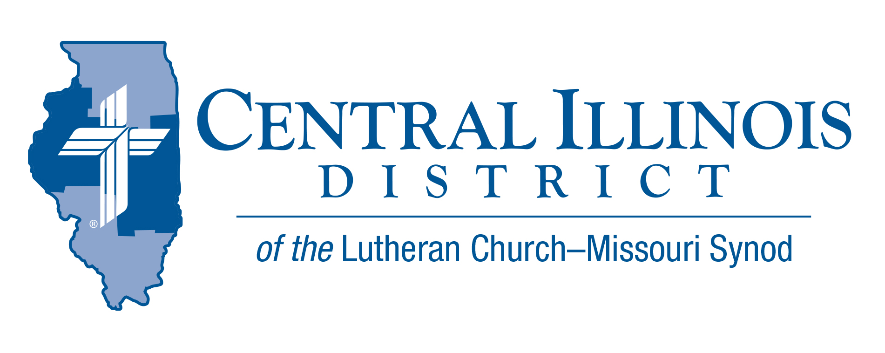
October 2026
News You Can Use

Devotional Message
"The life I live in the flesh, I live by faith in the Son of God, who loved me and gave himself for me." Galatians 2:20
There are many things that define our lives in this world. From small things like tastes and personal affinities —- what sort of ice cream you like and which teams you cheer for — all the way to your familial vocations — that you're a son, daughter, wife, husband, parent, and so on. We base our self-understanding off of these things and so do the people around us. But the most important defining reality for the Christian is that he belongs to Jesus Christ. By faith, the sacrifice of Jesus for the world's sins becomes personal for us as individuals, and it is the foundational reality of who we are — both in this life, and into eternity.

Rev. Aaron Uphoff

Pray for Our Central Illinois District Missions, supported by your church’s regular contributions to the District.
Please remember in your prayers Central Illinois Lutheran Deaf Outreach, CID’s District-wide parish conducting Word and Sacrament ministry in American Sign Language to bring the Good News about Jesus to the deaf and hearing-impaired. Most deaf people are non-churched. They need Christ!

CID BOARD OF DIRECTORS REVIEW REPORT 09/22/26
Pastor Tibben led an opening devotion on Matthew 9:9-13 in observance of the Feast of St. Matthew, Apostle and Evangelist. Pastor Rev. Philip Krupski gave a presentation for the LCMS Foundation. Mr. Matthew Fricke was elected District Reconciler. Disbursements for Dollars for Mission Disbursements were approved for:
- Beardstown Hispanic Ministry Travel - $1,800
- Immanuel Student Center (EIU) Kitchen Remodel – $10,000
- Central IL Deaf Ministry – Community Workshops - $10,000
- University Lutheran Masonry and Roof – $75,000
The district ratified scholarship amounts for CID students pursuing Church Work. A committee was formed to discuss combining Education Executive positions with SID. The Board approved masonry and roof repair work for UniLu for an estimated $750,000. The Board appointed a committee to work with the contracting firm and oversee the repair work for UniLu.
Next CID Board of Directors Meeting scheduled for Nov. 24, 2026 at 9 a.m.

“Rooted in Christ”:
CID Junior High Youth Event Set for November 7
Save the Date — Saturday, November 7 | Camp CILCA
Youth from across CID are invited to gather on Saturday, November 7, for a full day of worship, fellowship, and spiritual growth at Camp CILCA. This year's event carries the theme “Rooted in Christ,” drawn from Colossians 2:6–7, which calls believers to walk in Christ, “rooted and built up in Him and established in the faith.”
Check-in begins at 8:30 a.m., and programming runs until 4:00 p.m. Organizers plan a day of worship, small-group discussion, and recreation, all centered on what it means for young people to grow deep in their faith and stand firm together as a community.
Attendance costs $40 per youth and covers the full day of activities. Adult volunteers attend free of charge, and organizers are encouraging churches to bring chaperones to support their youth groups throughout the day.
Camp CILCA, a longtime retreat and camp facility, offers a peaceful, natural setting well-suited for a day of reflection and connection. Registration is now open — churches and families can sign up using the link below. Deadline is Oct. 30th.
Register Here https://pci.jotform.com/form/262385217608057

Announcing the 2026-27 CID Youth Bible Bowl topic: “The Lives of Abraham, Isaac, and Jacob” (Genesis 12-35; 49:1-50:13). Start planning now for who will guide your youth (grades 6-12) in the study of this part of God’s Word, and what resources you can use. The District Bible Bowl (Sunday, April 12, 2027) is limited to 2 teams per circuit. So, if your circuit would like to hold a preliminary Bible Bowl to determine which youth will go to District (and [more importantly] to get more young people learning God’s Word), you may contact either District President Mark Eddy or CID administrative assistant for education & youth, Trip Rodgers. They have rules & guidelines for holding a Circuit Bible Bowl. We’ll also get you on our list of participating circuits & congregations to keep you in the loop. We plan to get the questions to circuit Bible Bowl coordinators in February. E-mail trodgers@cidlcms.org or meddy@cidlcms.org. Or phone 217-793-1802. Or mail to 1850 North Grand Ave. West, Springfield, IL 62702.

A Lutheran Pastor from Israel will be at Trinity, Springfield's Parish Center (515 S. MacArthur Blvd.) to give a guest talk on October 28th. Pastor Sadlovsky serves in the Israeli Evangelical Lutheran Church and may be the only Lutheran pastor ministering in Israel. He reports that secular-minded Israelis are fascinated by Jesus. Come and hear how the Gospel is faring in this part of the world. His talk will be at the Parish Center located at Trinity Lutheran School on Wednesday, October 28, 6:00-7:00 p.m. Trinity's weekly Evening Prayer service will precede it at 5:30 p.m.

Current Dollar For Missions Project
Deaf ministry technology and instruction resources - Central IL Deaf Outreach
Amount to be funded: $7,000

New! Online Giving for Dollar For Mission
Online one-time and recurring donations can now be made at https://www.aplos.com/aws/give/LCMSCentralIllinoisDistrict/D4M

