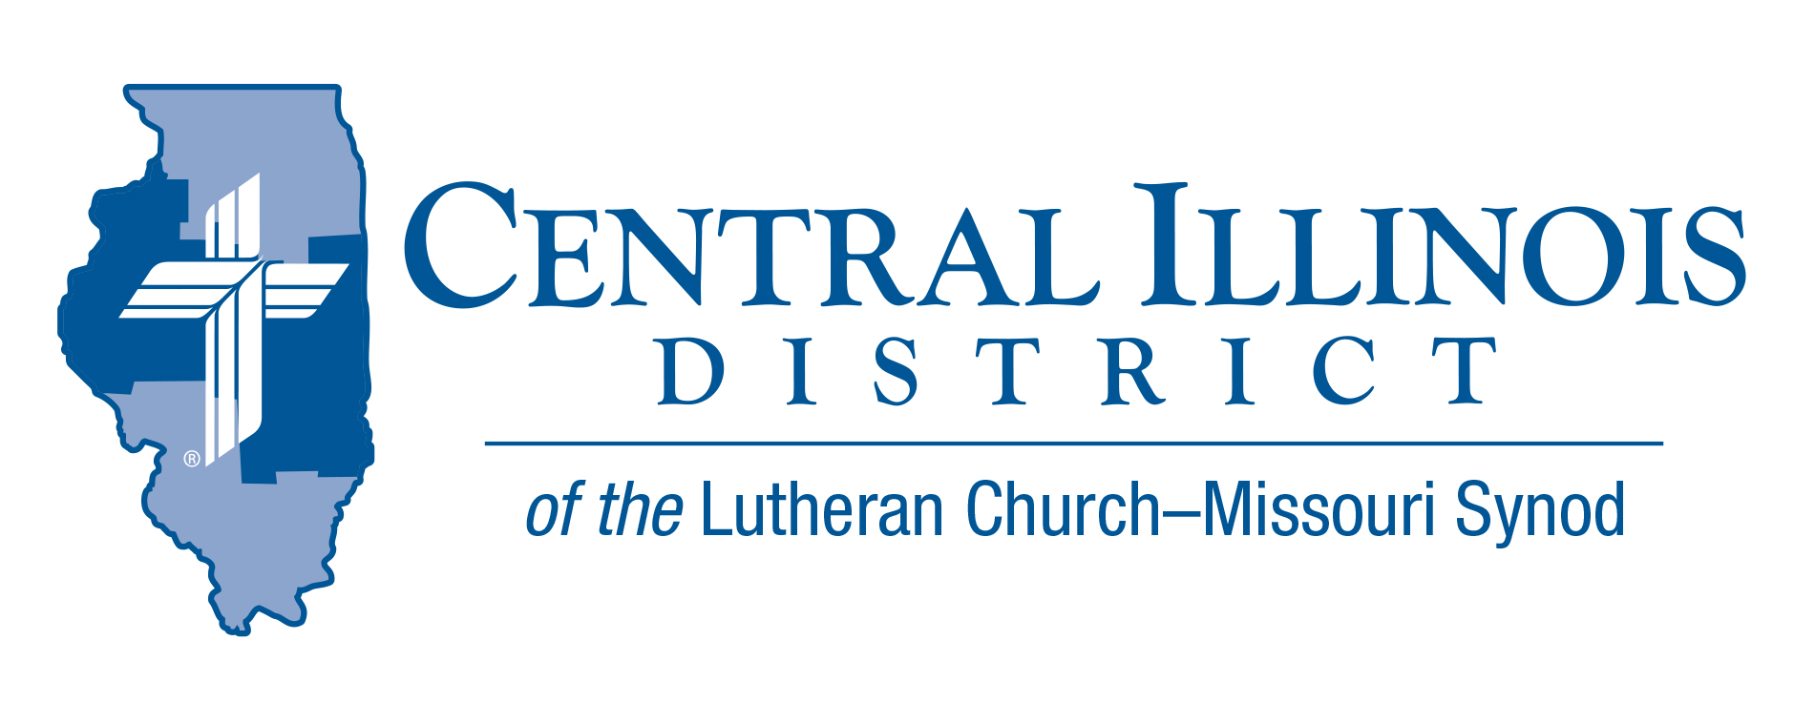

News that You Can Use-
Mid-month Update

Here is a list of additional items that were not available at the time of the November’s “News that You Can Use” publication. Because of the time sensitive nature of these items, we are sharing now.

ITEMS OF INTEREST TO SHARE

“Through the Old Testament in a Church Year”- audio resource by Issues, etc. with Ken Schurb

Through the Old Testament in a Church Year

You can find resources that survey the Old Testament in a year. Here, however, is one that does so in a church year. Going through Old Testament history in chronological order, it correlates various Old Testament incidents with the church year’s themes and emphases.

This audio resource will consist of a series of Issues, etc. interviews with CID staff member Ken Schurb during the 2020-2021 church year. The typical interview will run about 25 minutes, closer to 20 minutes if listeners fast-forward through various announcements. The interview recordings will be available on demand at https://issuesetc.org/archive

The series will commence on Thanksgiving Day, November 26, 2020, with an hour-long premiere that will highlight the biblical teachings of Creation (appropriate for Thanksgiving) and of the Fall and first prophecy of the coming Deliverer (for the First Sunday in Advent). In each succeeding week, God willing, you will find at least one interview, occasionally more than that, to unfold the story of the Old Testament through the church year. The series will end on the Sunday before Thanksgiving in 2021.

After listening to each of these interviews, you can ask yourself:
- Now, how did that go? – What was the Bible story on which the interview centered?
- Now, what is the Lord saying to me? – What was the Law in this biblical account? Where was the Gospel?
- Now, how does this apply? – What applications to life did this interview state? Or which others might be suggested by it?

Listen for these interviews week by week. Dig into the Old Testament. At the same time, renew your acquaintance with and appreciation for the church year. It all centers in Christ!

ACROSS OUR DISTRICT

YouthLead Training
February 25-28, 2021 – St. Louis, MO

YouthLead (formerly Lutheran Youth Fellowship) has equipped teens to develop and use their leadership skills as they serve Christ within their congregations and communities. The Synodical annual leadership training event in St. Louis is led by our teen Executive Team and gives teens the tools they need to mature in their faith, become leaders in their congregations, and reach out to their peers with the love of Christ.

Who is Invited Any high school youth who is an active member of an LCMS congregation can join us. We encourage you to contact your district before you register as some districts have supports for those attending this training. (CID has budgeted limited scholarship funds). We prefer teens attend with an adult leader from their congregation. Arrangements can be made for them to come unaccompanied.

Registration for youth and adults is $375. This covers your food, housing, supplies and a shirt during the whole training. You will need to also cover your transportation to and from St. Louis. REGISTRATION IS OPEN NOW. GO TO LCMS.ORG/YOUTHLEAD FOR MORE INFORMATION.

Responding to Idols- Book Discussion (Zoom format)

Identifying idols stands out as important in evangelism. When the church brings the Gospel to people around us, we should understand the idols we are up against. And we need to recognize the idols in our own hearts and lives.

Idolatry lies at the heart of all sin, so our dealing with it cannot be superficial. For when we sinners fail to fear and love and trust in God, we all find substitutes. We look for substitutes not only for God as Creator, but also as Redeemer and Sanctifier.

As a theologian and a preacher, Martin Luther had much to say about idolatry. Even when he wasn’t using the word “idolatry,” he was engaging with the subject. He did so regularly as he expounded God’s Word in pulpit and classroom.

The book The Unholy Trinity: Martin Luther against the Idol of Me, Myself, and I by Michael Lockwood (CPH, 2016) lays out Luther’s multi-faceted case against idolatry and for the one saving God. This book applies the reformer’s biblical insights to our times today. For our idolatrous culture takes even good things and casts them as ultimate things. It coaxes us to do likewise. Against this, Dr. Luther provides stimulating spiritual help, centered on Christ.

Starting on Thursday, January 14, CID Evangelism Executive Ken Schurb will conduct one-hour Zoom discussions of this book every other week, with a break in February. Sessions will be live on Thursdays at 3:00 p.m. on:
Jan. 14 (Introduction and chapter 1), Jan. 28 (chapters 2 & 3), Feb. 25 (chapter 4) Mar. 11 (chapter 5), Mar. 25 (chapter 6), Apr. 8 (chapter 7), Apr. 22 (chapter 8), May 6 (chapter 9). Any “make-up” session that proves necessary would occur on May 20.
These conversations are open to all members of CID churches. Pastors and other rostered church workers are especially encouraged to participate. Send an e-mail expressing interest. We will take that as your registration, and reply with the appropriate Zoom link.

The sessions on the above dates will be recorded. If you cannot participate live, you can view the session later.

There is no cost for the sessions. In fact, CID will provide the first 25 registrants for these sessions a gratis copy of the book The Unholy Trinity. (Please reimburse the District $3.00 for shipping costs.) If you register by January 3, 2021, we can mail a copy of the book early enough for you to read the introduction and chapter one before the first session on Jan. 14. Be sure to include both your e-mail address and your postal address in your e-mail message to kschurb@cidlcms.org

